Oracle BI Publisher 12c R1: Fundamentals

**Table of Contents**

Practices for Lesson 2: Introduction to Oracle BI Publisher 12c 5

Practices for Lesson 2: Overview 6

Practices for Lesson 2: Solution 7

Practices for Lesson 3: BI Publisher: Technology and Architecture 9

Practices for Lesson 3: Overview 10

Practices for Lesson 3: Solution 11

Practices for Lesson 4: Getting Started with BI Publisher 13

Practices for Lesson 4: Overview 14

Practice 4-1: Signing In to BI Publisher and Setting Preferences 15

Practice 4-2: Creating and Modifying JDBC Connections 18

Practice 4-3: Exploring the Catalog and Viewing a Predefined Report 24

Practice 4-4: Creating a Private Folder 28

Practice 4-5: Managing Favorites 30

Practice 4-6: Creating a Simple Report Based on a Predefined Data Model 32

Practice 4-7: Creating a Simple Report Based on BIEE Subject Area 51

Practices for Lesson 5: Using Data Model Editor 59

Practices for Lesson 5: Overview 60

Practice 5-1: Opening the Data Model Editor and Creating a Private Connection 61

Practice 5-2: Defining a SQL Query Data Set 68

Practice 5-3: Viewing the Output and Saving Sample Data for the Data Model 77

Practice 5-4: Editing the Data Model to Add a Parameter and an LOV 81

Practice 5-5: Creating a Report Based on the NewDMSQL Data Model 89

Practices for Lesson 6: Working with Layout Editor 97

Practices for Lesson 6: Overview 98

Practice 6-1: Adding a Chart to a Predefined Layout 99

Practice 6-2: Editing the Table. 113

Practice 6-3: Adding Repeating Sections 123

Practice 6-4: Creating a Layout with a Gauge and a Pivot Table 130

Practice 6-5: Creating a Boilerplate 143

Practices for Lesson 7: Using Template Builder to Create RTF Templates 155

Practices for Lesson 7: Overview 156

Practice 7-1: Exploring Template Builder and Creating an RTF Template from a Sample File 157

Practice 7-2: Working with a Chart and a Pivot Table in an RTF Template 173

Practice 7-3: Designing an RTF Template for a BI Publisher Report in Connected Mode 182

Practice 7-4: Building an RTF Template by Using an Existing Data Model 194

Practice 7-5: Reviewing a Report with Page-Level Calculations 202

Practices for Lesson 8: BI Publisher Server: Administration and Security 205

Practices for Lesson 8: Overview 206

Practice 8-1: Defining a File Data Source. 207

Practice 8-2: Reviewing Permissions Assigned to Default BI Publisher Users 210

Practice 8-3: Configuring the Email Server as a Delivery Option 215

Practices for Lesson 9: Scheduling and Bursting Reports 217

Practices for Lesson 9: Overview 218

Practice 9-1: Examining BI Publisher Scheduler and Scheduling a Report 219

Practice 9-2: Reviewing and Editing a Scheduled Job 225

Practice 9-3: Adding Schedule Triggers to a Report Job 230

Practice 9-4: Creating a Report for Bursting and Scheduling the Report to Burst to File Location 239

Practices for Lesson 10: Integrating BI Publisher with Oracle BI Enterprise Edition 251

Practices for Lesson 10: Overview 252

Practice 10-1: Viewing Presentation Catalog Integration Details 253

Practice 10-2: Creating a Data Model and Report Based on an Oracle BI Server SQL Data Set .254 Practice 10-3: Creating an Oracle BI Analysis 265

Practice 10-4: Creating a Data Model and Report Based on an Oracle BI Analysis 273

Practice 10-5: Adding a BI Publisher Report to an Oracle BI EE Dashboard 280

Practices for Lesson 11: Creating Data Models and BI Publisher Reports Based on Other Data Sources 287

Practices for Lesson 11: Overview 288

Practice 11-1: Creating a BI Publisher Report Based on an XML File 289

Practice 11-2: Creating a BI Publisher Report Based on a CSV file 298

**Practices for Lesson 2:**

**Introduction to Oracle BI Publisher 12c**

## Practices for Lesson 2: Overview

### Practices Overview

Complete the following quizzes to test your understanding of the concepts taught in this lesson.

### Fill in the Blanks

1. BI Publisher breaks apart the three report-design components— , , and —and treats them separately at design time.
2. Using , you can generate documents that can then be delivered via multiple delivery channels based on the recipient’s choice.
3. Oracle BI Publisher is available for quick downloading and installation, but

not for Oracle BIEE Integrated features.

1. The Oracle hardware is a single server that is optimally configured for in-memory analytics for BI workloads.
2. The trial version of Oracle BI Publisher includes self-contained WebLogic Server and .

### State whether the following statements are true or false

1. Oracle BI Foundation Suite is composed of Oracle BI EE, BI Publisher, Oracle Essbase, Oracle Scorecard, and Strategy Management.

True/False

1. BI Publisher cannot extract data from multiple data sources.

True/False

1. BI Publisher has the ability to publish multiple times by using the same data source. True/False
2. BI Publisher cannot support:
   1. Chinese, Japanese, Korean
   2. Bidirectional languages
   3. Unicode
   4. Multiple Language Support True/False
3. There is no way to use Oracle Reports as Oracle BI Publisher reports.

True/False

## Practices for Lesson 2: Solution

### Fill in the Blanks

1. BI Publisher breaks apart the three report-design components—data logic, layout, and translation—and treats them separately at design time.
2. Using Oracle BI Publisher, you can generate documents that can then be delivered via multiple delivery channels based on the recipient’s choice.
3. Oracle BI Publisher trial edition is available for quick downloading and installation, but not for the Oracle BIEE Integrated features.
4. The Oracle Exalytics In-Memory Machine hardware is a single server that is optimally configured for in-memory analytics for BI workloads.
5. The trial version of Oracle BI Publisher includes self-contained WebLogic Server and Java

Derby database.

### State whether the following statements are true or false

1. Oracle BI Foundation Suite is composed of Oracle BI EE, BI Publisher, Oracle Essbase, Oracle Scorecard, and Strategy Management.

*True*

1. BI Publisher cannot extract data from multiple data sources.

*False*

1. BI Publisher has the ability to publish multiple times by using the same data source.

*True*

1. BI Publisher cannot support:
   1. Chinese, Japanese, Korean
   2. Bidirectional Languages
   3. Unicode
   4. Multiple Language Support

*False*

1. There is no way to use Oracle Reports as Oracle BI Publisher reports.

*False*

**Practices for Lesson 3: BI**

**Publisher: Technology and Architecture**

## Practices for Lesson 3: Overview

### Practices Overview

Complete the following quizzes to test your understanding of the concepts taught in this lesson.

### Fill in the Blanks

1. The various functional components for BI Publisher are ,

, , ,

, and .

1. includes a guided workflow for creating simple reports.
2. enables you to build a single document from multiple data source

and template combinations, or create individual documents for each combination.

1. enables you to split a single report based on a key in the report data and deliver the report based on a second key in the report data.
2. converts RTF eText templates to XSL and merges the XSL with XML to produce text output for EDI and EFT transmissions.

### State whether the following statements are true or false

1. BI Publisher’s multitier architecture does not include a client tier, a middle tier, and a data tier.

True/False

1. BI Publisher Enterprise Server Architecture provides a complete, easy-to-use, template- based reporting and publishing solution.

True/False

1. RTF Processor merges XSL and XML data file to produce multiple output documents. True/False
2. You cannot burst reports with conditional triggers. True/False
3. XML data, by its nature, generates large objects and files, and these can cause serious memory issues during processing. BI Publisher has a stream-based implementation that reduces memory footprint, thereby enabling large XML input files to be processed. True/False

## Practices for Lesson 3: Solution

### Fill in the Blanks

1. The various functional components for BI Publisher are BI Publisher Server, Data Model Editor, Report Editor, Layout Editor, and Template Builder.
2. Create Report Wizard includes a guided workflow for creating simple reports.
3. Document Processor enables you to build a single document from multiple data source and template combinations, or create individual documents for each combination.
4. Bursting enables you to split a single report based on a key in the report data and deliver the report based on a second key in the report data.
5. RTF Processor converts RTF eText templates to XSL and merges the XSL with XML to

produce text output for EDI and EFT transmissions.

### State whether the following statements are true or false

1. BI Publisher’s multitier architecture does not include a client tier, a middle tier, and a data tier.

*False (BI Publisher’s multitier architecture includes client, middle, and data tiers.)*

1. BI Publisher Enterprise Server Architecture provides a complete, easy-to-use, template- based reporting and publishing solution.

*True*

1. RTF Processor merges XSL and XML data file to produce multiple output documents.

*False (FO Engine)*

1. You cannot burst the reports with conditional triggers.

*False*

1. XML data, by its nature, generates large objects and files, and these can cause serious memory issues during processing. BI Publisher has a stream-based implementation that reduces memory footprint, thereby enabling large XML input files to be processed.

*True*

12 Practices for Lesson 3: BI Publisher: Technology and Architecture

**Practices for Lesson 4:**

**Getting Started with BI Publisher**

## Practices for Lesson 4: Overview

### Goal

To explore the BI Publisher UI, to create and save a simple report based on a sample data model, and to create another report against the BIEE subject area.

### Practices Overview

You log in to BI Publisher, browse the Catalog, and explore preferences*.* You create and save a simple report based on an existing data model and view it.

### Time

30–40 minutes

## Practice 4-1: Signing In to BI Publisher and Setting Preferences

### Assumptions

You create a simple report based on a predefined data model, add layouts, and save the report in your private folder.

### Practice Overview

In this practice, you will log in to BI Publisher as a user with BI Administrator privileges. You explore your preferences, browse the Catalog, and open a predefined report.

### Tasks

1. Open BI Publisher. Enter the URL for BI Publisher in a browser window by using the

following format: http://<hostname>:<port>/xmlpserver/. Example: http://localhost:9502/xmlpserver/.

Your instructor can provide you with the correct URL, username, and password.

1. Sign in. On the sign-in screen for BI Publisher, enter the username and password for the user with BI Administrator privileges.

#### Username: weblogic Password: weblogic1

1. Click **Sign In**. When you sign in, the **Home** page appears.
2. 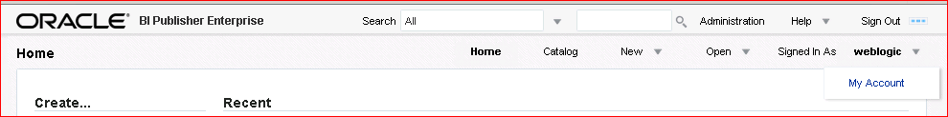Set your preferences. To set your preferences, click the “**Signed in as *<user>***” link, and select **My Account** from the drop-down list.
3. The My Account dialog box appears with two tabs: General and My Groups. The Password tab is enabled only when you use BI Publisher Security. Review the settings on these tabs, accept the defaults, and do not change anything—your lab environment uses Fusion Middleware Security and already has all the appropriate settings.

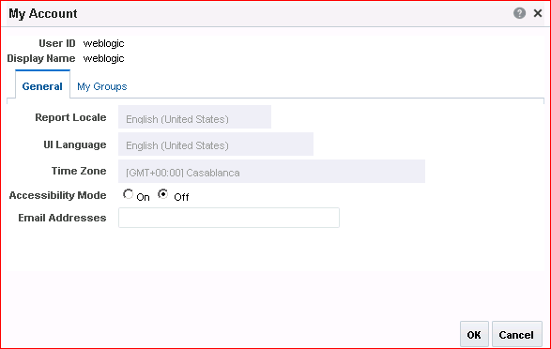

6.

Practices for Lesson 4: Getting Started with BI Publisher

17

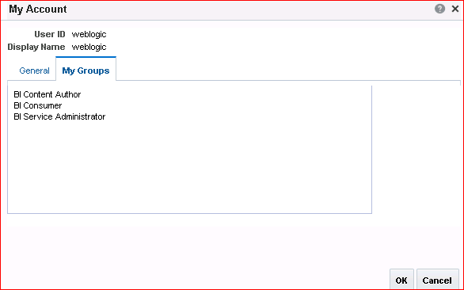**Note:** If you are running BI Publisher integrated with a security model other than BI Publisher, these preferences may be inherited from the other security model, and you will not be able to change them.

Click **Cancel**.

## Practice 4-2: Creating and Modifying JDBC Connections

### Practice Overview

In this practice, you create a JDBC connection for the OE schema (part of the Oracle database in the classroom environment) and you modify an existing JDBC connection for Demo Files.

### Assumptions

To perform the tasks in this practice, you should have:

* Administrative privileges
* Oracle Database 12 (or Oracle Database 11*g*) installed along with the sample schemas, HR and OE, unlocked
* Oracle BI Enterprise Edition 12c installed (including Oracle BI Publisher 12c Enterprise Edition)
* All Oracle BI EE services and Oracle Database up and running

### Tasks

1. Log in to BI Publisher (if not already logged in) as a user with BI Administrator privileges.
2. To define a JDBC connection, click the **Administration** link located on the right side of the BI Publisher page.
3. The Administration page appears. Note the different sections available on the Administration page. Click **JDBC Connection** in the Data Sources section.

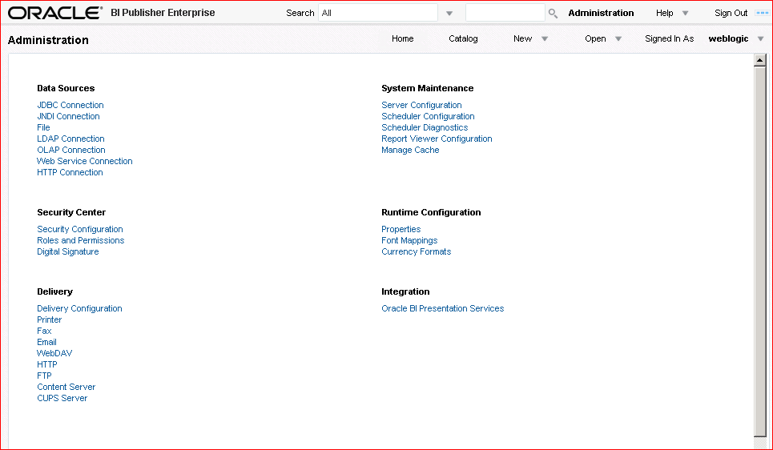

1. The **Data Sources** page appears. In the JDBC section, click **Add Data Source** to create a JDBC connection to your database.

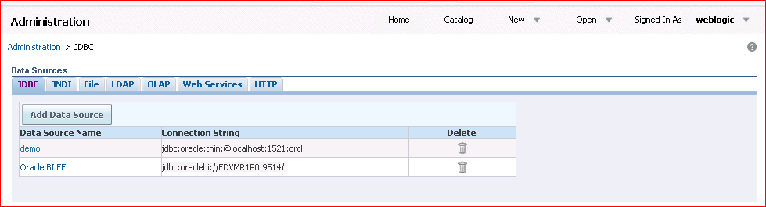

1. On the Add Data Source page, enter the following details:

|  |  |  |
| --- | --- | --- |
| **Step** | **Name** | **Values** |
| a. | **Data Source Name** | oe (Enter in lowercase.) |
| b. | **Driver Type** | Select Oracle 12c. This is the driver type for the  classroom database. |
| c. | **Database Driver Class** | Enter oracle.jdbc.OracleDriver This is a driver class for the classroom database. |
| d. | **Connection String** | Provide the database connection detail in the format  <hostname>:<port>:<sid>.  **Note**: For your practice, the string should look like this: jdbc:oracle:thin:@localhost:1521:fenago  However, confirm these details with your instructor. |
| e. | **Username** | oe (database username; enter in lowercase) |
| f. | **Password** | oe (database user password; enter in lowercase) |

Your Data Source page should look like the following screenshot.

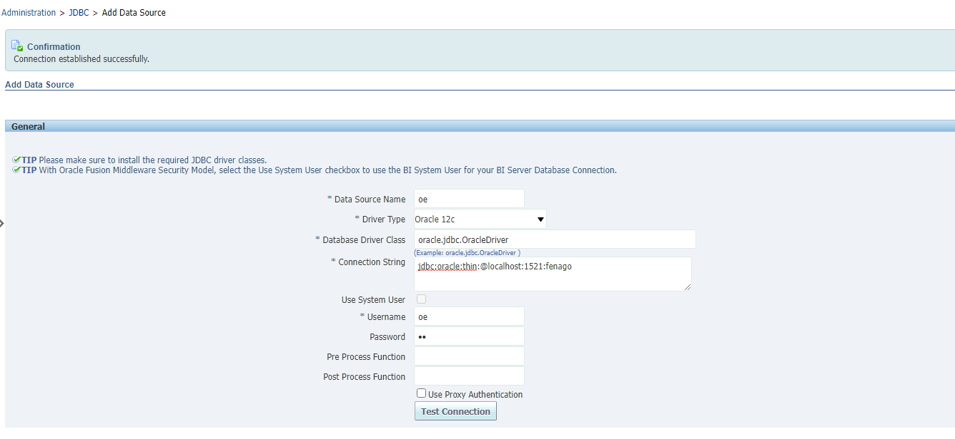

1. Do not click **Apply** or **Cancel** after entering the preceding details. Click **Test Connection**. If the connection is established properly, a confirmation message appears directly beneath the Administration tab as indicated in the following screenshot.

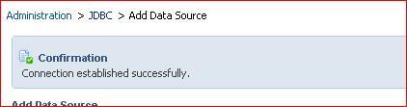

1. Click **Apply** when the connection is properly established. The data source appears in the Data Sources table.

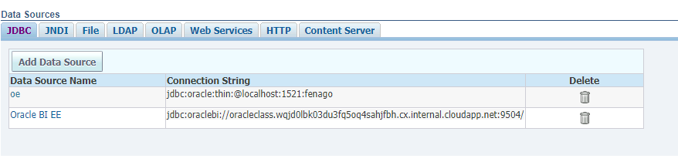

1. Click “Add Data Source” button again and input Data source name “**demo”** and set random username/password for now and save it. We will update it to points to the OE schema in database, because other practices will use this association. Click the link for **demo**.

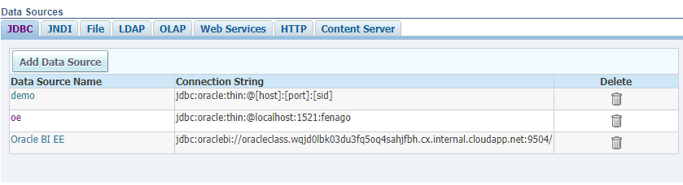

1. On the “Update Data Source: demo” page, enter the following details:

|  |  |  |
| --- | --- | --- |
| **Step** | **Name** | **Values** |
| a. | **Driver Type** | Select Oracle 12c. This is the driver type for the classroom database. |
| b. | **Database Driver Class** | Enter oracle.jdbc.OracleDriver. This is a driver class for the classroom database. |
| c. | **Connection String** | Provide the database connection detail in the format  <hostname>:<port>:<sid>.  **Note**: For your practice, the string should look like this: jdbc:oracle:thin:@localhost:1521:fenago  However, confirm these details with your instructor. |
| d. | **Username** | oe (database username) |
| e. | **Password** | oe (database user password) |

Your Data Source page should look like the following screenshot:

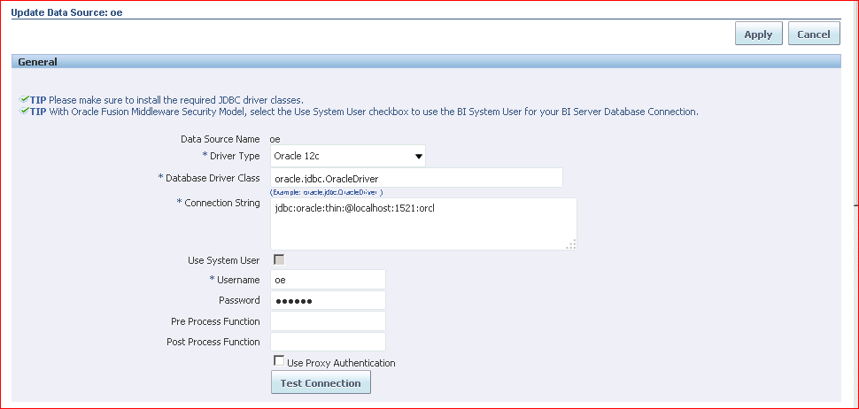

1. Click **Test Connection**. If the connection is established properly, the confirmation message appears.

Practices for Lesson 4: Getting Started with BI Publisher

23

1. Click **Apply** when the connection is properly established. The data source appears in the a Sources table.

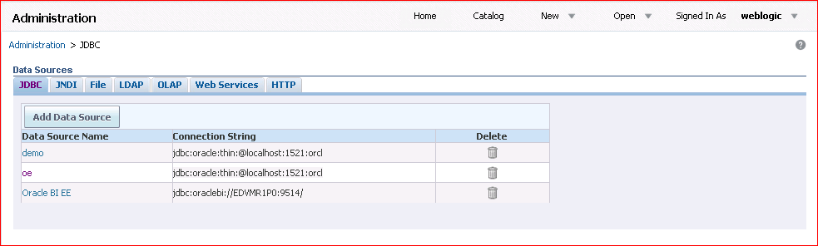

## Practice 4-3: Exploring the Catalog and Viewing a Predefined Report

### Overview

In the next few steps, you browse the Catalog and open a predefined report.

### Tasks

1. Click the **Catalog** link on the global header. The Catalog page appears with the folders displayed in a tree structure on the left pane and object details on the right.

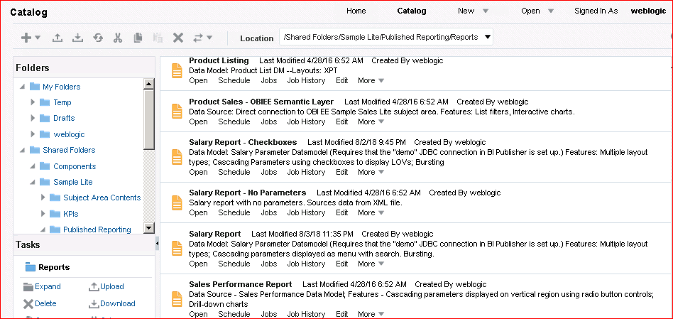

Catalog objects, such as reports and data models, are organized into folders. Shared Folders contain objects that can be used by others in reports, dashboards, and so on. My Folders contains private objects. Note that Sample Lite is contained within Shared Folders. Sample Lite is installed out of the box.

1. Navigate to Shared Folders > Sample Lite > Published Reporting > Reports. Click the

**Open** link below “Salary Report – Checkboxes” (as shown in the preceding screenshot).

1. 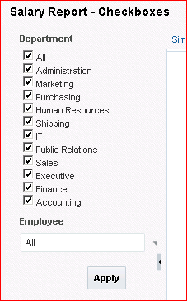Salary Report - Checkboxes runs and appears in a browser window.

The report data is displayed with parameters. The reports display parameters when it has parameters defined in the data model or report editor.

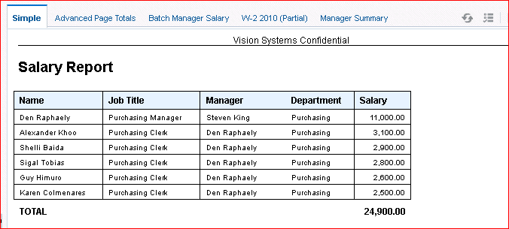**Note:** You can select different values for the Department drop-down list, such as Sales or Purchasing; and similarly select employees for these departments to view the data. The data in the report changes according to your selections. Because these parameters are connected (cascading parameters), when you select a specific department, the employees belonging to that department appear. Note that you can select a specific employee as well.

All the predefined layouts for the report appear as different tabs.

**Note:** The Sample Lite folder contains a set of predefined sample reports and other Catalog objects. You can open and view any of these reports.

1. View the report by using any of the supported formats.

Click the **View** icon in the Report Viewer and select any of the formats, such as HTML, PDF, RTF, Excel, or PowerPoint.

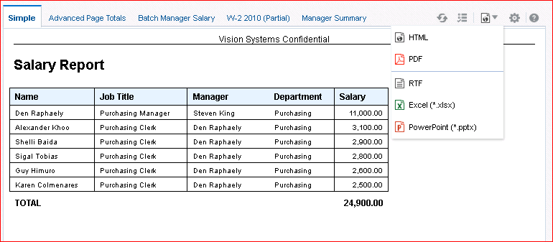

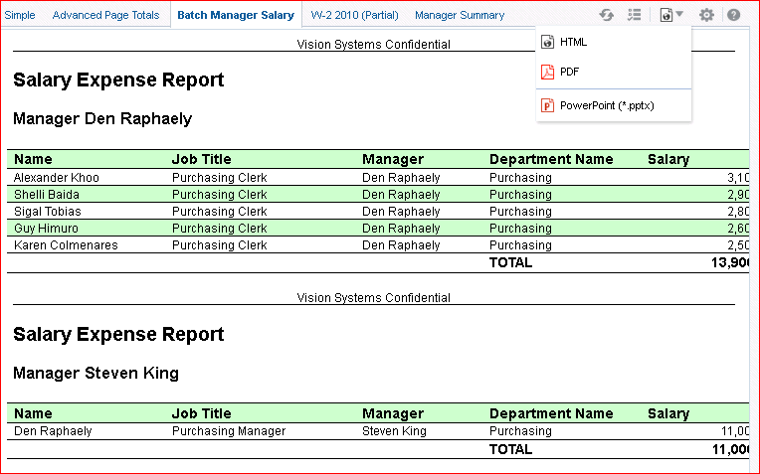Click the other tabs to view the different styles of layouts associated with this data. For example, click Batch Manager Salary to view a financial style.

Observe that, based on the layout you have chosen, report view options change. This layout has only HTML, PDF, and PowerPoint views. Click Manager Summary to see an interactive view.

Practices for Lesson 4: Getting Started with BI Publisher

27

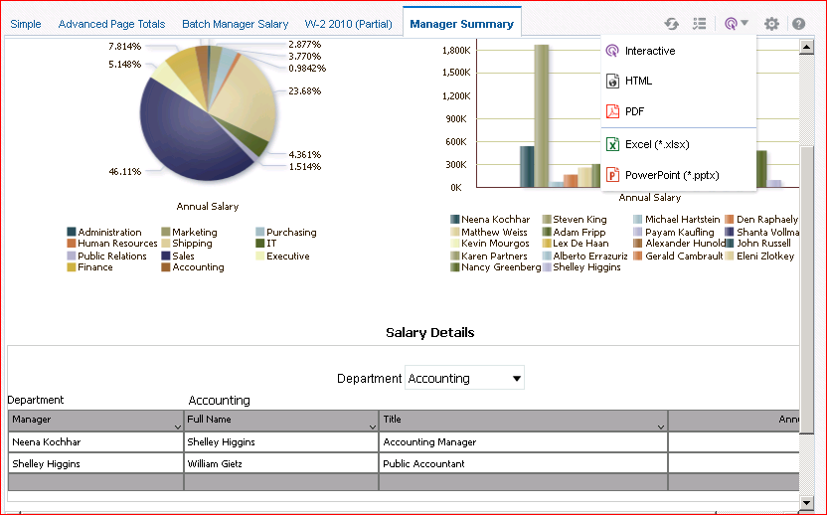

## Practice 4-4: Creating a Private Folder

### Overview

In this practice, you create a private folder in the Catalog. You will use this folder to save your objects.

### Tasks

1. Click the **Catalog** link and select **My Folders.**

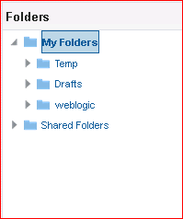

1. Click **New** > Folder to create a new folder under My Folders.

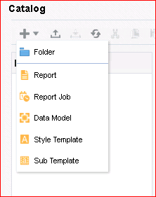

1. 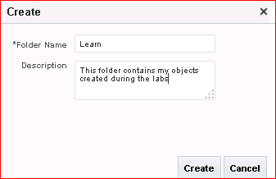The Create dialog box appears. Enter Learn in the Folder Name text box and, optionally, enter a Description. Click **Create**.
2. Your new folder appears in the Catalog folder tree and in the work area. All objects that you create during your practice sessions (data models, reports, and so on) should be saved to this folder except for the objects that you will add to your dashboard and the files that are stored locally.

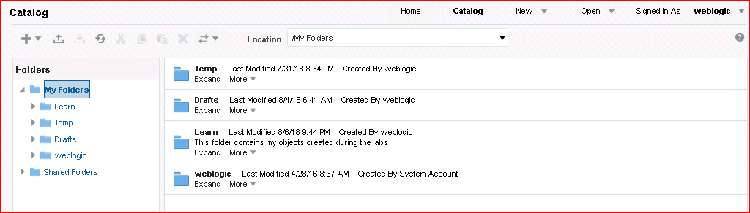

## Practice 4-5: Managing Favorites

### Overview

In this practice, you will add an existing report to the Favorites region and view it on the Home page.

### Tasks

1. Locate the **Balance Letter** report in the Catalog and click the **More** link.

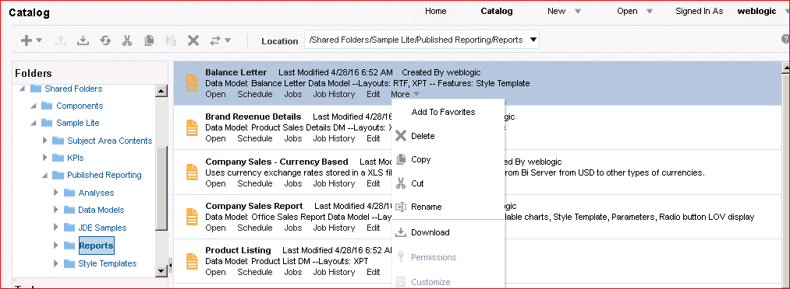

1. Click **Add To Favorites** in the **More** Menu.

An information window is displayed. Click OK. The report is now added to the **Favorites**

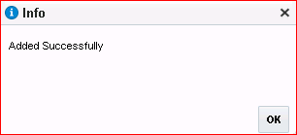section.

1. Navigate to the Home page to view the report under the **Favorites** section.

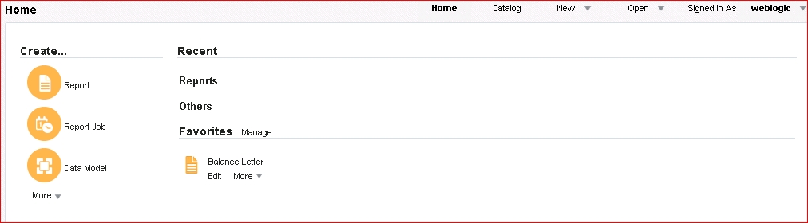

**Note:** There are several ways to add objects to the Favorites region:

* + You can also add a report to the Favorites section from Report Viewer. Use the Actions menu, and then click **Add to My Favorite**.
  + You can also use the **Manage** link in the Favorites section of the Home page for

adding and managing favorites.

## Practice 4-6: Creating a Simple Report Based on a Predefined Data Model

### Overview

In this practice, you create a simple report against an existing (predefined) data model, Salary Report Parameter, and view it in Report Viewer. This report will have a simple chart and table. You use the Report Wizard to create the new report.

### Tasks

1. Click New > Report in the global header.

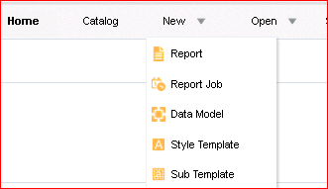

1. 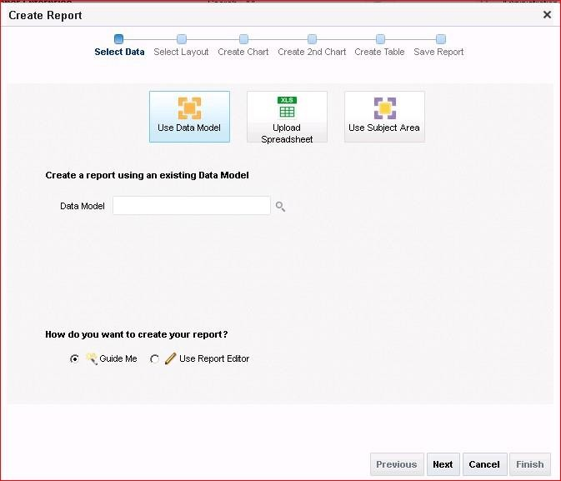The Create Report window is opened. You can select the data using any of the available choices: Use Data Model, Upload Excel Spreadsheet, or Use Subject Area. You create a report by using the existing data model—*Salary Parameter Datamodel.*

Click the Search icon beside the Data Model selection field to select an existing data model from the Catalog.

1. Select the data model from the Catalog folder: Shared Folders > Sample Lite> Published Reporting > Data Models > Salary Parameter Datamodel and click **Open.**

34

Practices for Lesson 4: Getting Started with BI Publisher

T4. his is reflected in the Report Wizard’s Data Model field. Click **Next.**

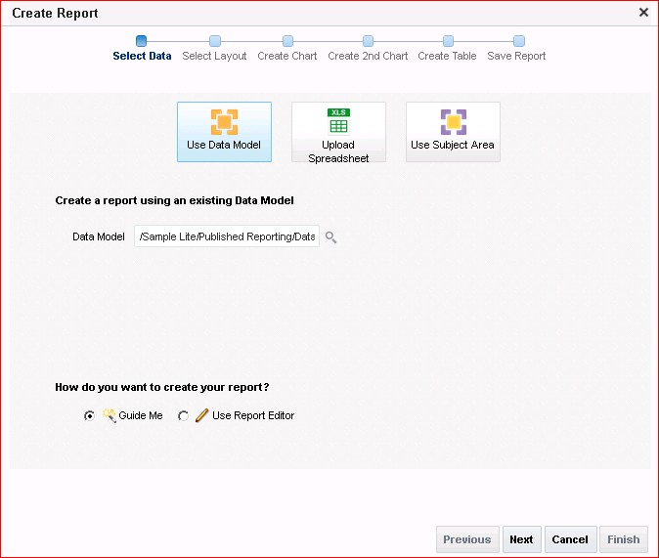

1. After you select the data source for the report, select the report page options and report layout to define how data is displayed in the report. In Page Options, select **Portrait** for the page orientation.

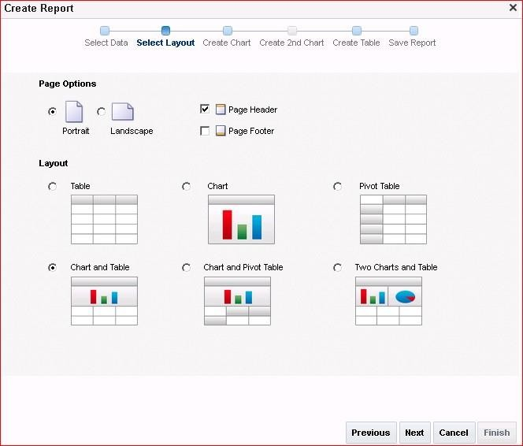

1. Select **Page Header** to display the page header.
2. From Layouts, select **Chart and Table**. You can choose any of the combinations based on

your requirement.

1. Click **Next.** The layout that you select on the Select Layout page drives the remaining pages that you must complete in order to create the report.
2. Because you have selected the Chart and Table layout, the Create Chart page opens. The Chart Layout page supports three types of charts. Select **Bar Chart**.

Add columns to the chart by dragging and dropping them from the Data Source pane to the chart area.

10.

36

Practices for Lesson 4: Getting Started with BI Publisher

* 1. Drag Annual Salary on to Drop Value Here.
  2. Drag Department on to Drop Series Here.

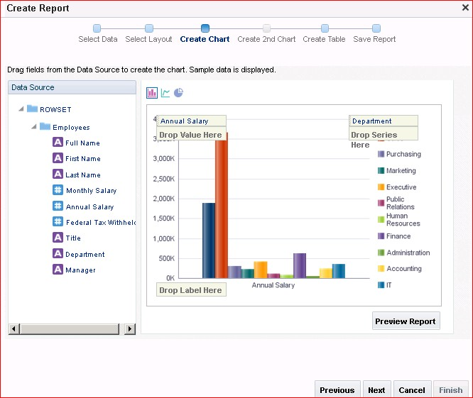

1. Click **Next** in the Report Wizard to create a table.

Practices for Lesson 4: Getting Started with BI Publisher

37

1. The Create Table page is displayed with the columns that you previously selected for the

chart. You will edit this table by adding and removing required columns.

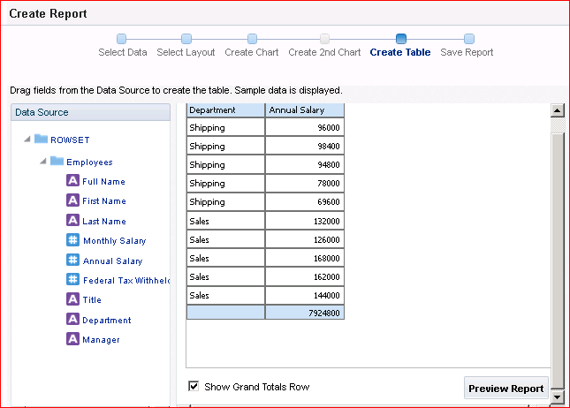

38

Practices for Lesson 4: Getting Started with BI Publisher

1. Remove the column **Annual Salary** from this table by selecting the column and clicking the remove option as shown.

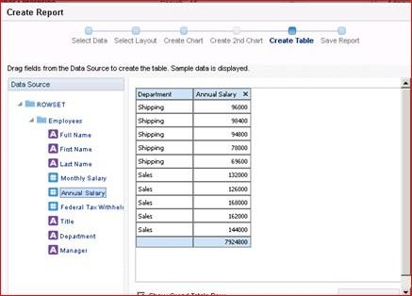

1. Add data to the table. Along with the existing Department column, add Manager, Full Name, and Monthly Salary by dragging the data elements to the table. The columns are displayed in a simple tabular format and the column widths are automatically adjusted based on the number of selected columns.

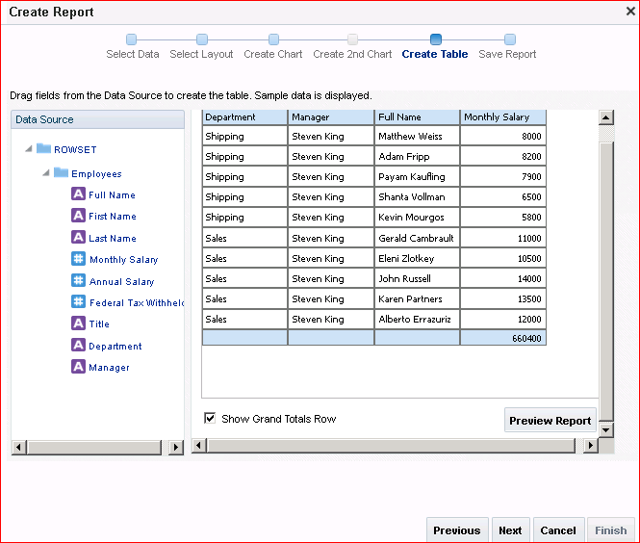

40

Practices for Lesson 4: Getting Started with BI Publisher

1. Click **Preview Report** to view the report in the interactive viewer.

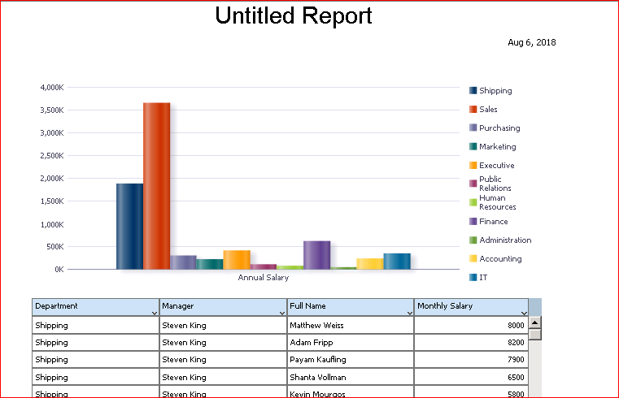

1. Close the viewer’s browser window.
2. Click **Next** in the Report Wizard to proceed to saving the report.
3. To run the report you just created, click **View Report** and then click **Finish**. The final page prompts you to save the report.

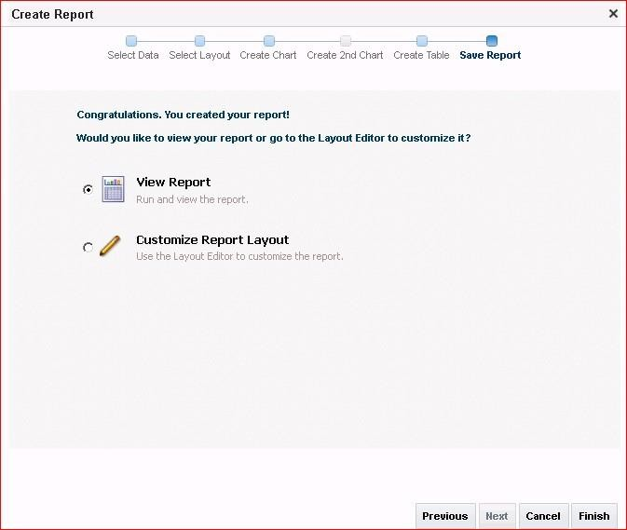

**Note:** If you select the Customize Report Layout option, the final page prompts you to save the report. After saving, the report is opened in the Layout Editor for further editing.

1. In the Save As dialog box, select the folder **My Folders > Learn**.
2. Name the report **My Salary Report.** Click **Save.**
3. 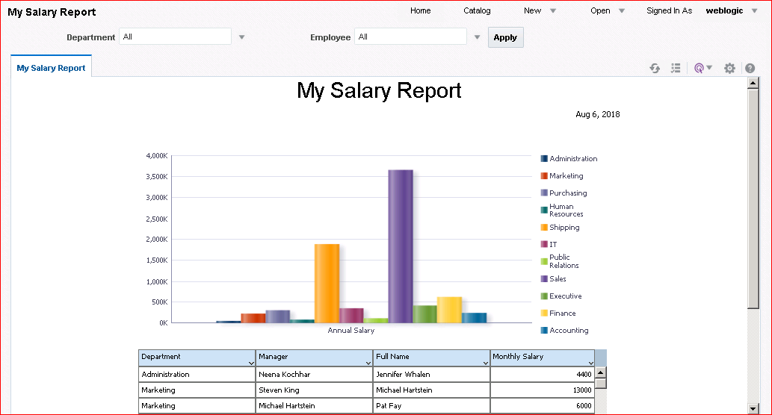The report is displayed in the report viewer. By default, the report header takes its name from the report file name you have given. You can edit this using the Layout Editor.

## Practice 4-7: Creating a Simple Report Based on BIEE Subject Area

### Assumptions

You create a simple report against the OBIEE subject area and view the report.

### Practice Overview

In this practice, you create a report using the OBIEE subject area for the report data.

### Tasks

1. Click New > Report in the global header.



1. The Create Report window is opened. You will create a report by using the subject area. Select **Sample Sales Lite** from the Subject Area list. Click Guide Me and click **Next.**

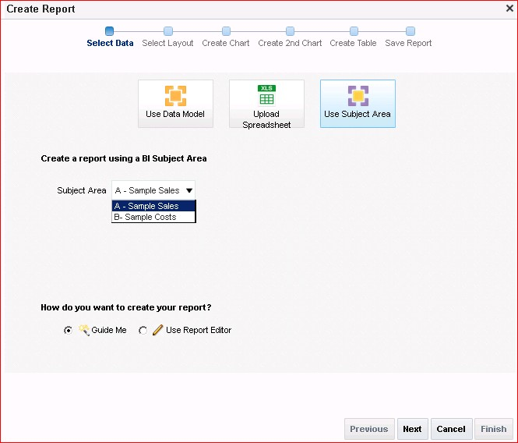

1. In Page Options, select **Portrait** for the page orientation. Select **Page Header** to display the page header. From the Layout section, select **Chart and Table**. You can choose any of the combinations based on your requirement.

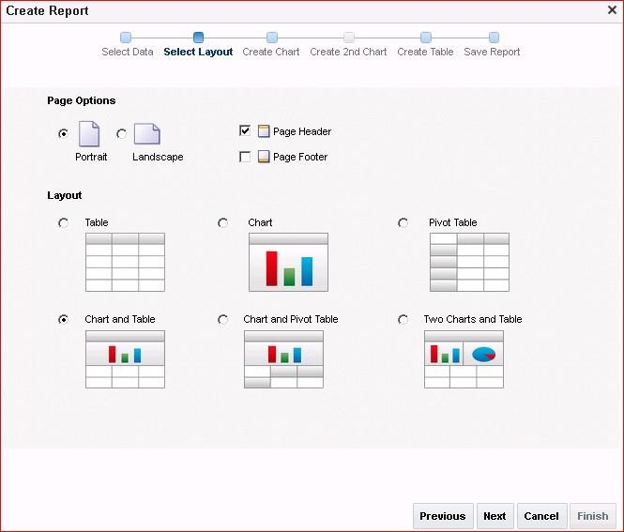

1. Click **Next.** The layout that you select in the Layout section drives the remaining pages that you must complete in order to create the report.
2. Create a chart from the selected subject area data. Select Bar Chart as the chart type.
3. Drag the data elements Product: Brand and Base Facts: Revenue, as shown in the screenshot, to the Drop Label Here and Drop Value Here areas in the chart.

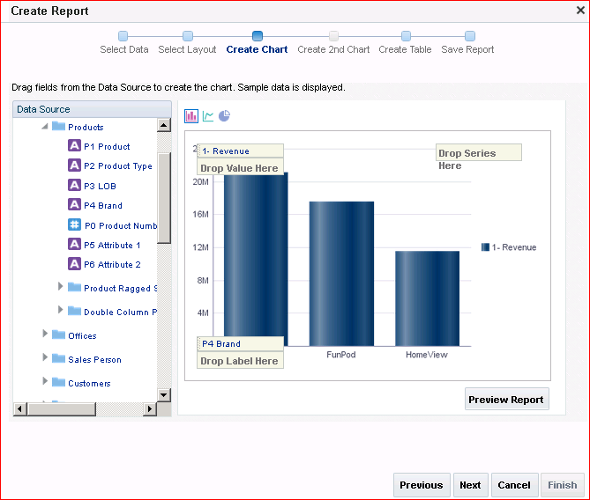

1. Click **Next.**
2. The Create Table step is displayed.
3. Add Brand and Revenue, if they are not already present. Add other required columns to the table. Drag data elements from the data source to the table columns, per the following table:

|  |  |
| --- | --- |
| **Data Element** | **Table Column** |
| Time | Per Name Qtr |
| Offices | Company |
| Orders | Order Status |

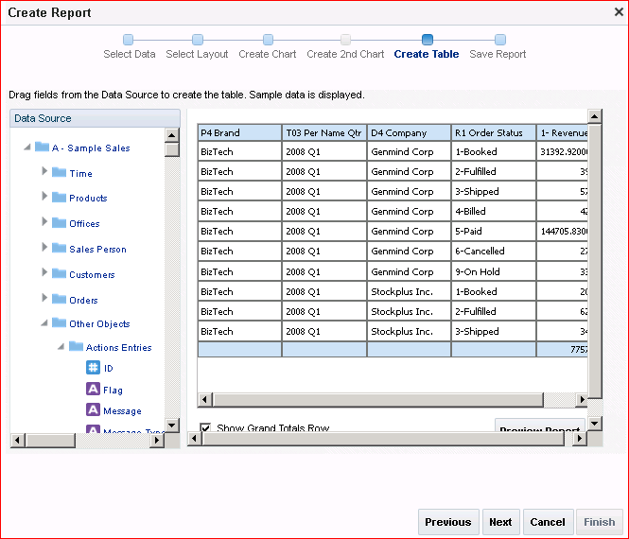

1. Click **Next** in the Report Wizard to proceed to saving the report.
2. To run the report you just created, click **View Report** and then click **Finish**. The final page prompts you to save the report.

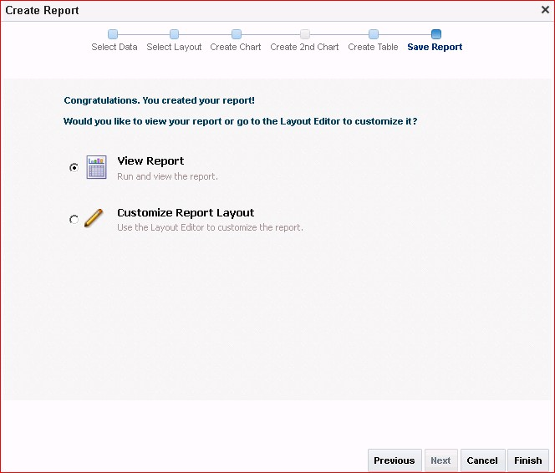

1. Save the report as **My Revenue Report** in My Folders > Learn.
2. 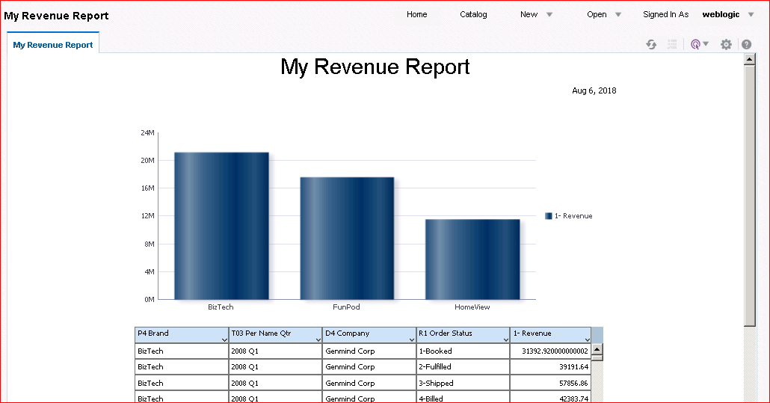The report is now displayed in the Report Viewer window.

58 Practices for Lesson 4: Getting Started with BI Publisher

# Practices for Lesson 5: Using Data Model Editor

## Practices for Lesson 5: Overview

### Goal

To explore the BI Publisher Data Model Editor and to create and edit a data model based on a SQL Query data set, and create a report for the same

### Practices Overview

You define a private JDBC connection, and you create and save a data model and a report based on a SQL Query data set.

### Time

60 - 75 minutes

## Practice 5-1: Opening the Data Model Editor and Creating a Private Connection

### Overview

In this practice, you create a private JDBC connection.

### Assumptions

You will use the folder My Folders directly to save the objects created in this practice.

### Tasks

1. Log in to BI Publisher as username weblogic and password weblogic1.
2. Choose one of the following ways to open the Data Model Editor:
   * From the Home page: Create section > Data Model

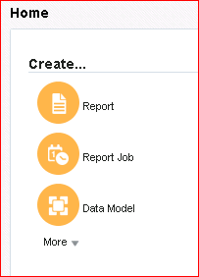

* + From the Catalog page: New > Data Model

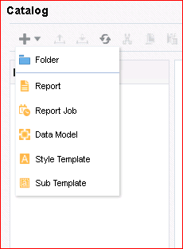

* + From the global header: New > Data Model

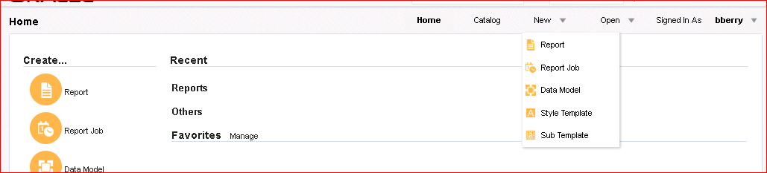

1. The Data Model Editor appears. This page is composed of two panes: Properties on the right and Data Model on the left.

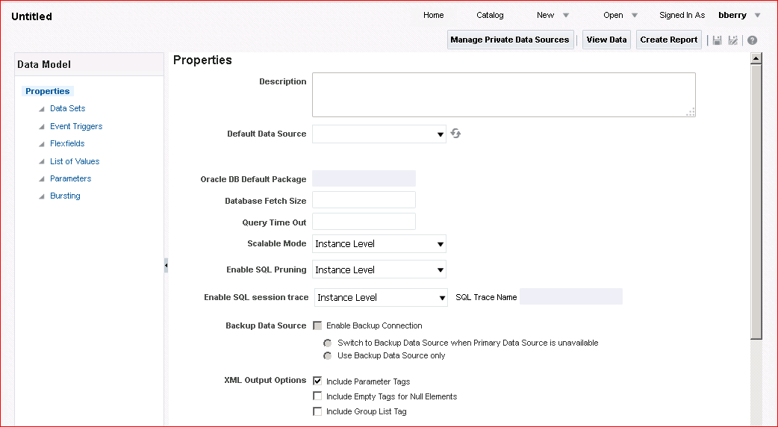

Click Manage Private Data Sources.

**Note:** You need to have the Data Model Developer privilege or BI Author role to create this

connection.

1. The Manage Private Data Sources window appears. Observe that you see only the JDBC and OLAP tabs. By default, the JDBC tab is displayed. Click **Add Data Source**.

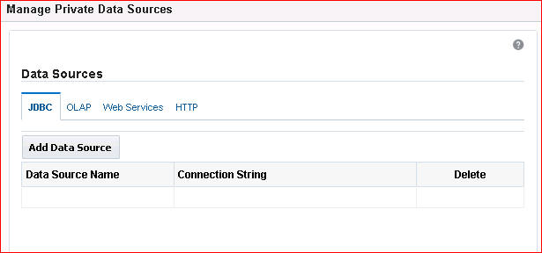**Note:** If you log in with administrative privileges, you can see other tabs.

1. The Manage Private Data Sources dialog box appears.

Enter the private connection name, and the required fields. Provide the following details:

1. Data Source Name: MyJDBC
2. Driver Type: Oracle 12c
3. Database Driver Class: oracle.jdbc.OracleDriver
4. Connection String: jdbc:oracle:thin:@localhost:1521:fenago
5. 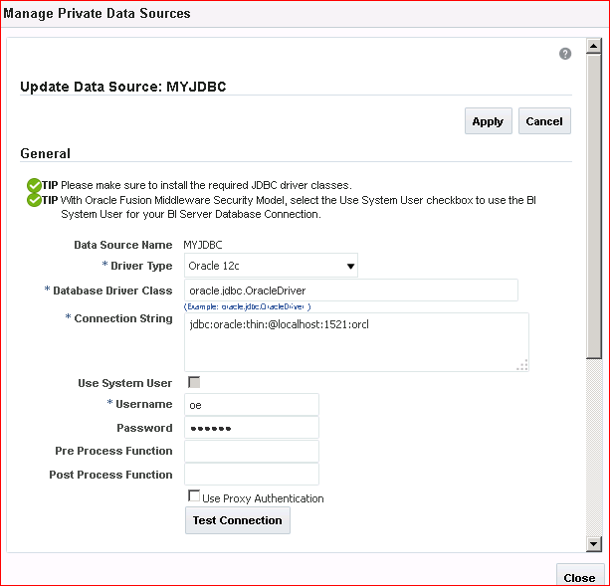Username and Password: oe/oe
6. 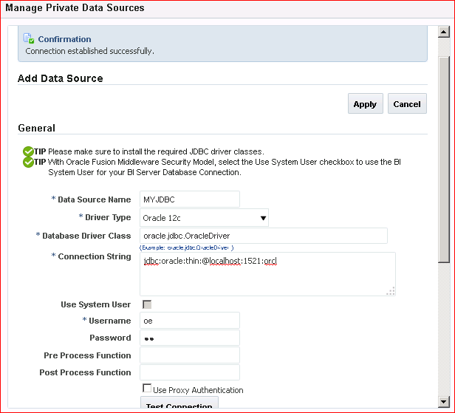Click Test Connection. A confirmation prompt is displayed.
7. 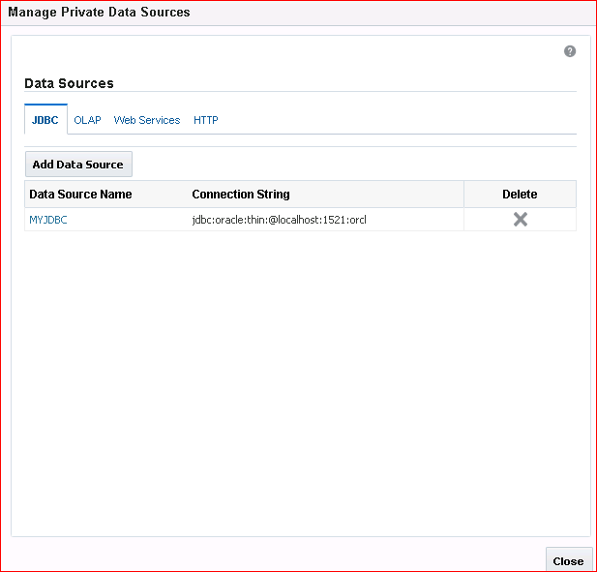Click Apply and click Close. The private data source connection is now available for use in data sets as a defined data source.
8. 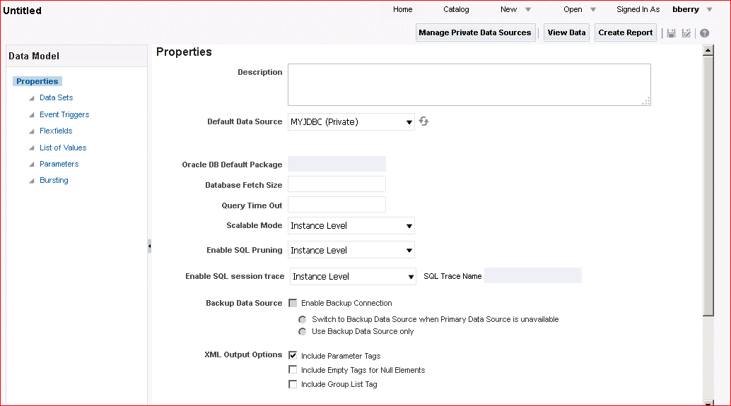In the Data Model Editor, observe that the default data source is listed as MyJDBC (Private), indicating that this is a private connection.

Ensure that the Include Parameter Tags check box is selected for XML Output Options.

## Practice 5-2: Defining a SQL Query Data Set

### Overview

In this practice, you create a SQL query data set.

### Tasks

1. In the Data Model pane on the left, select Data Sets. The working pane for Data Sets appears on the right.

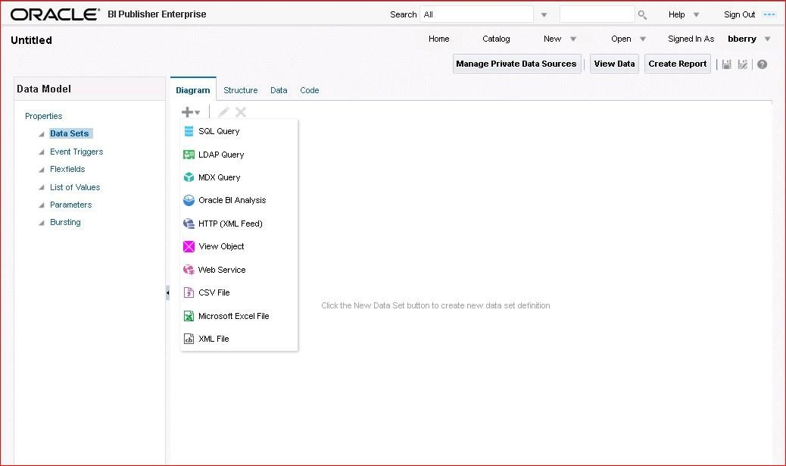

1. From the New Data Set drop-down list, select SQL Query as the type of data set.
2. 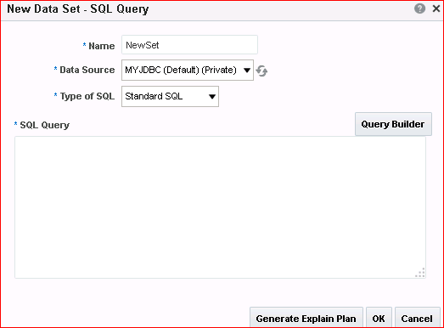The New Data Set - SQL Query dialog box appears. Enter the name NewSet for the data set.

If you are not using the default data source for this data set, select the required data source from the list. In this example, you use the default data source MyJDBC (Private).

1. Click Query Builder to create a query.

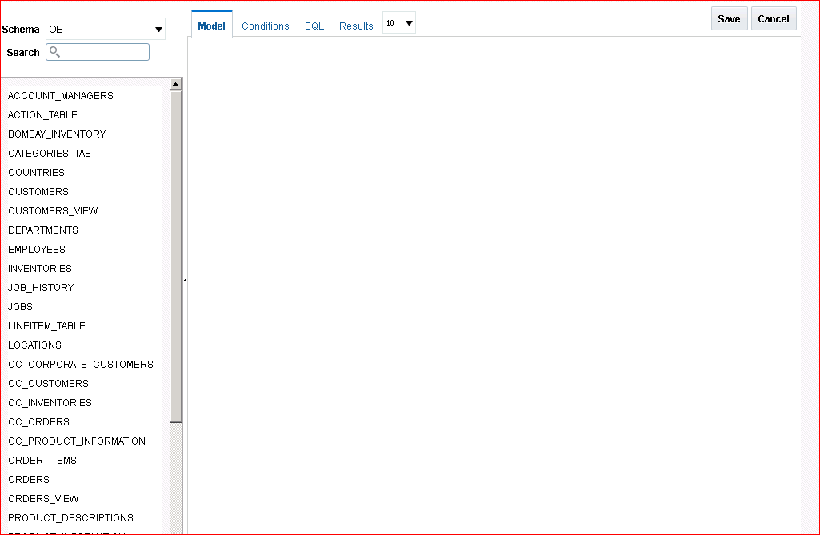The Query Builder window appears, displaying the **oe** schema objects in the left pane. Note the four tabs (links) on the right: Model, Conditions, SQL, and Results.

1. 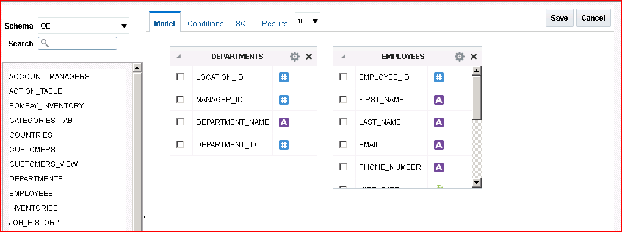Click the DEPARTMENTS and EMPLOYEES tables to add them to the Model canvas on the right.
2. Define a join between these two tables as follows:

|  |  |
| --- | --- |
| **Step** | **Instructions** |
| a. | Click the empty box to the right of the attribute type column for **DEPARTMENT_ID** in the **DEPARTMENTS**  table. The box turns grey. |
| b. | Click the empty box to the right of the attribute type column for **DEPARTMENT_ID** in the **EMPLOYEES** table. A fine line appears, indicating that a join has been created. |

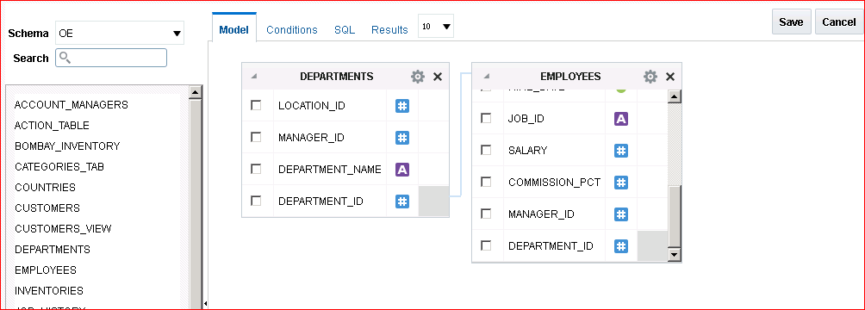

1. Select the check box to the left of the following columns from each table to select the column:
   * **DEPARTMENT_NAME** from DEPARTMENTS
   * 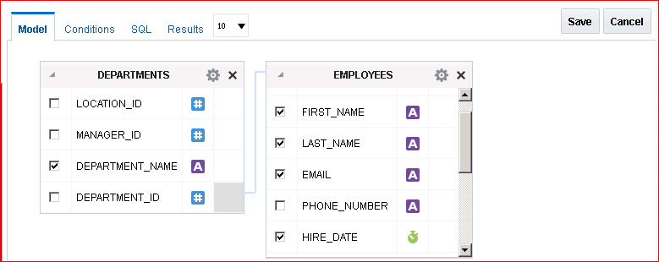**FIRST_NAME**, **LAST_NAME**, **EMAIL**, **HIRE_DATE**, and **SALARY** from EMPLOYEES
2. 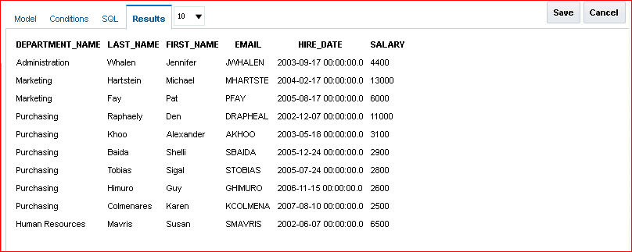Click the **Results** tab to view the query results, and then click **Save**.
3. The New Data Set - SQL Query dialog box reappears. Observe that the SQL code is automatically created for you and is reflected in the SQL Query pane of the dialog box.

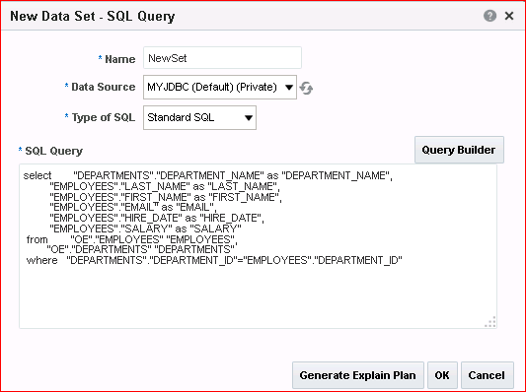

1. 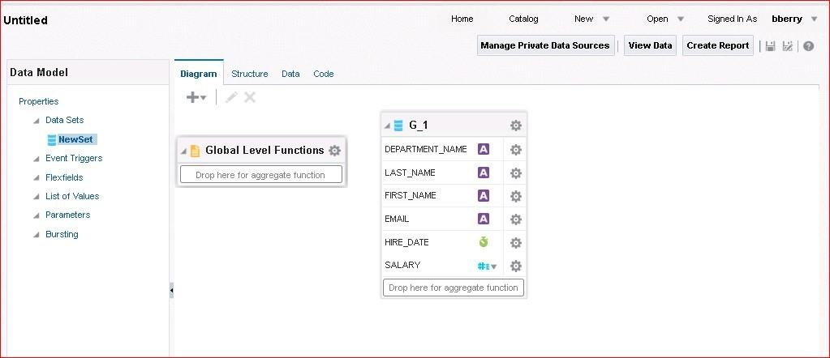Click **OK** to add this data set to the data model. The Diagram tab reappears with your data set.
2. Change the names of the columns to make them user-friendly. Click the double-headed arrow () next to DEPARTMENT_NAME and select **Properties**.

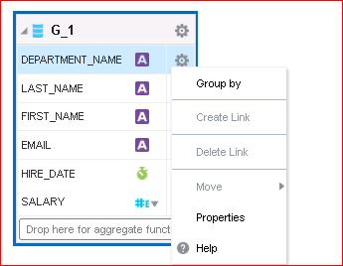

The Edit Properties dialog box appears.

1. 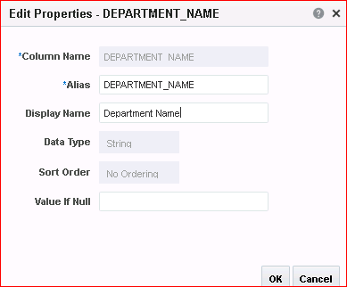Enter Department Name as the Display Name.
2. Click **OK**
3. Use the Structure tab to change the display names for each of the following columns:

|  |  |  |
| --- | --- | --- |
| **Step** | **Column Name** | **Value** |
| a. | **FIRST_NAME** | First Name |
| b. | **LAST_NAME** | Last Name |
| c. | **EMAIL** | Email |
| d. | **HIRE_DATE** | Hire Date |
| e. | **SALARY** | Salary |

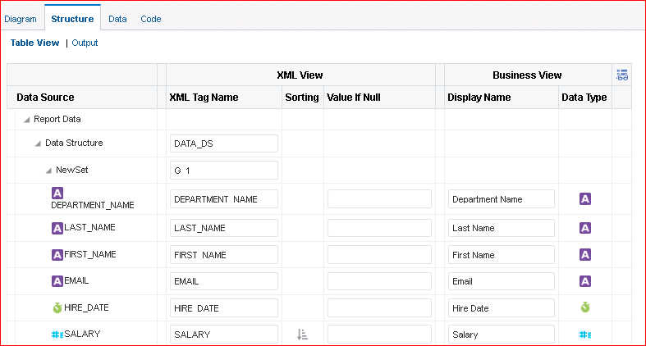

76 Practices for Lesson 5: Using Data Model Editor

## Practice 5-3: Viewing the Output and Saving Sample Data for the Data Model

### Overview

In this practice, you view the data and save the sample data. You also save the data model.

### Tasks

1. 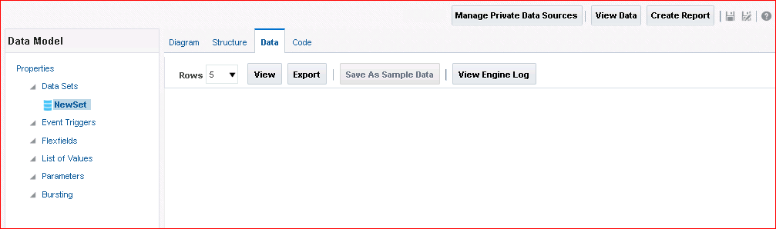Click the **Data** tab.
2. 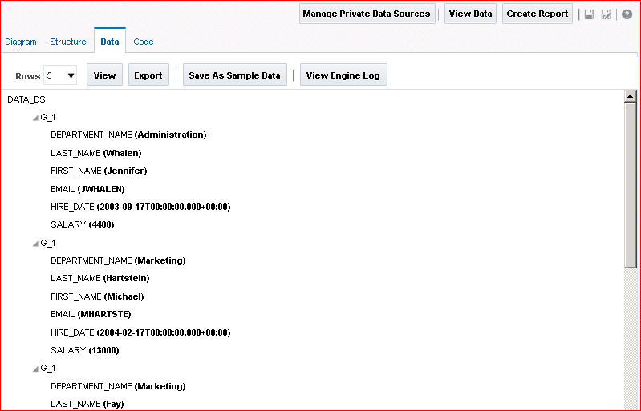Select the number of rows that you want to display for the data, and click **View.**
3. Click **Save As Sample Data**. You receive a confirmation prompt that this data is saved as sample data. Click **OK.**

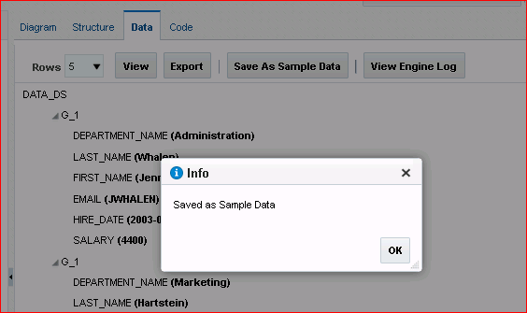

1. Click the Properties node in the left pane to view the Properties page. You can see that the

sample.xml file is listed under the Attachment section. This is the sample data that you just saved.

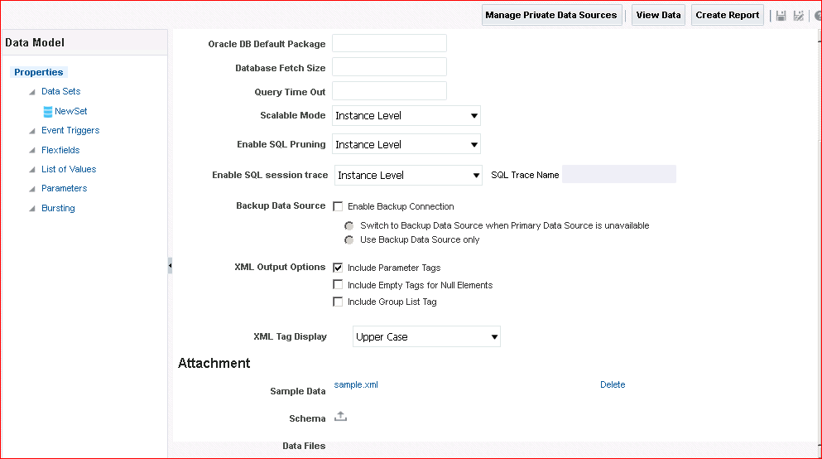

1. 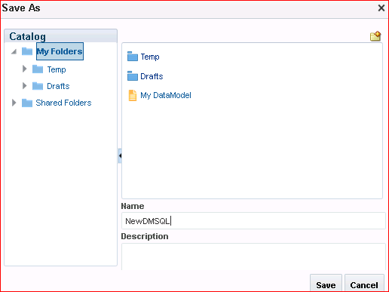Click the Save icon to save the data model.

Select My Folders in the Save As dialog box, and provide the name NewDMSQL.

## Practice 5-4: Editing the Data Model to Add a Parameter and an LOV

### Overview

In this practice, you add a parameter and a list of values (LOV) to your NewDMSQL data model.

### Tasks

1. Add a bind parameter for the Department Name column.

You can add a parameter by clicking the Parameters node in the Data Model pane and entering the details for the parameter, or by using the Query Builder - Conditions tab.

To edit the query by using Query Builder, select the **NewSet** data set and click **Edit** (  ).

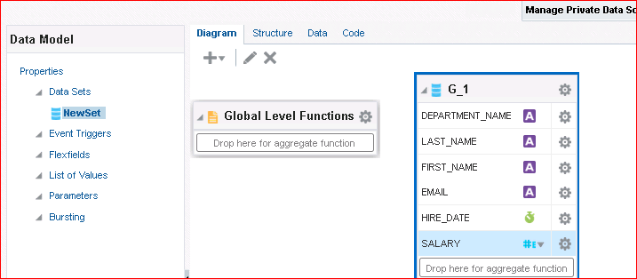

1. Click **Query Builder** when the Edit Data Set – NewSet dialog box appears.

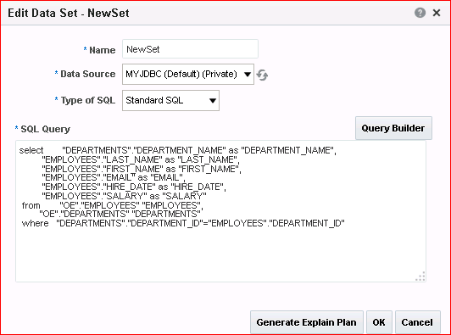

1. Click the **Conditions** tab and, in the Condition text box for Department Name, enter **IN (:P_DNAME)**.

This creates a bind parameter, P_DNAME, on the Department Name column.

The “IN” condition allows the parameter to accept all or multiple values for the Department Name column.

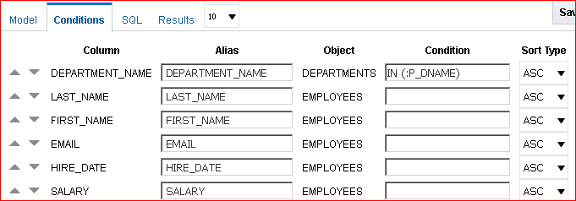

1. Click the **Results** tab to view the query results.
2. 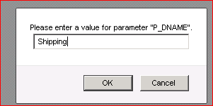You are prompted to enter a value for the parameter.

Enter **Shipping** and click **OK**.

1. 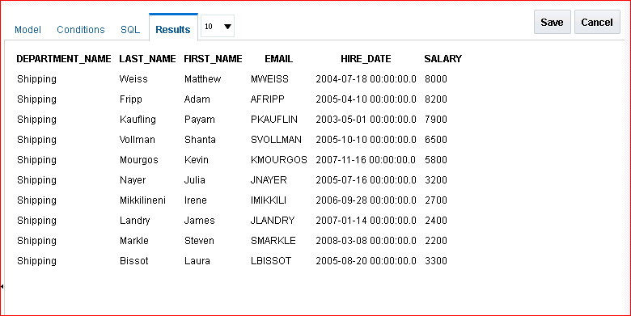The results appear.

Click **Save**.

1. The Edit Data Set dialog box reappears. Notice that your parameter is reflected in the SQL Query pane.

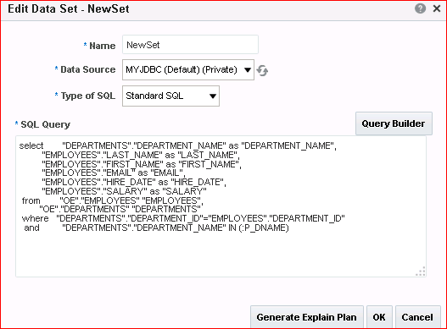

Click **OK**.

1. 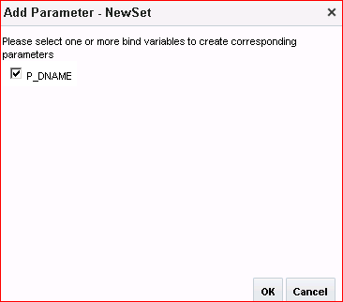A message dialog box appears asking you to select the bind variable for the parameter that you created. Select P_DNAME and click **OK**.

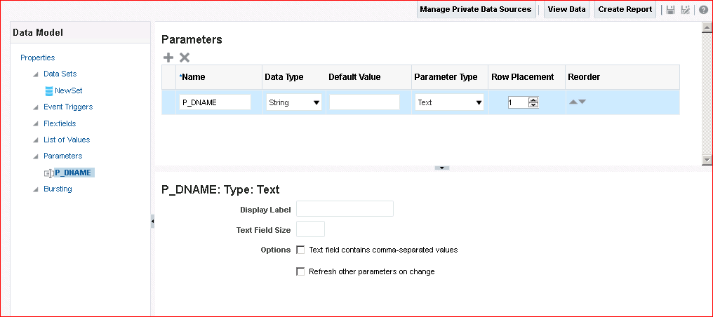The bind parameter appears in the Data Model pane.

1. The next step is to create an LOV. Select **List of Values** in the Data Model pane.
2. The List of Values pane appears in the workspace on the right.

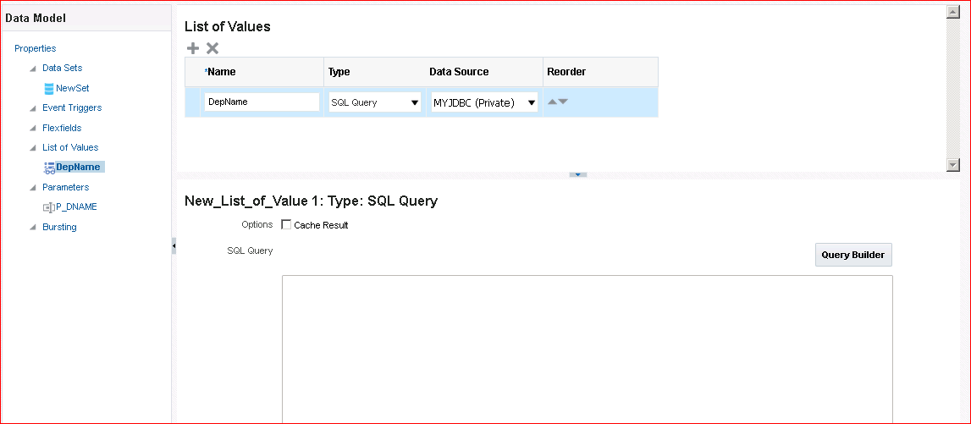Click **Create a new list of values** ( ) as indicated in the screenshot.

1. In the **List of Values** table, enter the following details:

|  |  |  |
| --- | --- | --- |
| **Step** | **Field Name** | **Values** |
| a. | **Name** | DepName |
| b. | **Type** | SQL Query |
| c. | **Data Source** | MyJDBC (Private) |

1. Click **Query Builder** (  values for the LOV.

Query Builder appears.

) to define the query that returns Department Name

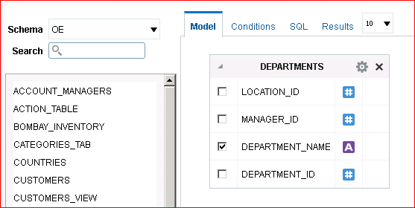

1. Click **DEPARTMENTS** and select **DEPARTMENT_NAME** in the table.
2. Click **Save**.

The List of Values pane reappears with the query for the LOV reflected in the SQL Query

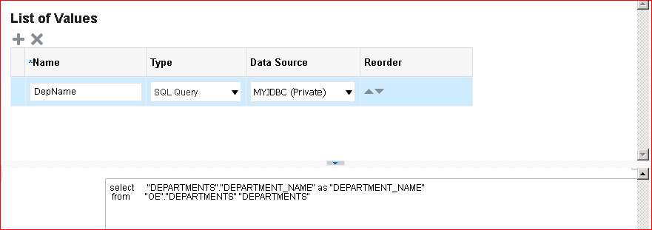pane at the bottom of the page.

1. Now you set the properties for the P_DNAME parameter to use this LOV. Select **P_DNAME** in the Parameters node of the Data Model pane.

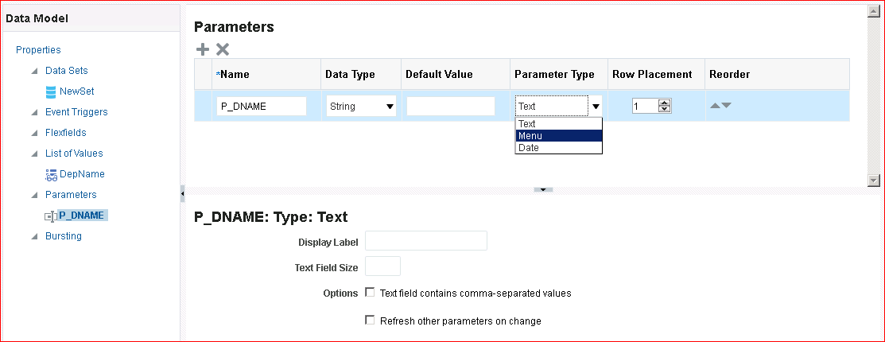Observe that the bottom pane for the parameter is not displaying any list of values, because the parameter type is yet to be chosen.

1. Enter Shipping in the Default Value text box for P_DNAME and select **Menu** as the Parameter Type.
2. In the lower half of the Parameters workspace, select the following:

|  |  |  |
| --- | --- | --- |
| **Step** | **Field Name** | **Values or Actions** |
| a. | **Display Label** | Enter Department Name |
| b. | **List of Values** | Select DepName |
| c. | **Multiple Selection** | Select the check box. |
| d. | **Can select all** | Select the check box. |
| e. | **All Values Passed** | Select the option button. |

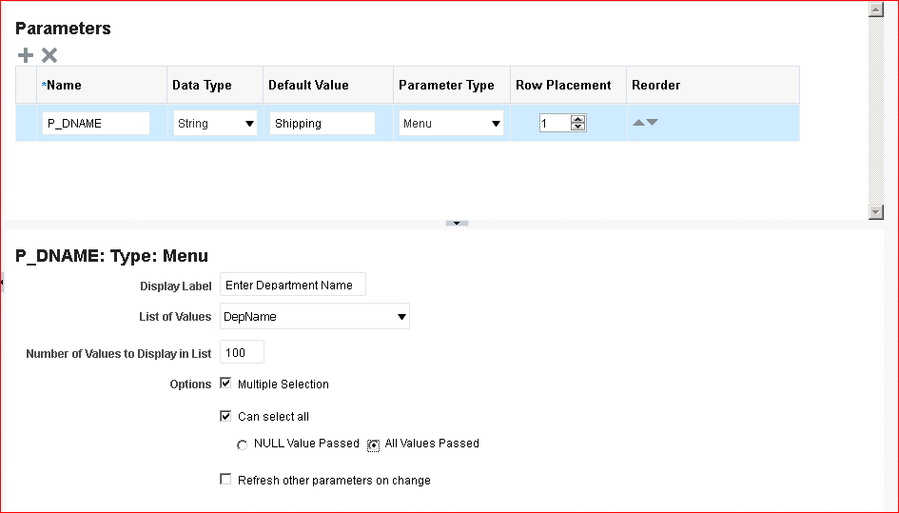

1. Click the Save icon to save the data model. Note that, at any time, you can use the Save As icon to save the data model with a new name.

## Practice 5-5: Creating a Report Based on the NewDMSQL Data Model

### Overview

In this practice, you use the Create Report Wizard to create a report using the NewDMSQL data model, and then you view the report in Report Viewer.

### Tasks

1. Click Create Report on the toolbar.

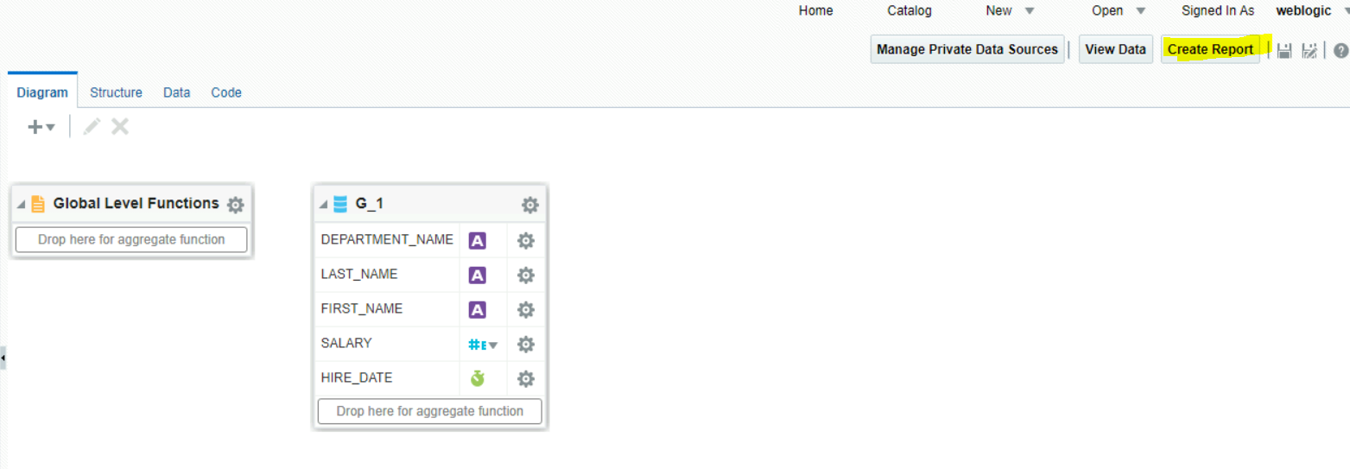

1. 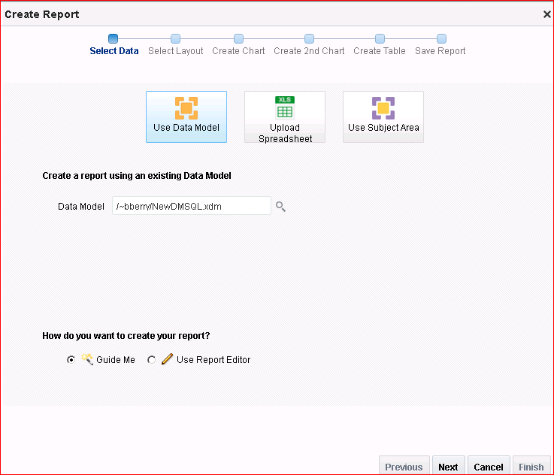This launches the Report Wizard to create a new report and automatically populates the Data Model field with the current data model name.
2. Click Next to select the layout and other components for the report.
3. Select the options as shown in the screenshot to include a chart and a table in the Portrait layout.

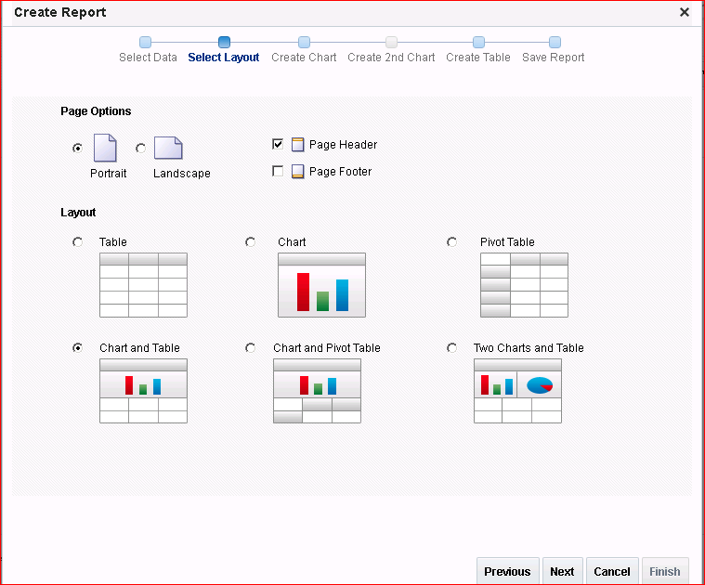

1. Click Next.
2. Select Bar Chart and drop the values as given below:
   1. Drag Salary to Drop Value Here.
   2. 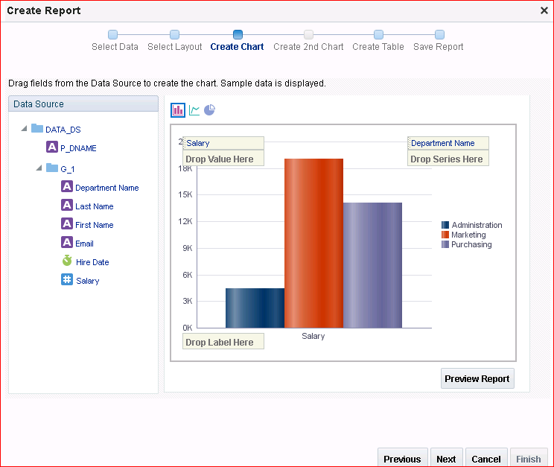Drag Department Name to Drop Series Here.

The chart is displayed with the selected data.

1. Click Next to select columns for the table.
2. 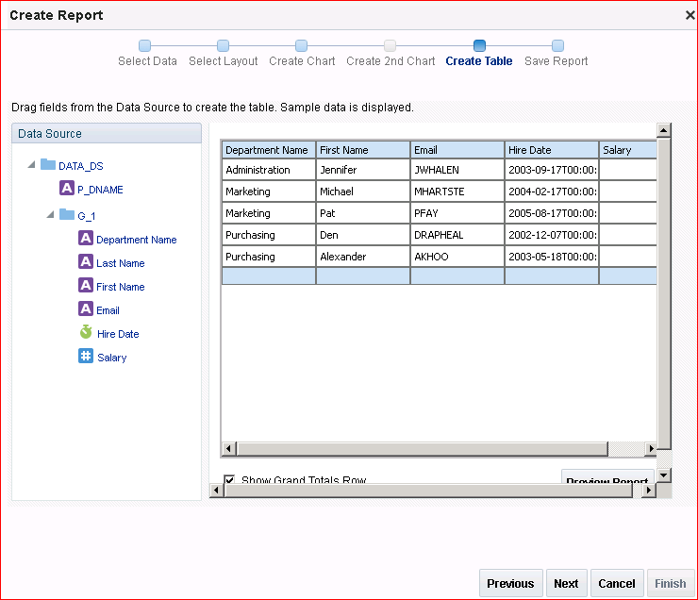Add the columns First Name, Email, and Hire Date to the table (after Department Name).
3. Click Next.
4. 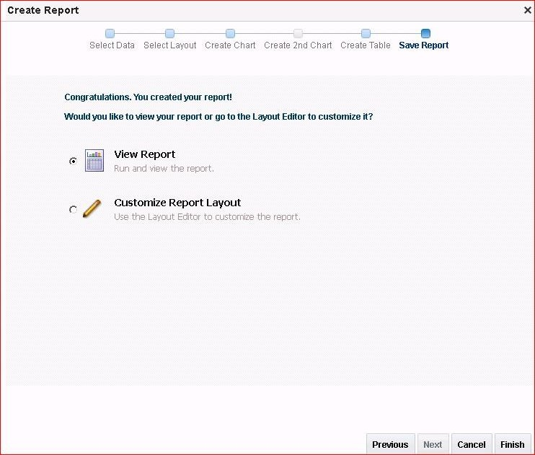You are prompted to save the report to complete the last step in the Create Report Wizard.

Click View Report.

1. Click Finish to save the report.
2. 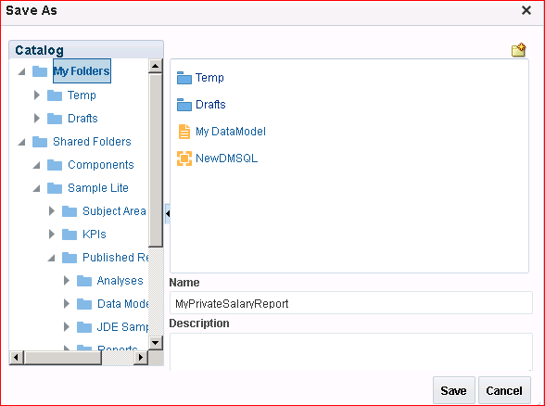Save the report as MyPrivateSalaryReport under My Folders.

The report is saved and displayed in the Report Viewer window.

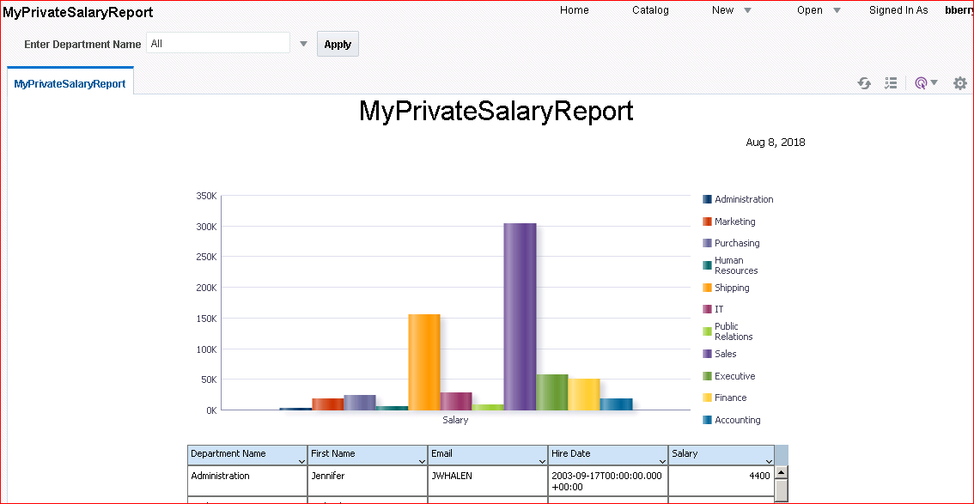Observe that you can change the default parameter display in Report Viewer. The following screenshot shows the report with all departments selected.

You can edit the report to change the layout, data model, scheduling properties, and so on.

Use the Actions menu to select various options to edit the report.

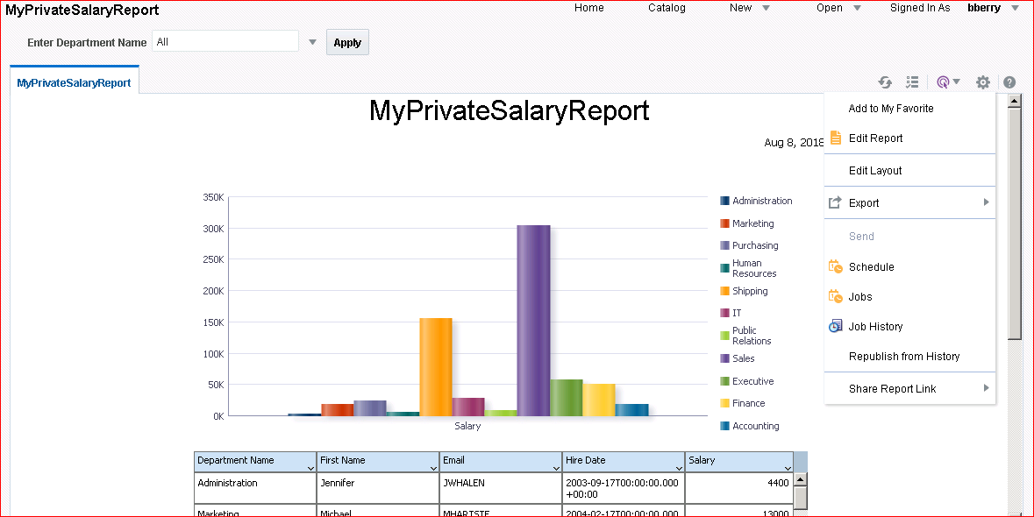

Layout Editor options are covered in “Practices for Lesson 5: Working with Layout Editor.”

**Practices for Lesson 6: Working with Layout Editor**

## Practices for Lesson 6: Overview

### Goal

To explore BI Publisher Layout Editor and to create and save BI Publisher report layouts

### Practices Overview

You explore Layout Editor’s capabilities by opening an existing report and formatting the layout, which contains data tables, charts, conditional formatting, and so on.

### Time

75–85 minutes

## Practice 6-1: Adding a Chart to a Predefined Layout

### Overview

In this practice, you will use the Report Wizard to create a report based on the Salary Report Datamodel. You will edit this report in Layout Editor.

### Assumptions

* You are familiar with using Create Report Wizard to create a simple report.
* The data model selected for the report is Salary Parameter Datamodel (Shared Folders > Sample Lite > Published Reporting > Data Models > Salary Report Datamodel).

### Tasks

1. Log in to BI Publisher with the username weblogic and password weblogic1.
2. 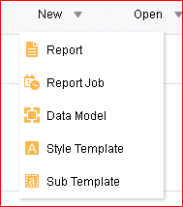Click **New** > **Report** in the global header.
3. The Create Report window is opened. You create a report by using the existing data model

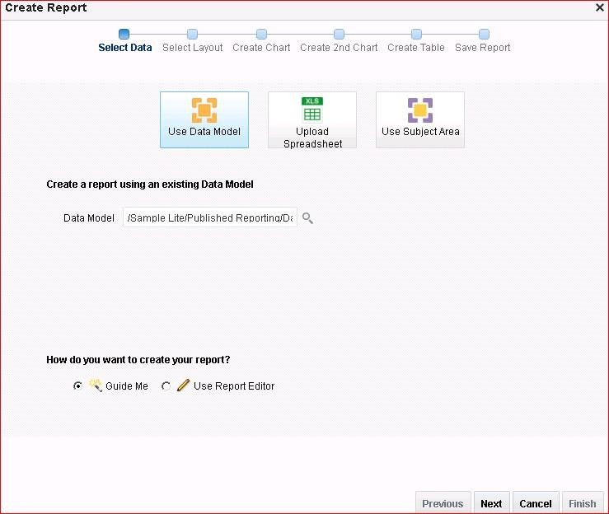– *Shared Folders > Sample Lite > Published Reporting > Data Models > Salary Report Data Model.*

1. Click **Next.**
2. In the layout selection step, select:
   * Portrait
   * Page Header
   * Chart and Table

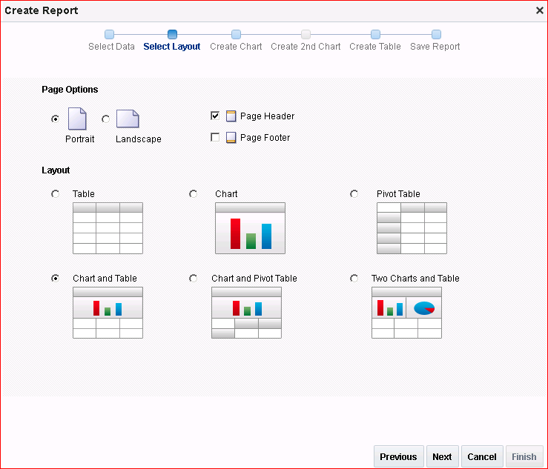

1. Click **Next.** The layout that you select on the Select Layout page drives the remaining

pages that you must complete in order to create the report.

1. Because you have selected Chart and Table layout, the Create Chart page opens. Select

#### Bar Chart.

1. Add columns to the chart by dragging them from the Data Source pane to the chart area.
2. Drag Annual Salary on to Drop Value Here.
3. Drag Department Name on to Drop Series Here.

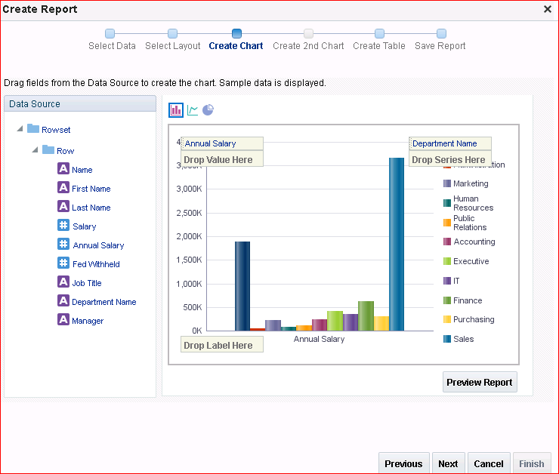

1. Click **Next**. The Create Table page is displayed with the columns that you previously selected for the chart. You will edit this table by appending the required columns.
2. Along with the existing columns, add Manager and Name by dragging the data elements to the table. The columns are displayed in a simple tabular format and the column widths are automatically adjusted based on the number of selected columns.

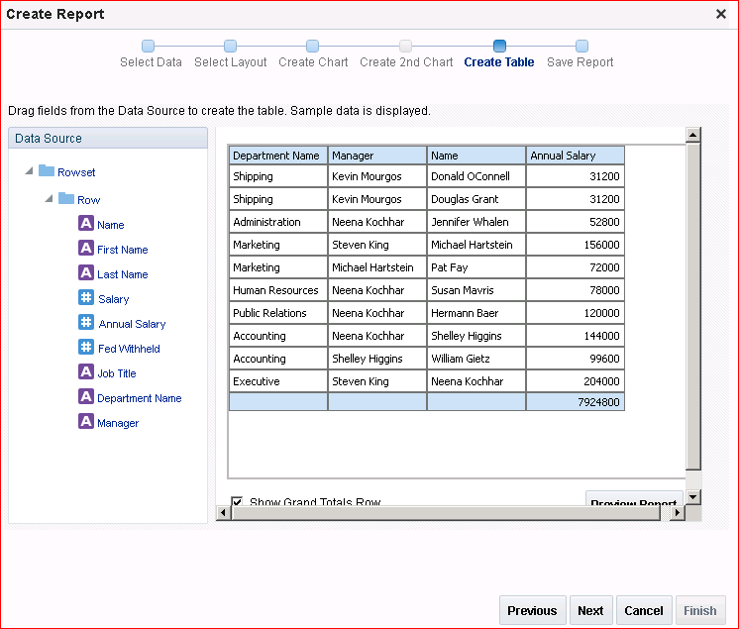

1. Click **Next** in the Report Wizard to proceed to saving the report. You can edit the table with

more formatting in Layout Editor after saving the report.

1. Click **Customize Report Layout** and then click **Finish**. The final page prompts you to save the report.

**Note:** Because you selected the Customize Report Layout option, after saving the report, it is opened in Layout Editor for further editing. In addition, the Learn folder is available again.

1. 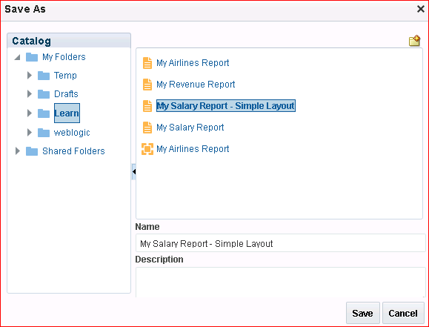In the Save As dialog box, select the folder My Folders > Learn. Name the report **My Salary Report – Simple Layout.**
2. The report is opened in Layout Editor for you to further customize it. Observe the various sections—Data Source, Components, and Properties—that enable you to create a pixel- perfect layout.

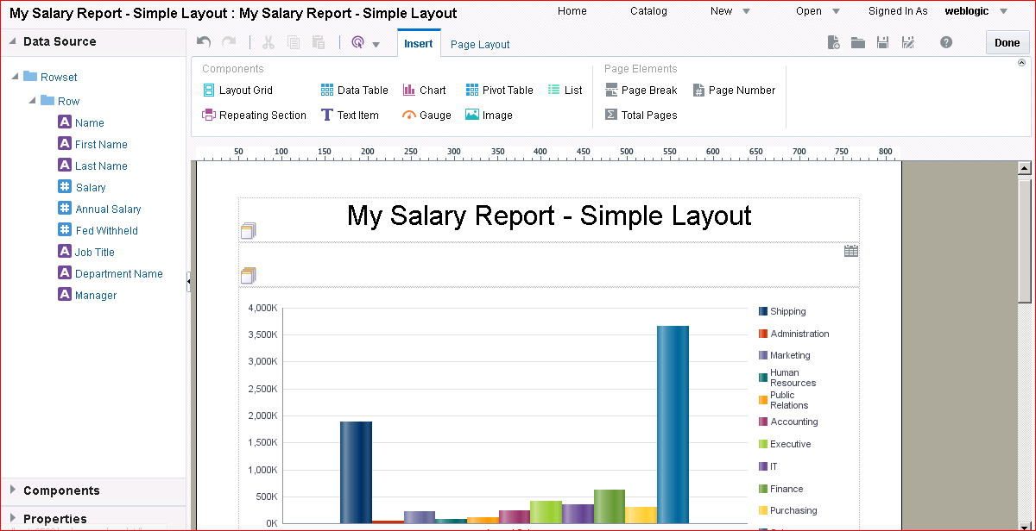Data Source displays the data available, because this is a predefined layout with a chart and table structure in place.

By default, the report name is displayed as the layout name.

1. To edit the title of the report, do the following:
2. Select the existing report title. The Text options are highlighted.
3. Edit the text for the title to change it to My Salary Report – Formatted.
4. 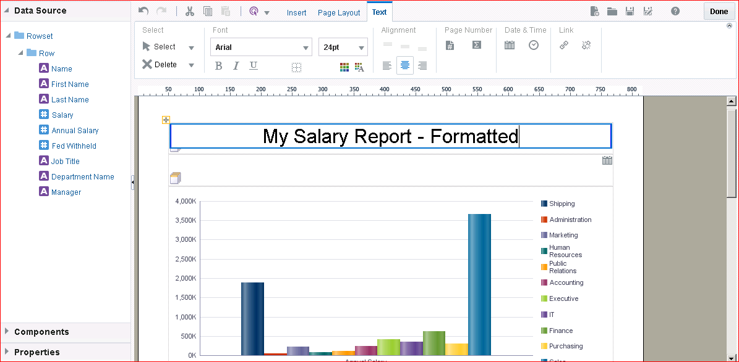Edit the Title font format as well.
5. Insert a grid below the title. Select the title grid and click **Insert > Layout Grid.**

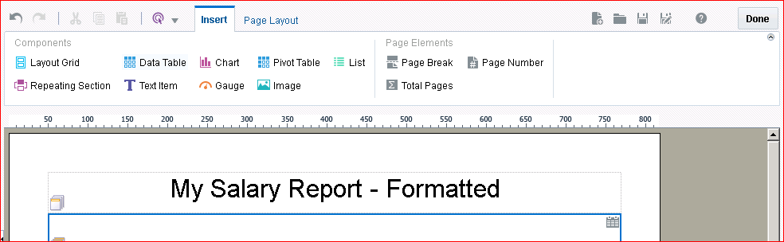

1. In the Insert a Layout Grid dialog box, select 2 rows and 2 columns, and then click OK.

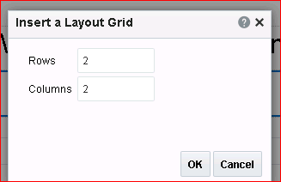

1. Select the top row, and insert a Text Item. Enter **Salary by Job Title** and format the text as:
   * Font: Tahoma
   * Size:12
   * Type: Bold
   * 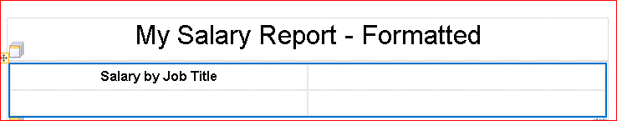Color: Grey 808080
2. Add a new pie chart to this report.

Select the next row in the same column and insert a chart item.

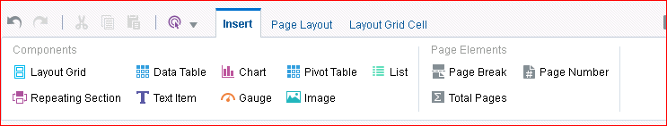

1. Select Chart Types: Pie > Pie to select a pie chart.

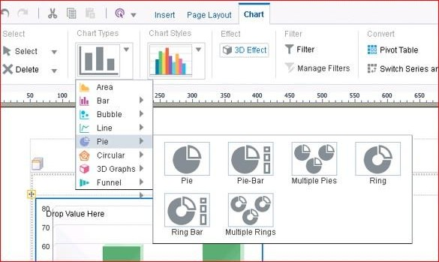

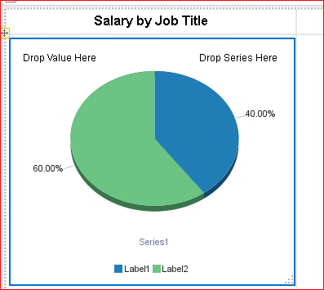A chart is inserted in the row.

1. Add the data elements from the Data Source pane to the pie chart.
2. Drag Salary to Drop Value Here.
3. Drag Job Title to Drop Series Here.

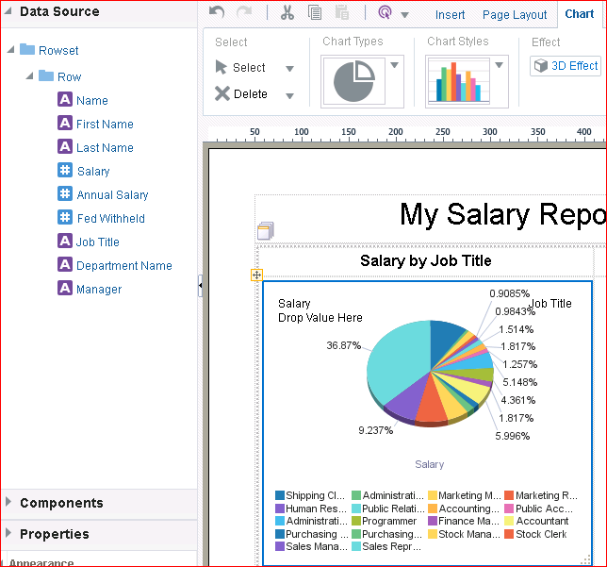

The pie chart displaying the salary for various job titles is displayed.

1. 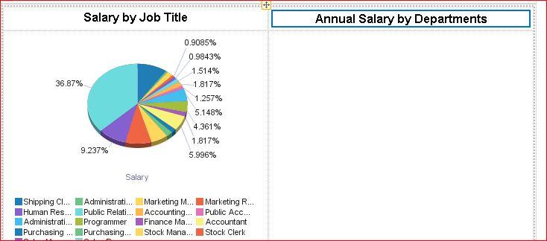Move the existing bar chart that was created with the Report Wizard to the column next to the pie chart. Add the title Annual Salary by Departments to the column and format it similar to the pie chart title.

**Note:** You cannot add the existing bar chart to this column with its current size. The chart has to fit in a thin column.

1. Select the bar chart as shown in the following screenshot:

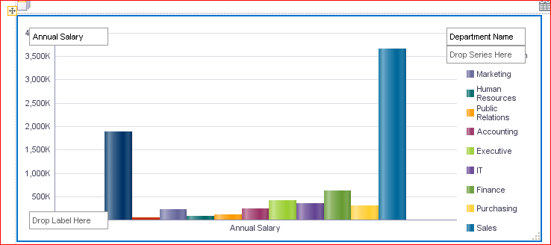

You will see a resizing cursor to change the size of the chart. Use this resizing cursor to make the chart small enough to fit into the column next to the pie chart.

The resized chart is refreshed and displayed.

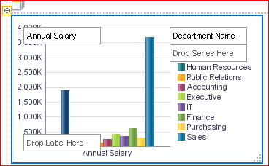

1. Select the chart. You will see a movement cursor on the chart. Drag the chart to the column above, next to the pie chart.

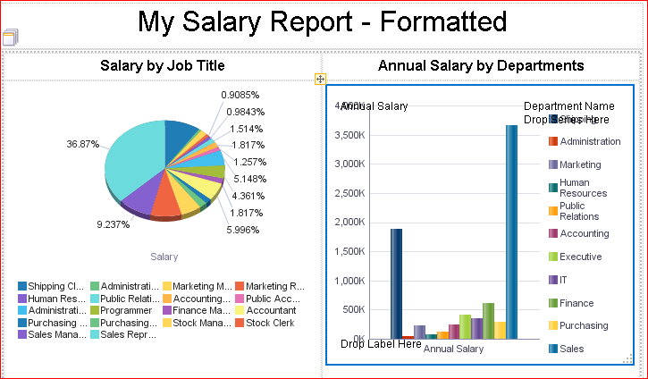

1. Click the Save As Icon to save the layout as **Formatted.**

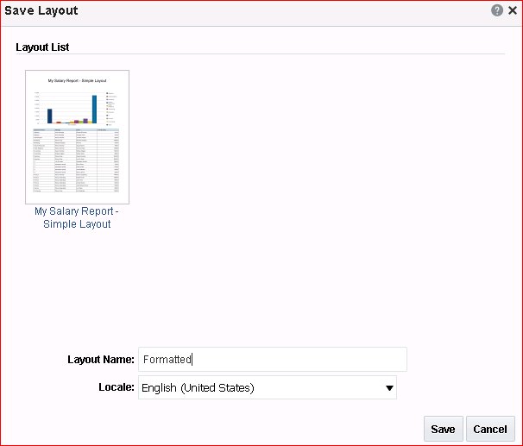

You can see the list of layouts for the report. The current list has the default layout that you were editing until now.

1. Click Save to save and return to Layout Editor.

## Practice 6-2: Editing the Table

### Overview

In this practice, you edit the existing data table created from the Report Wizard to enhance it.

### Assumptions

You successfully saved the report layout from Practice 5-1 as Formatted. The same layout is opened for editing now.

### Tasks

1. Edit the existing data table and format the data. Resize the column width to add more

columns to the table.

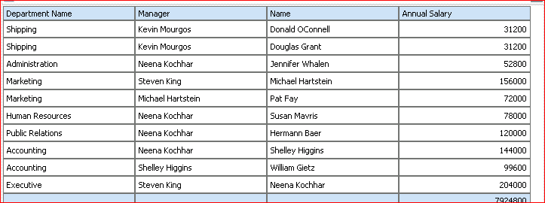

* 1. To do this, place your cursor between two columns. The column indicator turns blue, and sizing handles appear.
  2. Drag the column indicators for **Department Name**, **Manager**, **Name**, and **Annual Salary** to the left, reducing some of the column space.

1. Add another data element Job Title from the data source pane between the **Manager** and

**Name** columns.

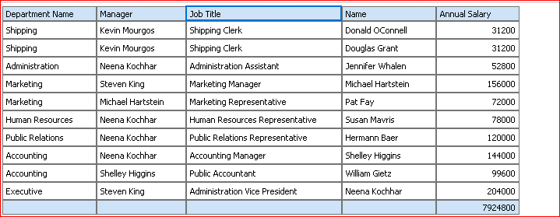

1. Format the Annual Salary column. Click any data value cell for the **Annual Salary** column. This selects the entire column. Click the **Column** tab and from the Data Formatting drop- down list, select **($1,234.57)** (**Currency)**.

Formatting is applied to the column:

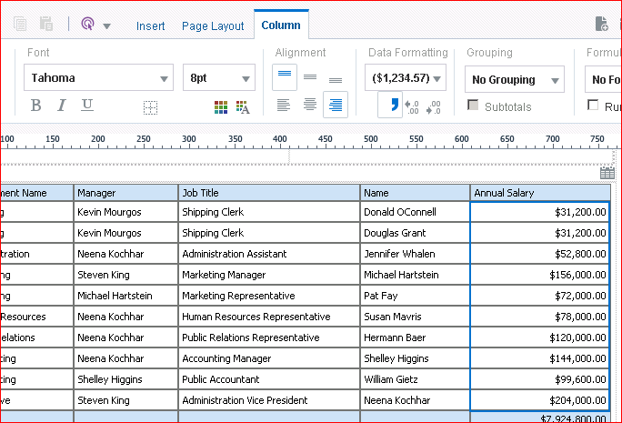

1. Change the sort order for Annual Salary to ascending. Keep the Annual Salary column selected.

Click the **Ascending Order** icon as indicated in the following screenshot:

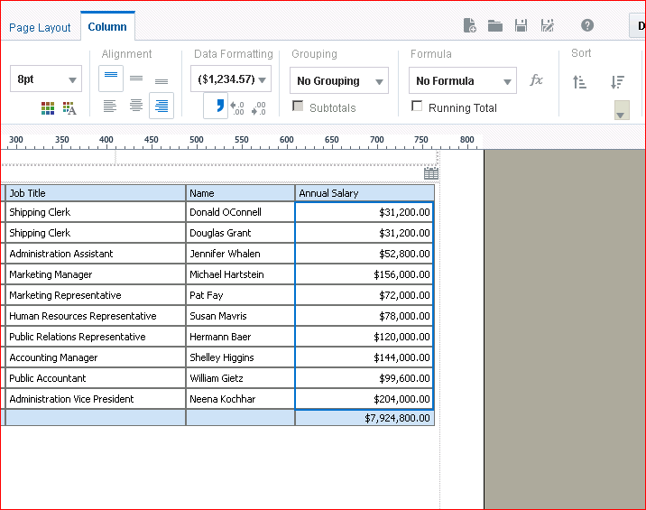

The column re-sorts in ascending order.

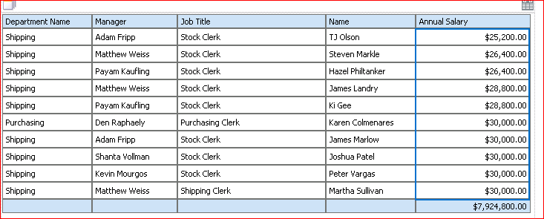

1. Add conditional formatting to the Annual Salary column. Conditional formats allow you to highlight data fields based on a condition.

With the Annual Salary column still selected, click **Conditional Formatting > Highlight** on the Column tab.

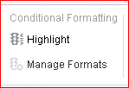

The Highlight dialog box appears.

1. In the Highlight dialog box, enter the following attributes:

|  |  |  |
| --- | --- | --- |
| **Step** | **Attribute** | **Choices or Values** |
| a. | **Operator** | is greater than or equal to |
| b. | **Value** | 29000 |
| c. | **Background Color** | Bright Yellow (ffff00) |

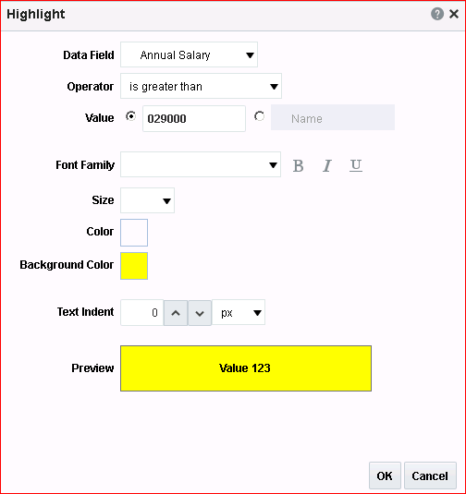The Highlight dialog box should look like this:

Click **OK** in the Color Picker and then click **OK** again.

1. Notice that Manage Formats now appears in the Conditional Formatting section.

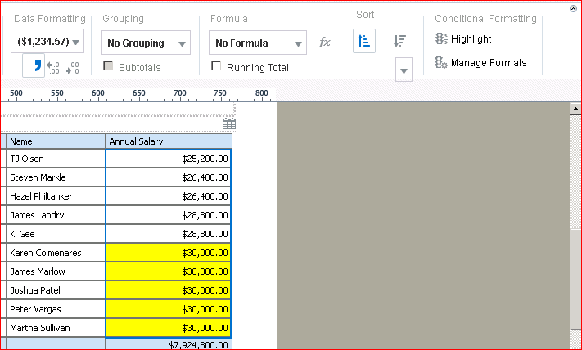

This allows you to edit the existing conditional formats. Click **Manage Formats**.

1. In the Manage Conditional Formats dialog box, click the Edit Condition icon and change the highlight color to green.

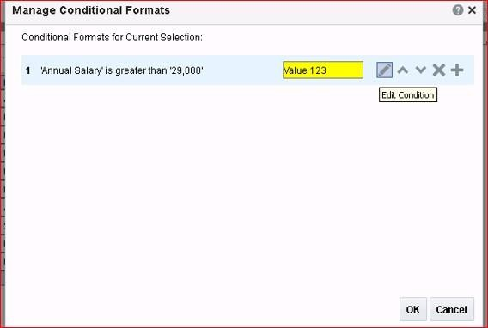

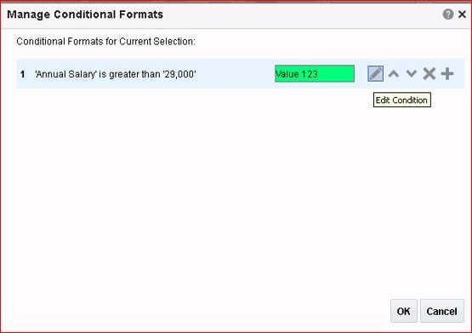In the Highlight dialog box, change the highlight color and click OK. The edited condition will look like this.

Click OK to return to Layout Editor. The table highlights the rows with the set condition in

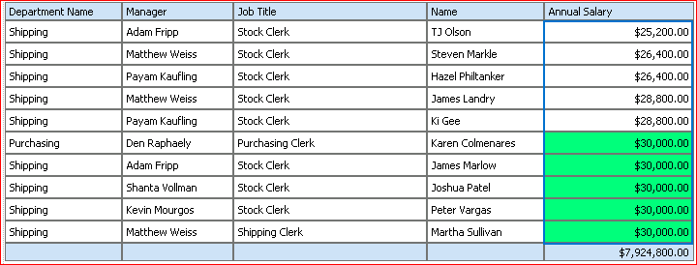green.

1. Similarly add another condition on Annual Salary as follows:

|  |  |  |
| --- | --- | --- |
| **Step** | **Attribute** | **Choices or Values** |
| a. | Operator | is less than |
| b. | Value | 26000 |
| c. | Background Color | Red |

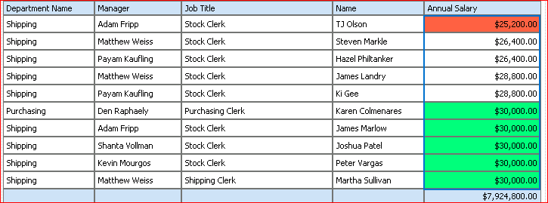The table now looks like this:

Add a filter to this table. Select the table as shown in the image. Click **Select > Table**.

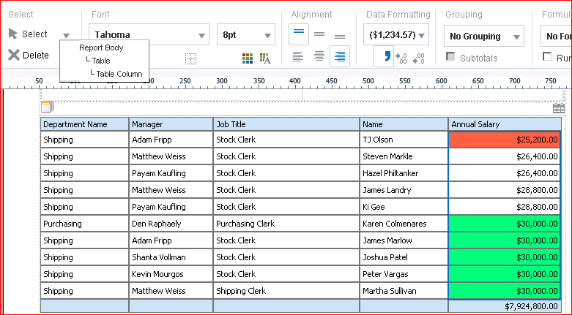

1. 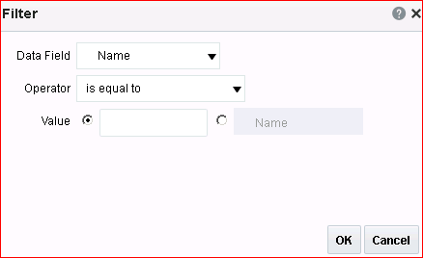When you select the table, all the table elements are available for editing. Select Filter. The Filter dialog box appears:

In the Filter dialog box, change or enter the following attributes:

|  |  |  |
| --- | --- | --- |
| **Step** | **Attribute** | **Choices or Values** |
| a. | **Data Field** | Department Name |
| b. | **Operator** | is equal to |
| c. | **Value** | Purchasing |

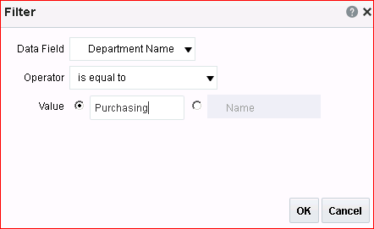

**Note:** All elements are available for selection from the Data Field drop-down list.

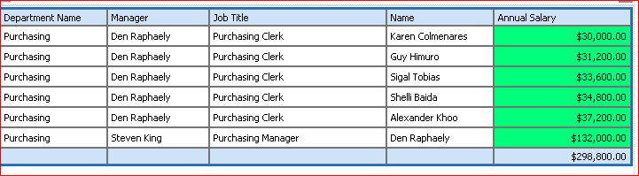Click **OK**. The table should look like this:

Observe that the Manage Filters option is enabled after you added a filter.

1. Remove the Department filter from your report layout.

Click **Manage Filters** in the Filter section. The Manage Filters dialog box appears.

1. 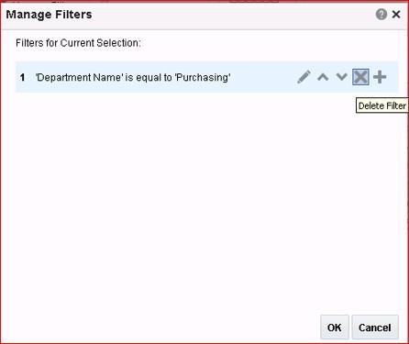In the Manage Filters dialog box, click the **Delete** icon and click **OK**.
2. All values reappear in the data table with the applied conditional format as earlier. Click

**Save**.

## Practice 6-3: Adding Repeating Sections

### Overview

In this practice, you add repeating sections to the table from the previous practice. Repeating sections are used to create classic banded reports, as well as repeating pages or sections for different data elements, such as Group Above/Outline.

Repeating sections repeat the components within the section of the layout based on the occurrence of an element in the data.

### Assumptions

You successfully saved the report layout from the previous practice as Formatted. The same layout is opened for editing now.

### Tasks

1. In Layout Editor, select the next grid below the table and click **Insert > Layout Grid.**

Insert two rows with a single column.

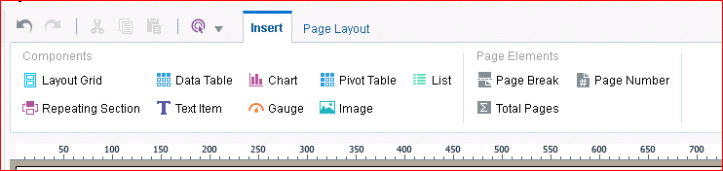

1. Provide a title for this table by inserting a text item in the first row of the layout grid. Enter Salary Details and format the title.

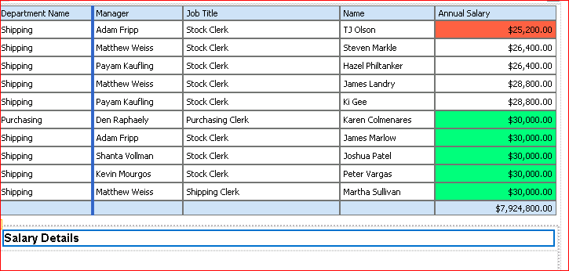

1. Select the second row of the layout grid, click the **Insert** tab, and select **Repeating Section**.

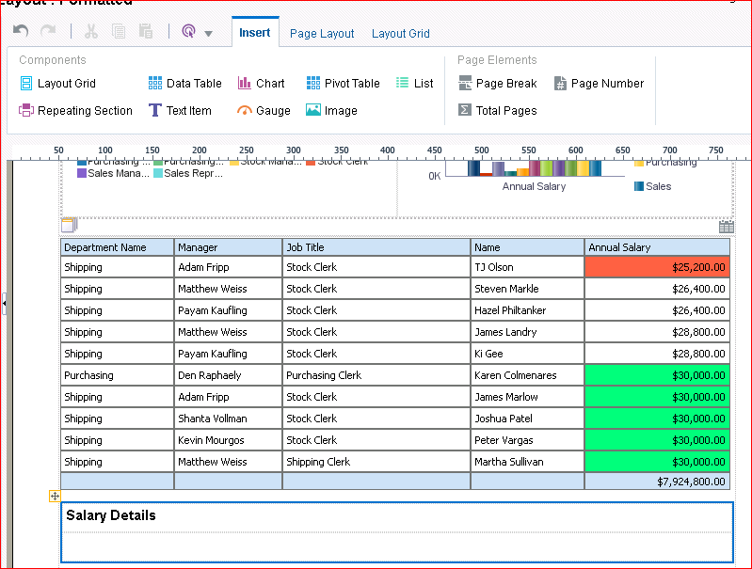

1. The “Insert a Repeating Section” dialog box appears.

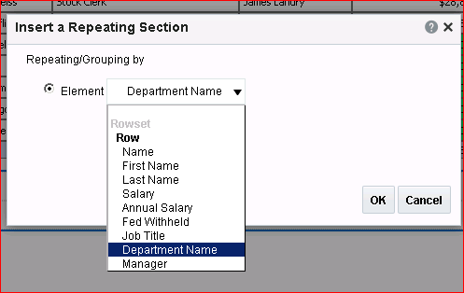

The Element option allows you to specify the data item that repeats for each group.

You use Group Detail when you have nested groups, such as “state within country for the United States.”

Select **Department Name** from the Element drop-down list and click **OK**. The repeating section area appears in the design area.

1. 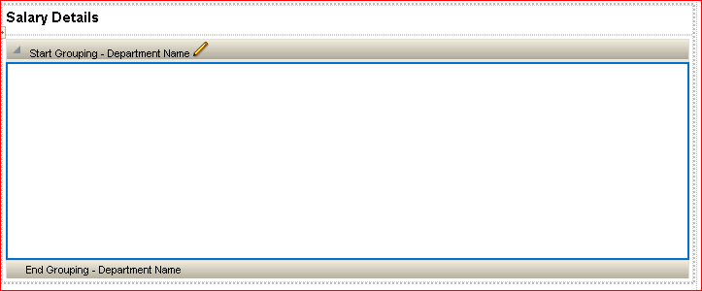The layout should look like this:

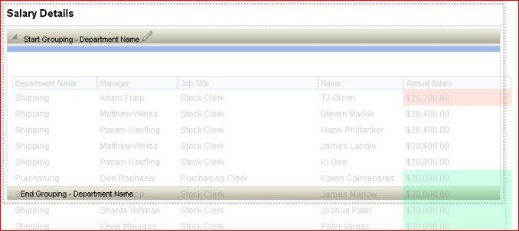Drag the previously edited data table to this area.

The table is placed between the Start Grouping and End Grouping area of the repeating section.

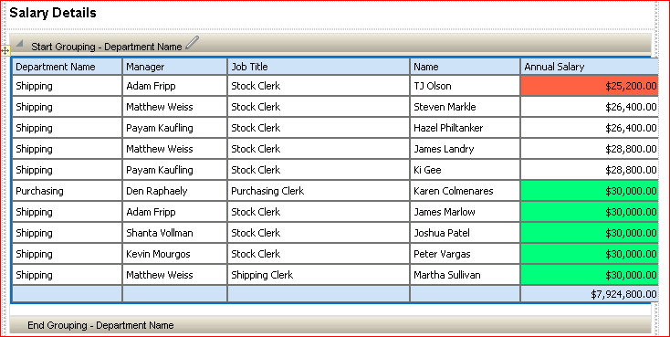

1. Select the **Department Name** data column and then click the **Column** tab. Select Grouping > Group Left.

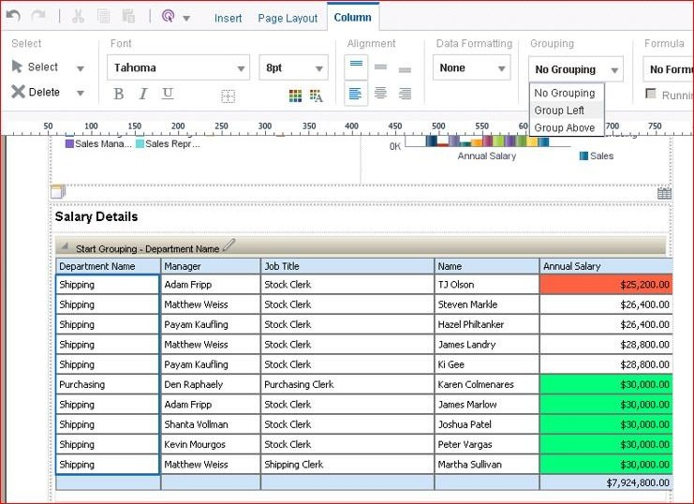

The table with the grouping should look like this:

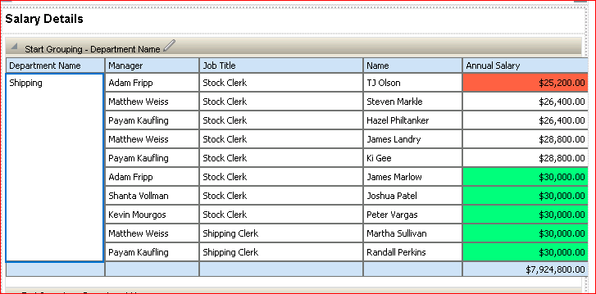

1. Now, you format the table to display colored alternate rows. Select the table and click Properties.

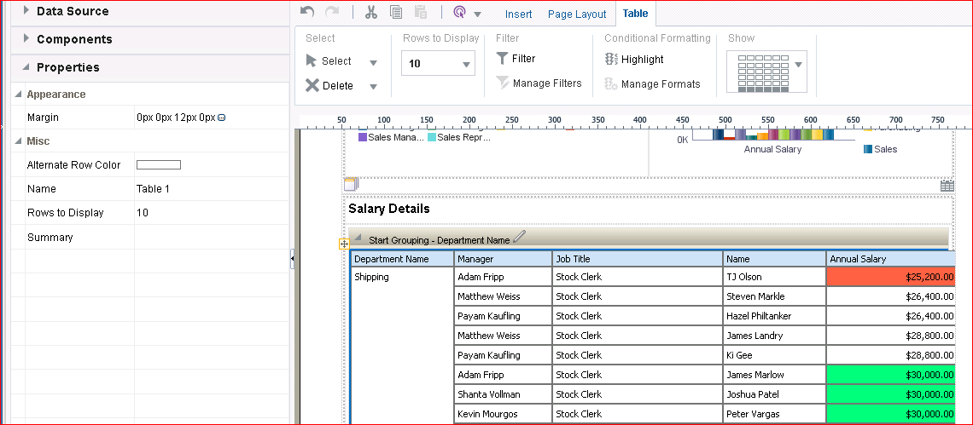

1. Select the Alternate Row Color option and pick a light yellow color from the Color Picker.

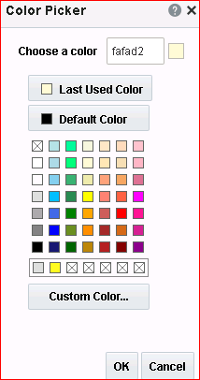

Click OK.

1. Add a page break to the repeating sections.

Select the table. Click **Page Break** under the Page Elements section.

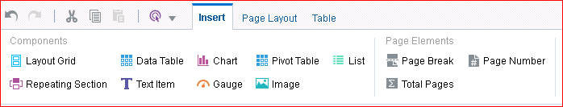

1. Save the layout and select PDF from the preview options.
2. 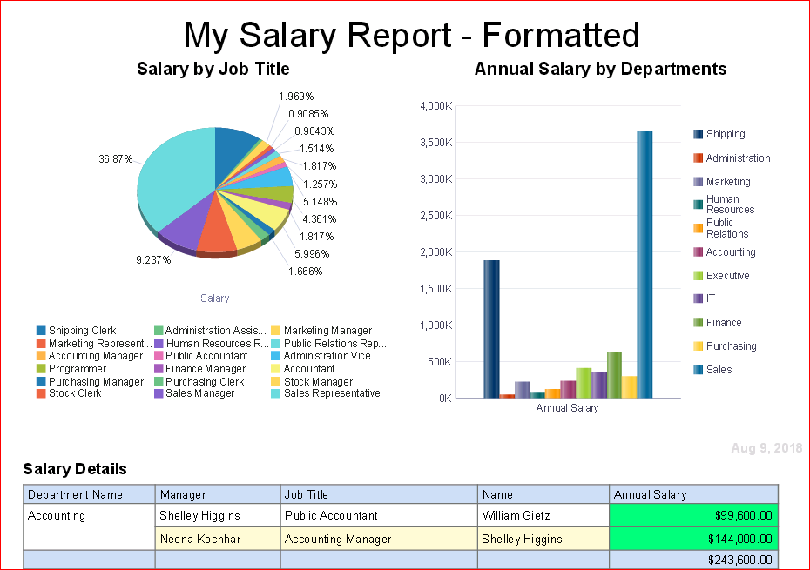The report is displayed in a new browser window in PDF format.

Observe that the report has multiple pages, and is displaying page 1. Explore the other pages.

1. Close the window. Save the layout and return to Report Viewer.

## Practice 6-4: Creating a Layout with a Gauge and a Pivot Table

### Overview

In this practice, you create a layout that contains a gauge and a chart. You convert the chart into a pivot table, and you add a static image to the layout.

#### Assumptions:

You are logged in to BI Publisher.

### Tasks

1. In the Report Editor, click **Add New Layout**.

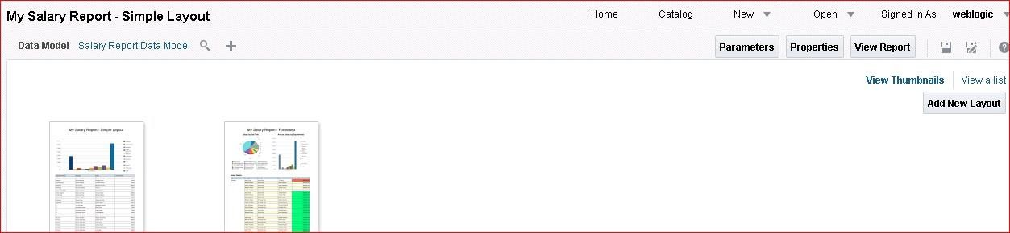

1. Select **Blank Portrait** from the Basic Templates section.

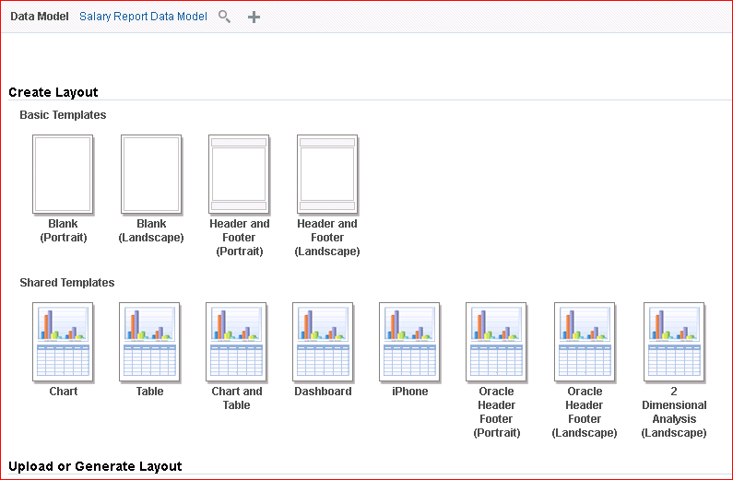

1. On the Page Layout tab, click **Page Header**. The page header appears. Select the **Page Header** object.

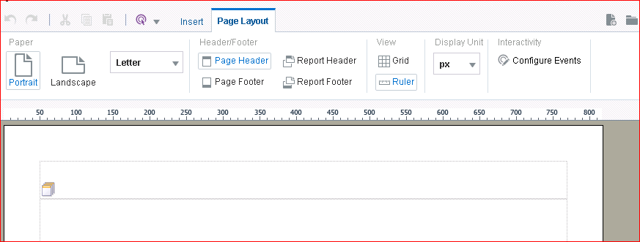

1. Click the **Insert** tab. Click **Image**.

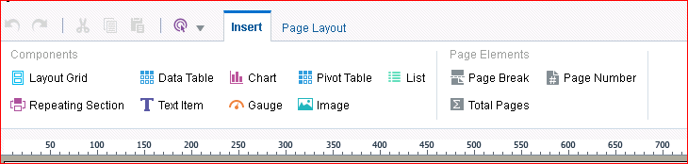

1. The “Insert an Image” dialog box appears. Click **Browse** to select the image. Navigate to D:/MyFiles and select oracle_logo.gif. Click **Insert**.

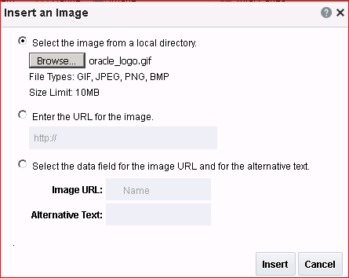

1. 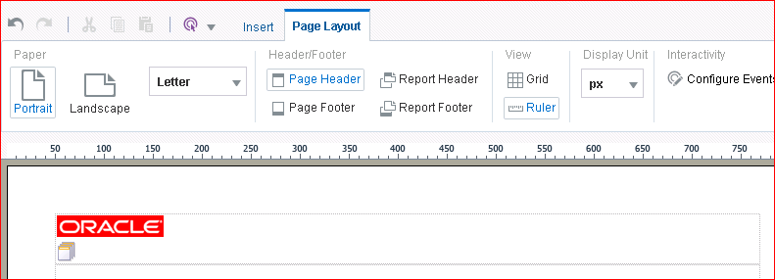The image appears in the header.
2. Select the header and Insert **Text Item**. Double-click in the Text Item and enter **Department Salaries**. Format the title as you choose. The layout should look similar to this:

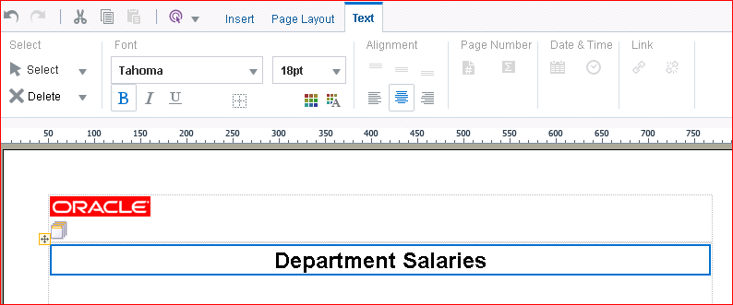

1. Insert a layout grid with five rows and 1 column.
2. 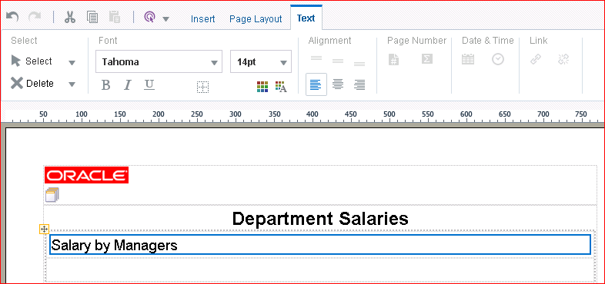In the first row, provide the subtitle “Salary by Managers” to the gauge that you are going to create. Format it similar to the subtitles that you created in the previous practices.
3. Add a repeating section below the subtitle as you did in the previous practice, selecting

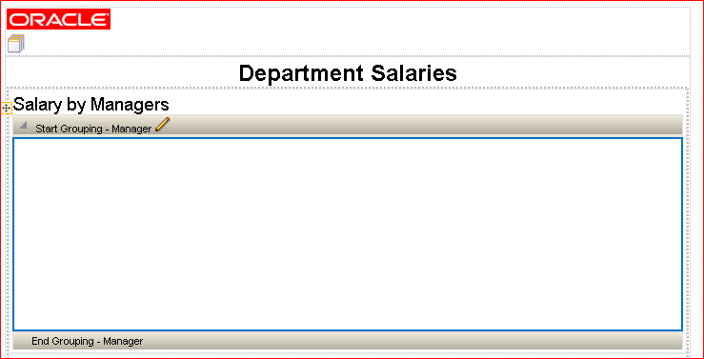**Manager** as the repeating element. Your layout should look like this:

1. 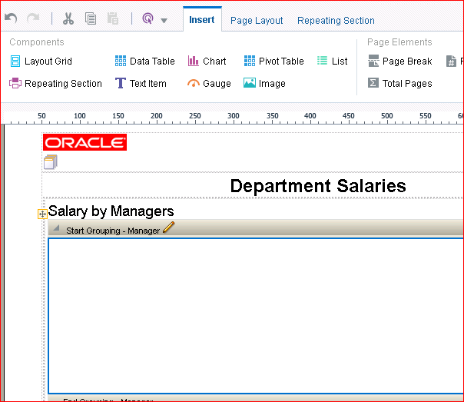Select the repeating section and then click the **Insert** tab. Click **Gauge**.

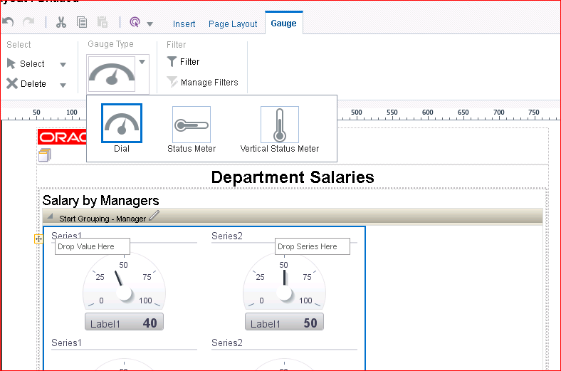A gauge appears within the repeating section.

1. Drag **Annual Salary** to Drop Value Here and **Department Name** to Drop Label Here.

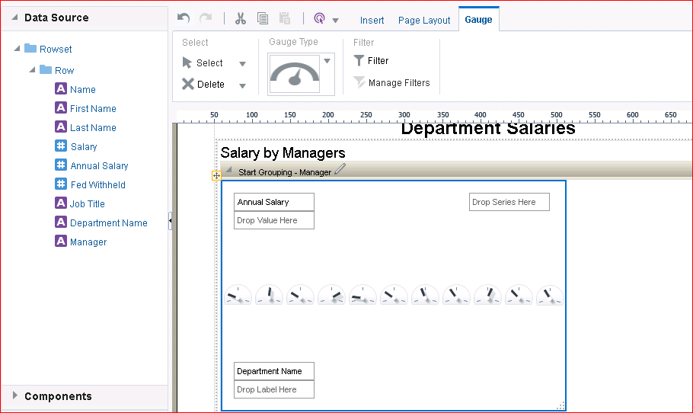

1. You can resize the gauge to fit it in the display area.

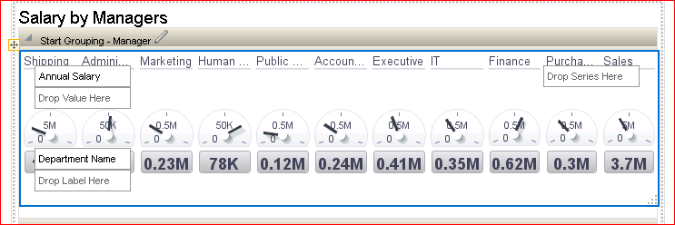

1. Add a pivot table to this layout.

A pivot table provides views of multidimensional data in tabular form. It supports multiple measures and dimensions, and subtotals at all levels. Layout Editor converts the label, series, and value elements of a chart into the appropriate rows, columns, and data elements of a pivot table. No formatting is applied to the pivot table.

Note that when the pivot table is selected, a Pivot Table tab appears. You use this tab to apply filters, totals, and so on.

Provide the subtitle Salary Pivot to the grid and format it as you have done previously for other subtitles.

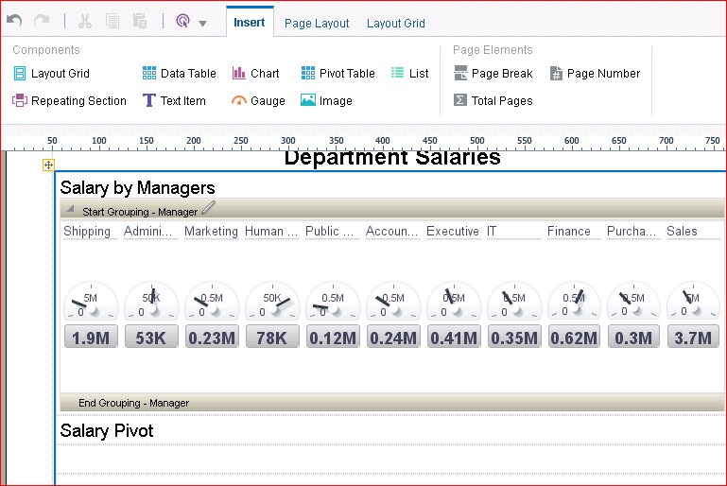

1. Select the grid row, click the **Insert** tab, and then click **Pivot Table**, or drag the Pivot Table object from the Components pane. A pivot table is displayed.

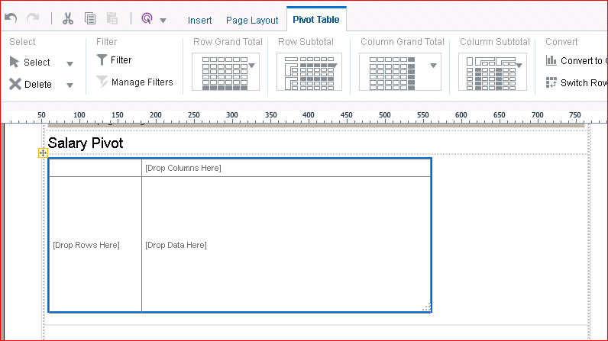

1. Add the data elements from the Data Source pane. Drag:
   1. Department Name to Drop Rows Here
   2. Job Title to Drop Columns Here
   3. Annual Salary to Drop Data Here

The pivot table will look like this:

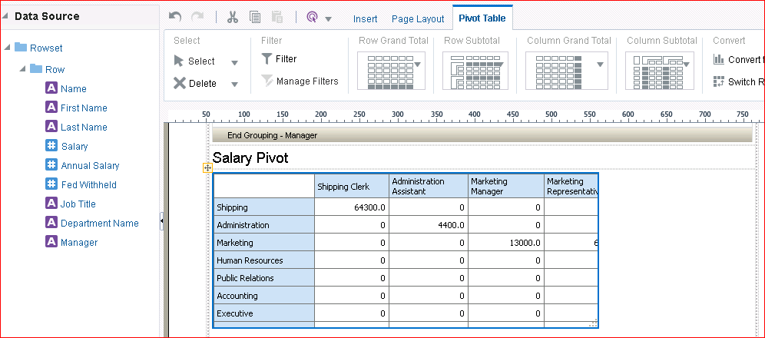

1. Convert a pivot table to a chart. For this, you use a copy of the pivot table that you just created. Use the Copy and Paste icons in Layout Editor to copy the pivot table.

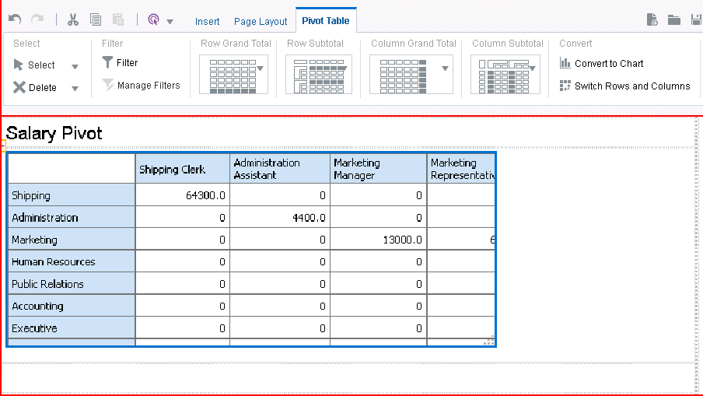

1. Select the next grid and paste the table.

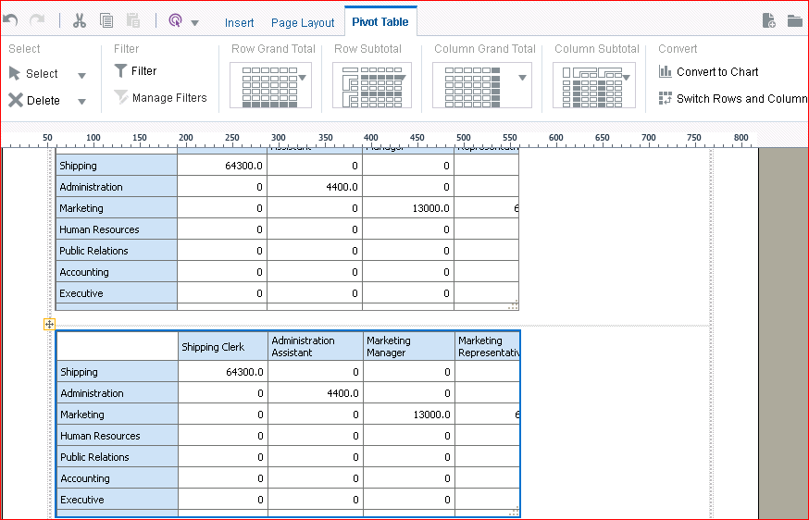

Observe that when you select a pivot table, the options to convert the table to a chart or to switch rows and columns are enabled.

1. 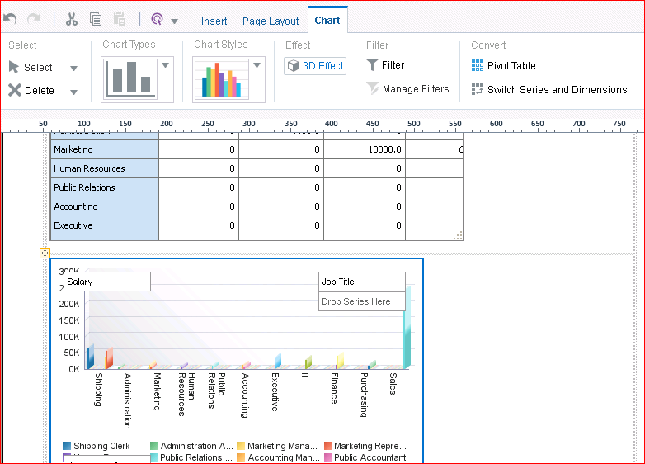Click Convert to Chart. A copy of the pivot table is converted to a chart and displayed. Similarly, you can convert a chart element to a pivot table in Layout Editor.
2. Click Save to save the layout with the name Advanced.

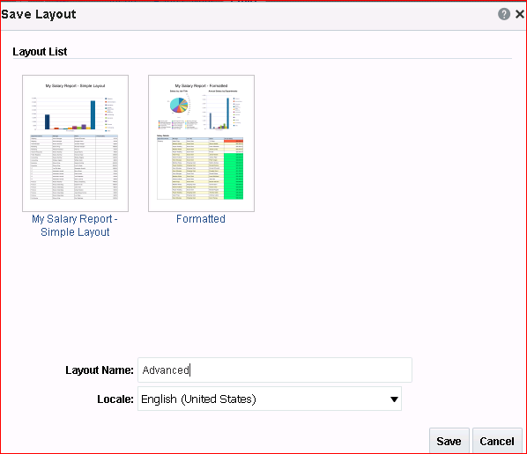

1. The layout now displays the saved name in the layout title bar. Click **Return.**
2. The Report Editor window opens. Observe that all the available layouts for the report are displayed.

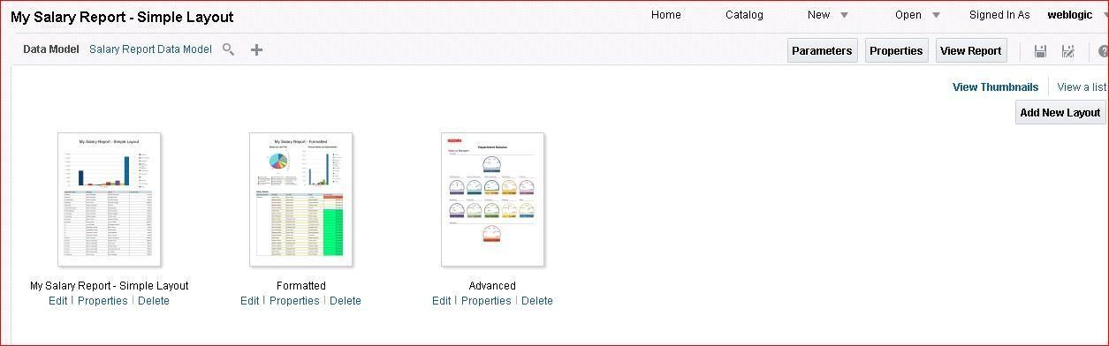

Save the report and click the View Report icon.

1. 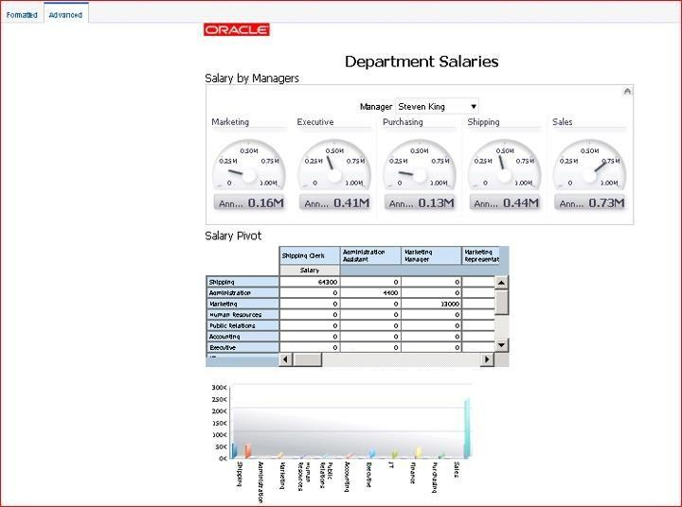The report is displayed in Report Viewer with the gauge, pivot table, and the chart created by converting the pivot table.

**Note:** You can drill down through the data further to suit your requirements. The gauge reflects the data values for the manager Steven King.

## Practice 6-5: Creating a Boilerplate

### Overview

In this practice, you create a boilerplate template available for use by all users.

When a predefined layout does not suit your business needs, you can create a boilerplate template—a predefined template that you or your administrator designs or uploads for all users or for your personal use.

### Tasks

1. Click the **Catalog** link on the global header, and navigate to \Shared Folders\Components.
2. Click the **Edit** link under Boilerplates.

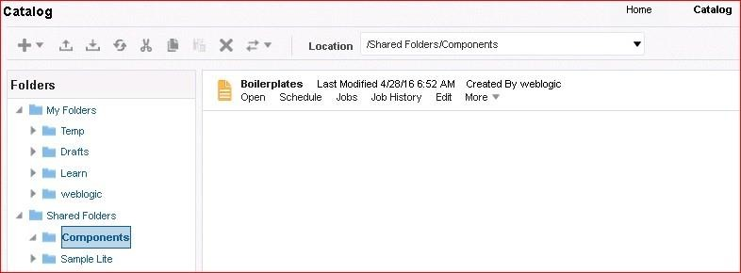

1. Report Editor appears. BI Publisher provides predefined layouts for use as skeleton-type boilerplates, such as Chart or Mobile Apple iPhone. You can, however, create your own templates to use as boilerplates.

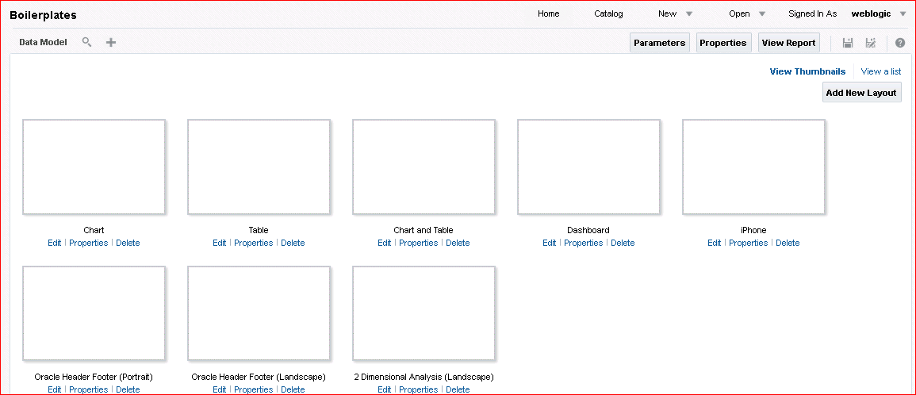

1. Click **Add New Layout**. You can upload your own layout created by using Template Builder for MS Word (you will practice this later in the course) or design a new layout by using Layout Editor.

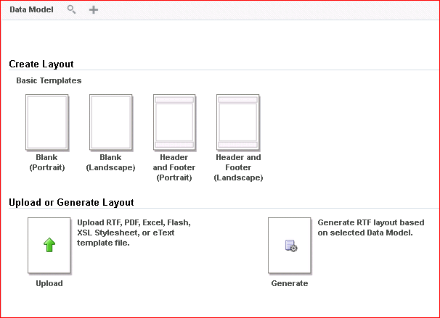

1. Select **Blank (Landscape)**.
2. The Layout Editor appears. Because you do not have a data model for the template, the Data Source pane is blank.
   1. Just as you added components previously, begin to design your new boilerplate

template. Create a layout grid with three columns and a single row.

* 1. 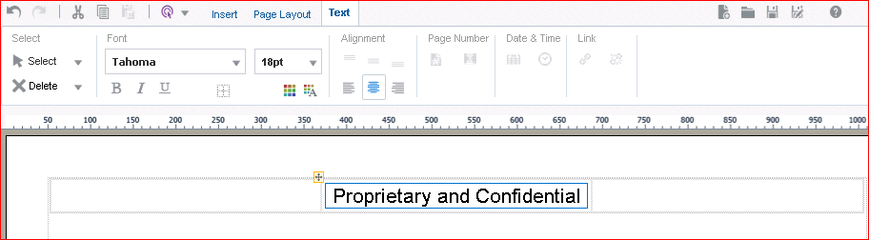Add Text Item to the center column and enter **Proprietary and Confidential**.

1. Click Page Layout > Page Header.

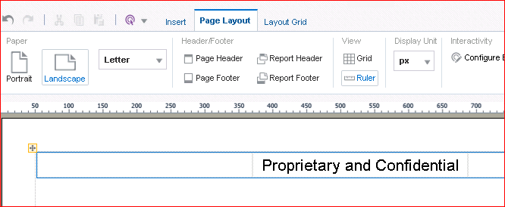

1. Insert an image in this page header. Navigate to and select the **Oracle** corporate image,

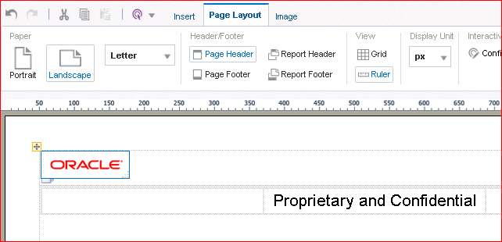O_signature_clr.gif, located in D:/MyFiles

1. Drag the **Data Table** object to below the row with “Proprietary and Confidential.”

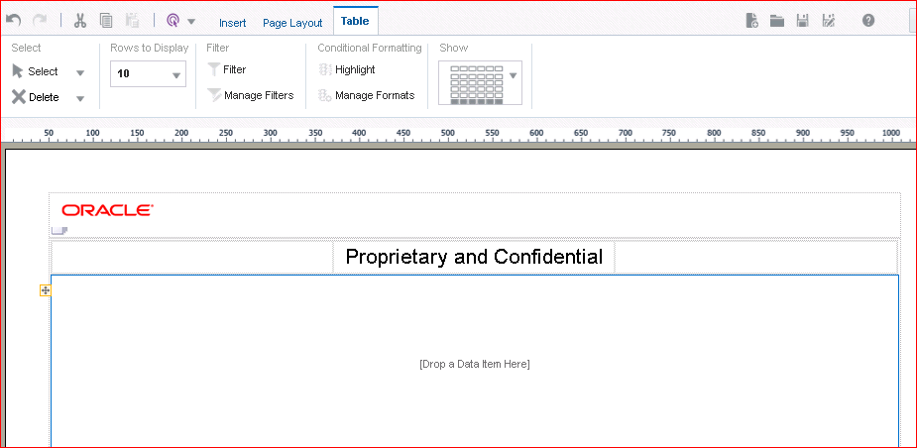When an end user opens this template for use, he or she can add any columns to the “Drop a Data Item Here” section for their report.

1. 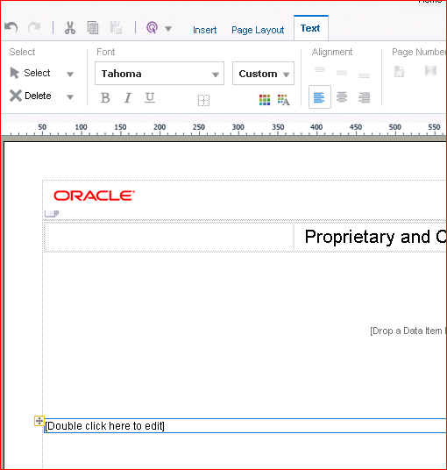Drag a **Text Item** object below the data table.
2. Double-click in the Text Item object and enter **-- End of Report--**.

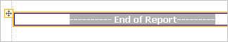

1. Your template should look similar to this:

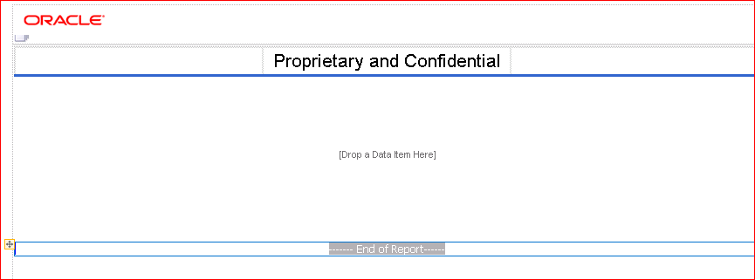

1. Click the **Page Layout** tab and click **Report Footer**.

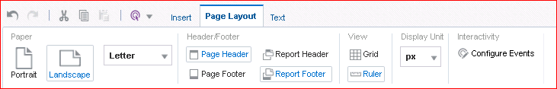

1. Click the **Insert** tab and then click **Page Number**. Page number appears in the Report Footer section.

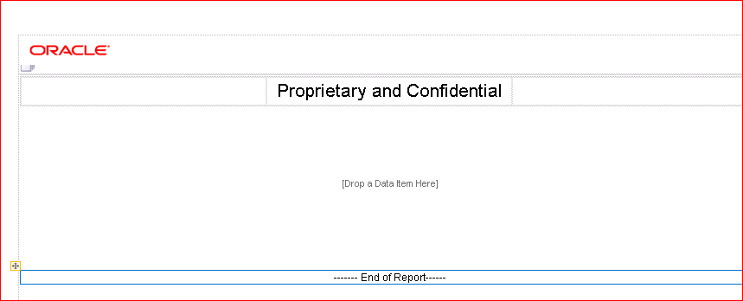The layout template should look like this:

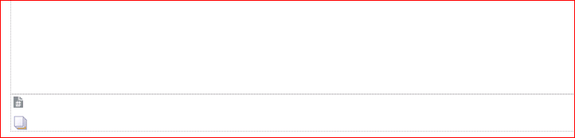

1. Click the Save icon and, in the Layout Name text box, enter **MyBoilerplate** and click

#### Save.

1. Click **Return**. Your boilerplate appears in Report Editor and is now ready for use.

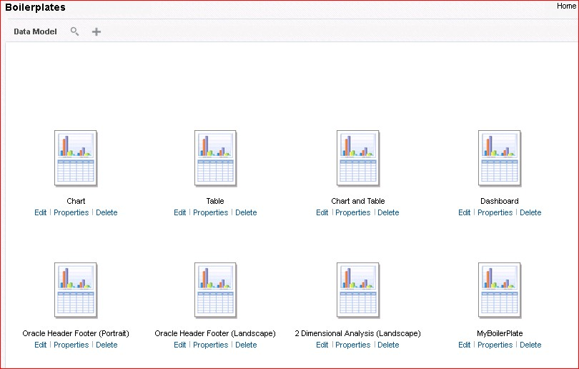

1. Create a new report and select the data model Shared Folders > Sample Lite > Published Reporting > Data Models > Salary Report Datamodel.

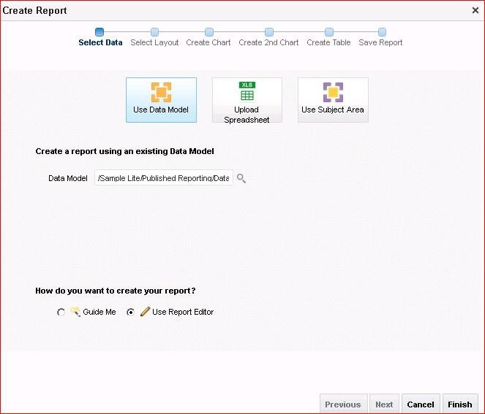

1. Select the User Report Editor option; this will guide you to save the report. Click the Finish button to save the report.
2. Save the report as My Salary Report – Boiler Plate under My Folders > Learn.
3. The report is opened in the Report Editor window. Select **MyBoilerplate** from the Shared Templates section.

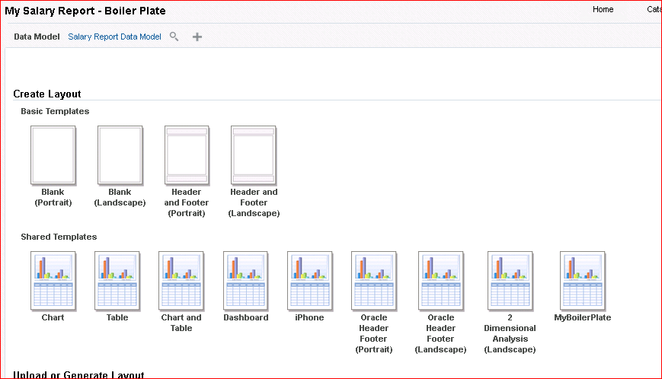

1. This will open Layout Editor for the report. Observe that you have the data elements available because the boilerplate layout is now associated with a data source (data model).

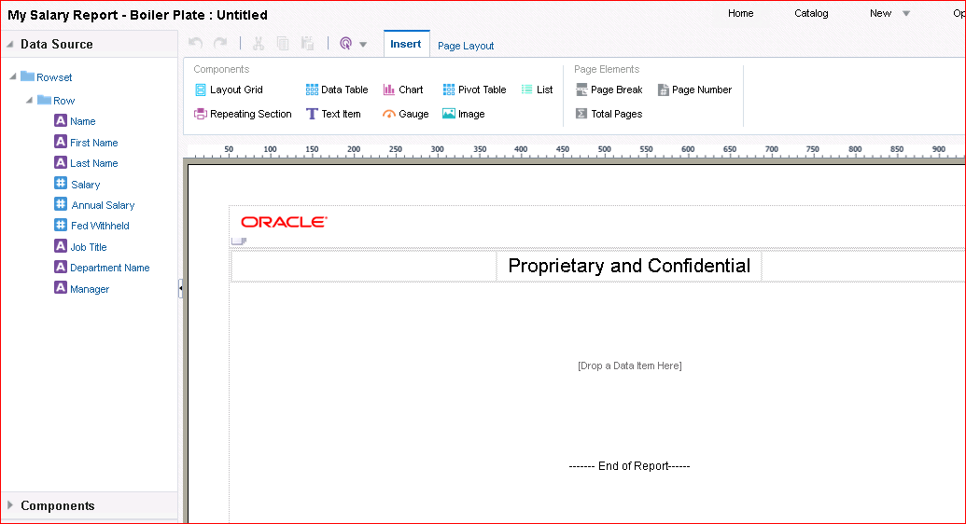

1. Add the data elements to the table to suit your requirements.

Drag the elements from the data source to the grid “Drop a Data Item Here” area.

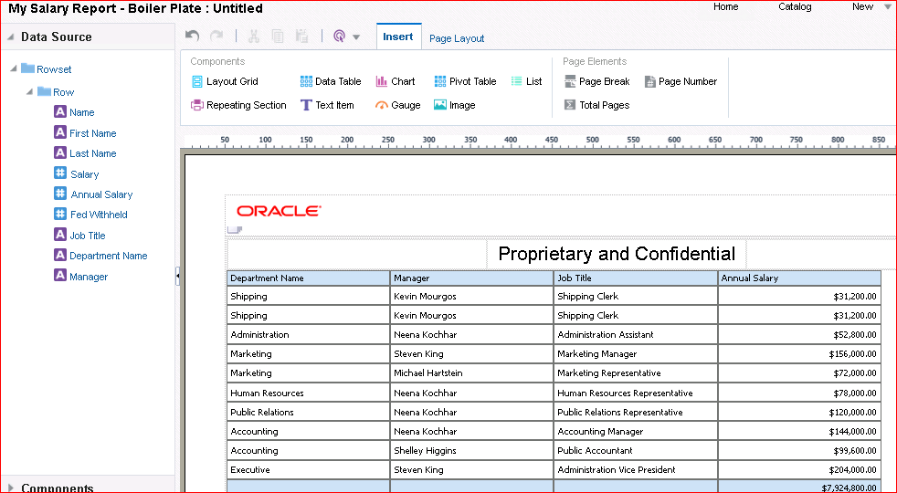In this example, Department Name, Manager, Job Title, and Annual Salary are added. Format the Annual Salary column to display currency. Save the layout template as BP.

1. Click **Return** to return to Report Editor.

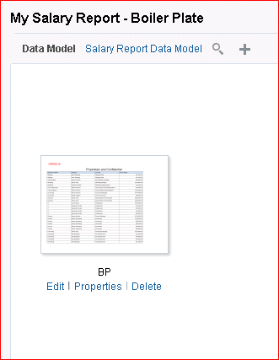

Report Editor displays the layout that you created just now, using the boilerplate template.

1. 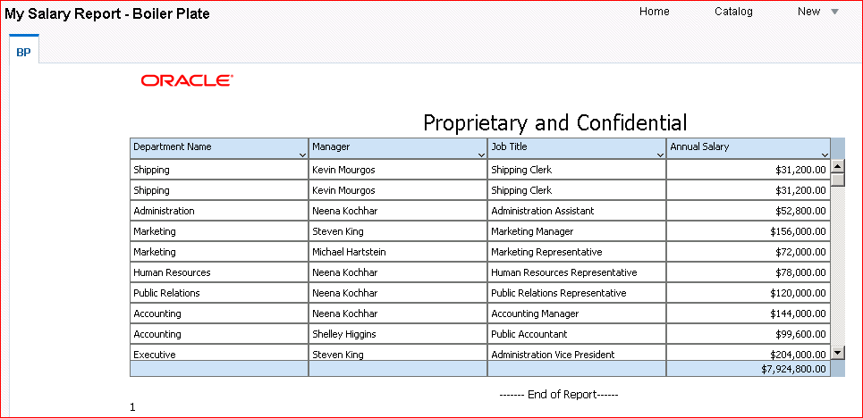Save the report and click the View Report icon. The report is displayed in Report Viewer.

# Practices for Lesson 7: Using Template Builder to Create RTF Templates

## Practices for Lesson 7: Overview

### Goal

To explore and create RTF templates by using the MS Word Template Builder add-in (Template Builder)

### Practices Overview

You create RTF templates, add formatting, review and update properties for fields, and work in both connected and disconnected modes. You also create Excel templates using Excel Template Builder.

### Time

70 - 80 minutes

## Practice 7-1: Exploring Template Builder and Creating an RTF Template from a Sample File

### Overview

In this practice, you review Template Builder components and build an RTF template from a sample file. You load sample XML data, preview the report, update field properties, and save the RTF layout.

### Tasks

1. Create a new top-level folder on your D drive named **Learn**.
2. Navigate to D:\Program Files (x86)\Oracle\BI Publisher\BI Publisher Desktop\Template Builder for Word\samples\RTF templates\Balance Letter and select **Balance Letter Start**. Balance Letter Start.rtf is a sample template file. Copy Balance Letter Start.rtf to the D:\Learn folder. The reason why we are copying the sample template is so we do not overwrite the original.
3. Downloading the data model xml file: Edit the Balance Letter Datamodel. Connect to BI Publisher and Navigate to the Balance Letter Datamodel found in Shared Folders -> Sample Lite -> Published Reporting -> Data Models.

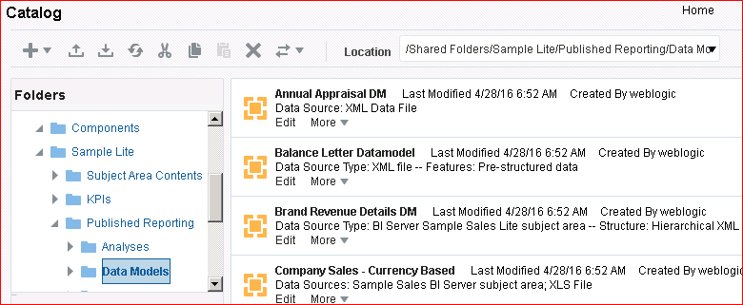

1. Click Data Tab and view the data. Click the Export Tab to export the xml file.

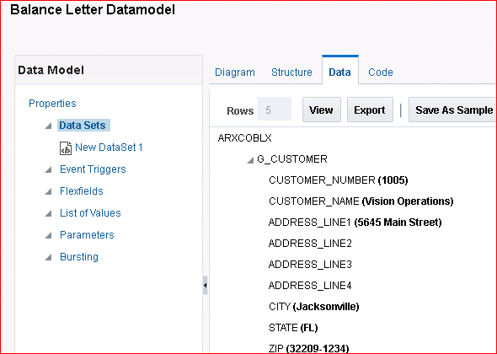

1. Select the Save File option. Click the OK button.

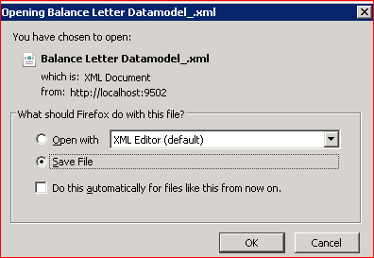

1. Click the Arrow at the top-right corner to display the saved file.

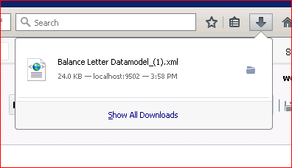

1. Click the Open Containing Folder icon to navigate to the Balance Letter Datamodel.xml saved file location.



1. Copy Balance Letter Datamodel.xml to the D:\Learn folder.
2. Open MS Word (Start > Programs > Microsoft Office > Microsoft Office Word 2007).
3. 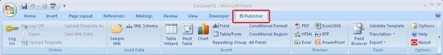Select **BI Publisher** on the ribbon.

The BI Publisher menu bar contains several groupings that include Online, Load Data, Insert, Preview, Tools, and Options. You can work with Template Builder online to connect to BI Publisher Server and generate templates for reports, or you can work with it offline to create templates based on sample XML data or files. You use the Online grouping to connect to BI Publisher Server. For this practice, you work in disconnected mode.

1. 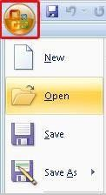Click the MS Office button and click **Open**.
2. Navigate to D:\Learn and select Balance Letter Start.rtf.
3. 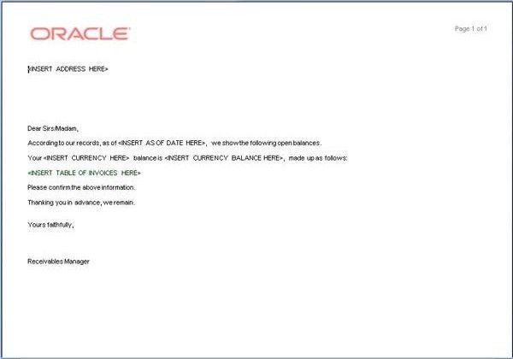Click **Open**. You often have a template from which to begin. The RTF template file appears in MS Word.
4. 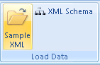To build a report and view the report with data, you must load sample XML data. When working in disconnected mode, you must have sample data stored locally. Click **Sample XML** in the Load Data grouping (BI Publisher ribbon).
5. Select **Balance Letter Datamodel.xml** (located in the D:\Learn folder) and click

#### Open.

1. Click **OK** in the message box confirming that you have successfully loaded the sample data.
2. The next step is to add fields to the Balance Letter by replacing the placeholders. Select the

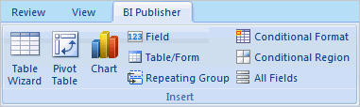**<INSERT ADDRESS HERE>** placeholder and, in the Insert grouping, click **123 Field**.

The Field dialog box appears.

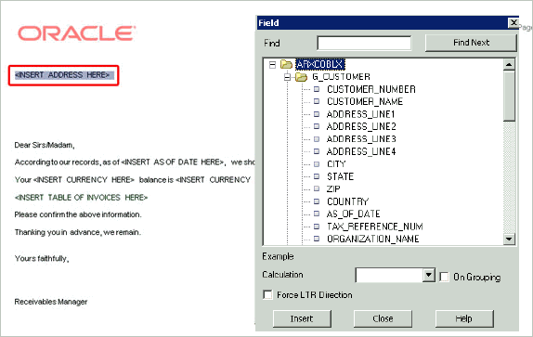

1. 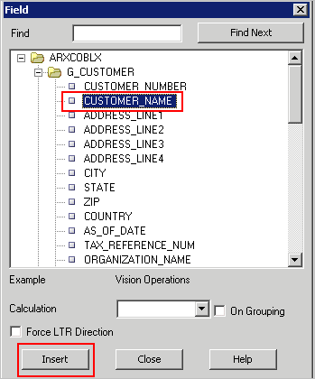Select **Customer Name** in the Field dialog box and click **Insert**.

The Customer Name form field appears in the Balance Letter. Click the space following the

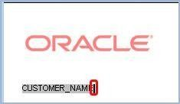**CUSTOMER_NAME** form field to bring the focus back to the letter.

Press **Enter**. This adds a line break.

1. Repeat this process, adding **Address Line1**, **Address Line2**, **Address Line3**, and

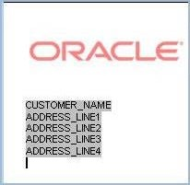**Address Line4**. The letter should look like this:

1. Add **City** followed by a comma and a space, and then add **State** followed by a space.

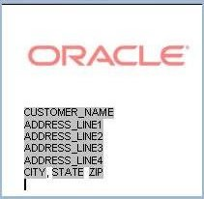Finally, add **Zip**.

1. 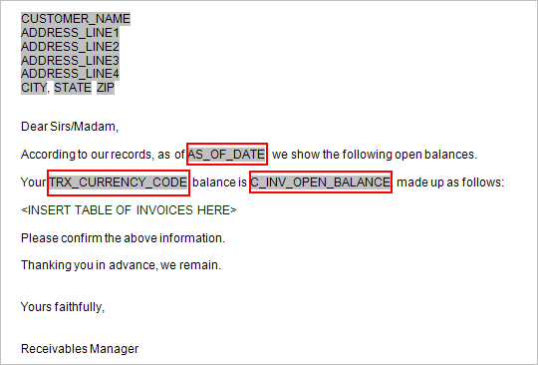Insert the following fields into the letter, in the appropriate placeholders: **As_Of_Date**, **Trx Currency Code**, and **C Inv Open Balance**. Note that you may have to scroll in the Field dialog box to locate these fields.
2. Preview what you have added so far. Click **Close** in the Field dialog box. In the Preview grouping, click **PDF**.

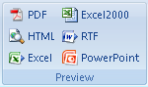

The PDF Preview appears with the XML file data.

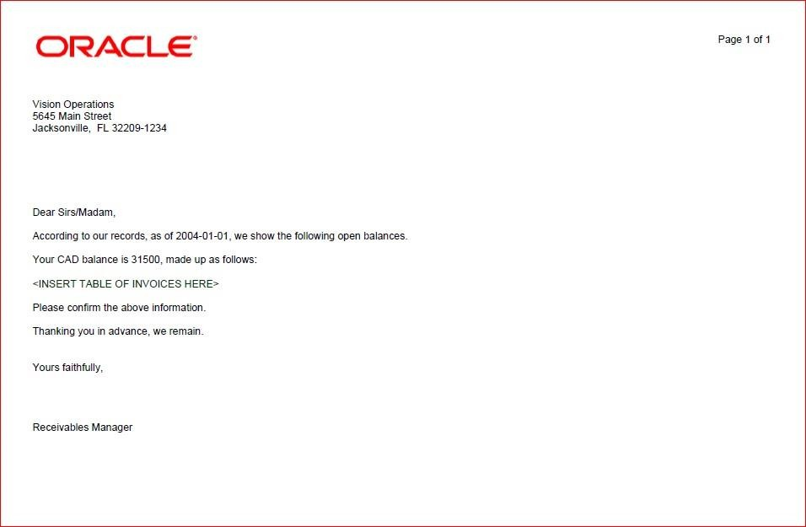

1. The next step is to include the table of invoices by using the Table Wizard. The Table Wizard allows you to add tables, forms, charts, and other objects. Select the **<INSERT TABLE OF INVOICE HERE>** placeholder in the form letter. Click **Table Wizard** in the Insert grouping.

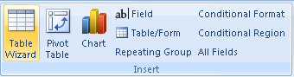

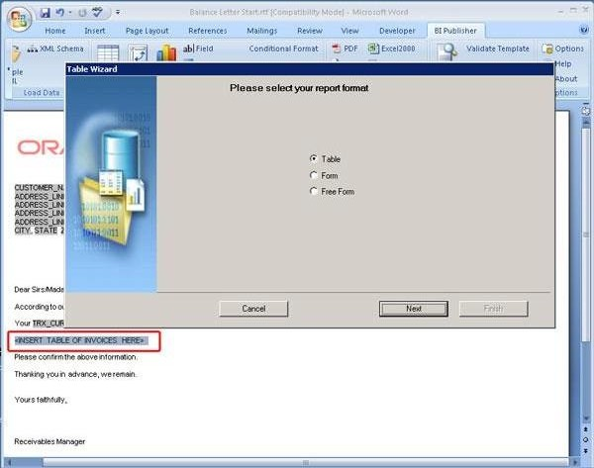The Table Wizard appears.

1. Accept the default (Table) and click **Next**.
2. 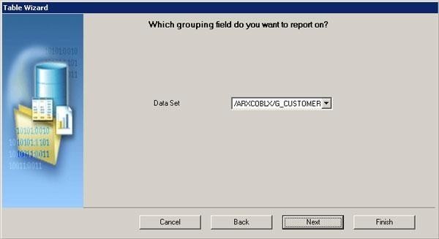The Table Wizard intuitively selects the correct dataset for you. You can change this, however, by clicking the drop-down list. Accept the default and click **Next**.
3. Select the columns that you want to see in the table. Select **Trx Number**, **Trans Type**, **Transaction Date**, **Trans Amount**, and **Trans Amount Remaining**.

Use the shuttle icons (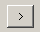) to move items to the selected column one at a time, or use the double-headed shuttle icons to move all columns at once. Use the resequence icons

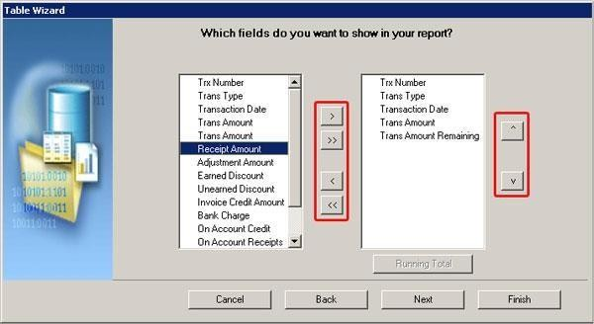( ) to resequence the columns up and down.

Observe that you can also add a running total to this report.

1. Click **Next**.
2. 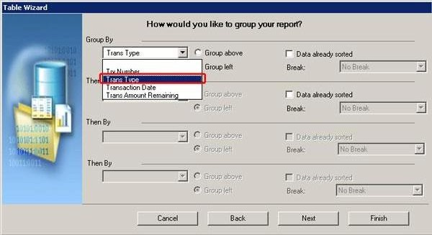You can group your data. From the Group By drop-down list, select **Trans Type** and then select **Group left**.

You use the Break option to insert either a page break or section break after each occurrence of a group.

Click **Next**.

1. 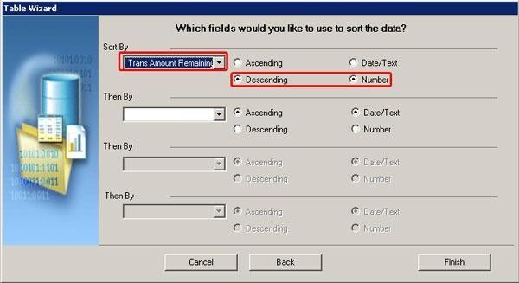Select a sort sequence and indicate the type of data that is being sorted. Select **Trans Amount Remaining**, indicate that this field is a **Number**, and sort the column in **Descending** order.

Click **Finish**.

1. 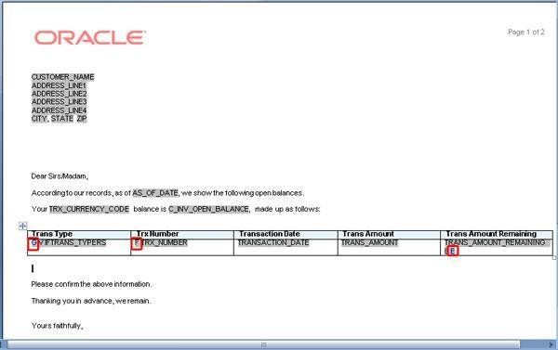The table appears in your letter. Note the “G (grouping)” and “F-E (for-each)” codes in the table.
2. 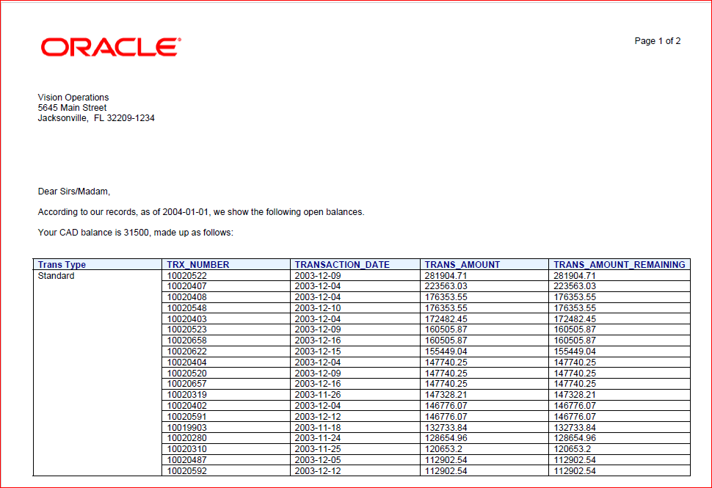Preview your letter once again in **PDF** format.

Close the PDF.

1. You can view the properties of any table field that you added to your template. Select

**TRANS_AMOUNT** in the table, and double-click to view the properties.

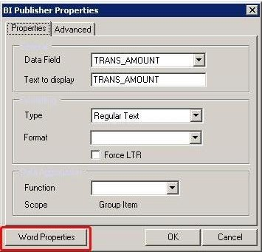Click **Word Properties** in the BI Publisher Properties dialog box.

1. Select **Number** from the Type drop-down list.

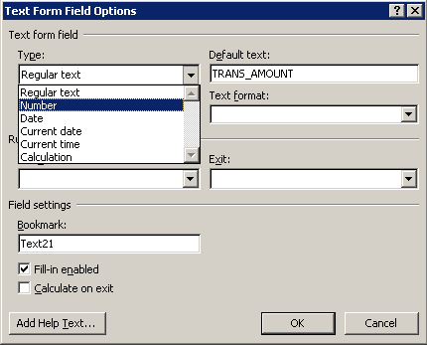

1. 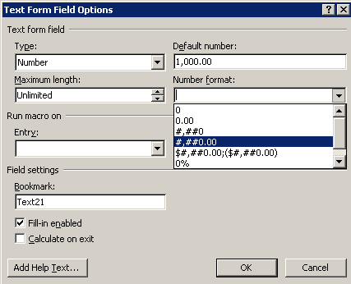Set the “Default number” and “Number format.” Enter **1,000.00** in the “Default number” text box and select **#,##0.00** from the “Number format” drop-down list.
2. Click **OK**. The Balance Letter and applied formatting appear.

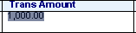

1. Format **Trans Amount Remaining** exactly the same way. You can also format the date field if you choose.
2. Preview your changes in PDF and save the file in the D:\Learn directory.
3. Leave MS Word open.

## Practice 7-2: Working with a Chart and a Pivot Table in an RTF Template

### Overview

In this practice, you open an existing RTF template. Then you insert, define, and preview a chart, and add a pivot table to the template.

### Tasks

1. Copy the Retail Sales.rtf and RetailSales.xml. These files are located in D:\Program Files (x86)\Oracle\BI Publisher\BI Publisher Desktop\Template Builder for Word\samples\RTF templates\Sales Report to the D:\Learn directory.
2. Open Retail Sales.rtf. The file looks like this. From the BI Publisher menu, select

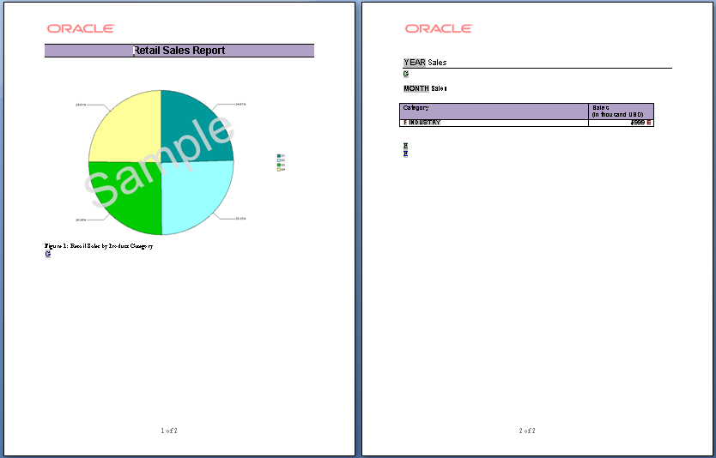**Sample XML** in the Load Data grouping.

1. Navigate to and select **RetailSales.xml** (located in D:\Learn), and click **Open**. This file contains retail sales data from different industries.
2. Click **OK** in the message dialog box.
3. 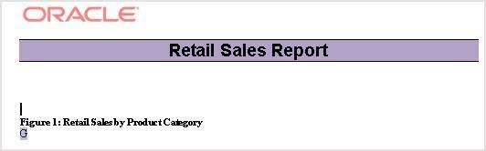This template contains both a sample chart and a data table (scroll to view the table). Select the chart in the template and press **Delete**.
4. On the BI Publisher ribbon, click **Chart** in the Insert grouping. The Chart dialog box appears.

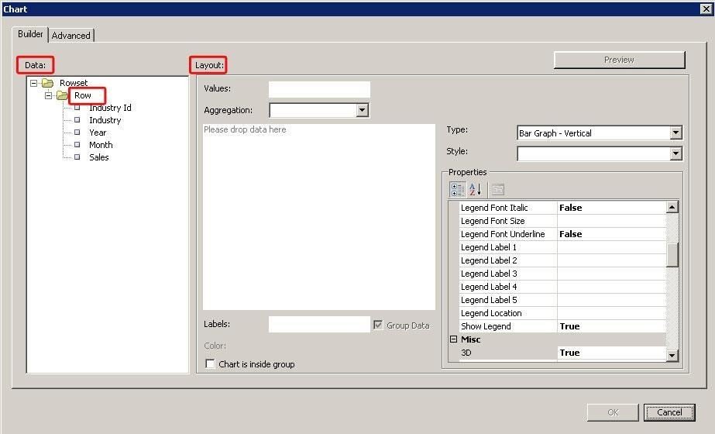

1. Select **Row** in the Data pane.
2. In the Layout pane, select the following information:

|  |  |  |
| --- | --- | --- |
| **Step** | **Attribute** | **Choices or Values** |
| a. | **Type** | Pie Chart |
| b. | **Style** | Earth |
| c. | **Aggregation** | SUM |
| d. | **Properties – Misc** | 3D = True |
| e. | **Properties – Misc** | Gradient = True |

1. Drag **Sales** to Values in the Layout pane.
2. Drag **Industry** to the Labels text box. Your chart should look like this:

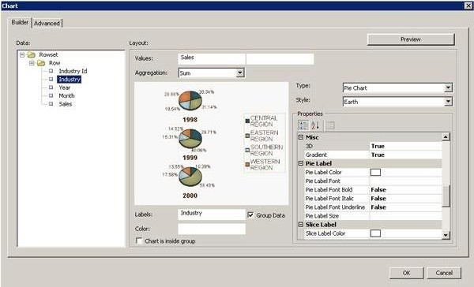

1. 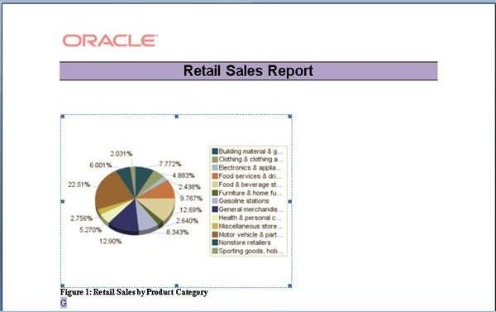Click **OK**. The chart appears in the template:
2. Save this as **My Retail Sales** in the **Learn** folder.
3. 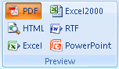In the Preview grouping, click **PDF**.

The PDF appears in a new browser window.

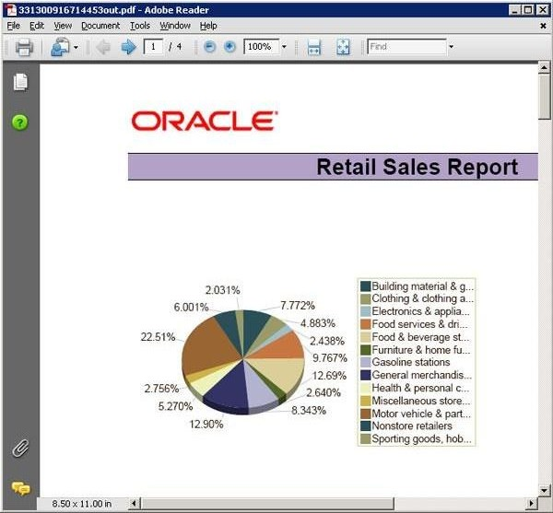

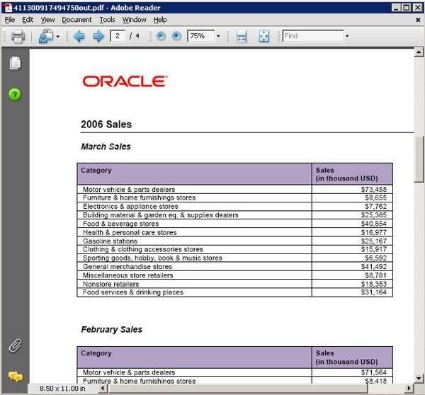Scroll down and examine the table.

Close the browser window.

1. 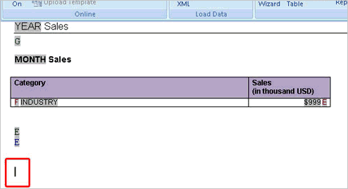Scroll down in the template, and then position your cursor after the end of the last form field (on page two) and press **Enter** twice.
2. Click **Pivot Table** in the Insert grouping.
3. 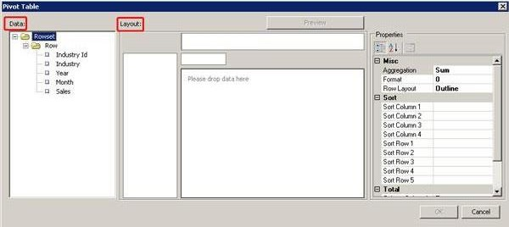The Pivot Table dialog box appears.

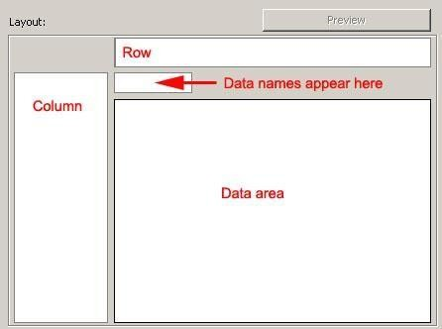You drag data columns from the Data pane to the blank Layout pane on the right to build a pivot table.

1. Perform the following tasks:

|  |  |  |
| --- | --- | --- |
| **Step** | **Begin Action** | **End Action** |
| a. | **Drag Year** | To Column |
| b. | **Drag Month (below Year)** | To Column |
| c. | **Drag Industry** | To Row |
| d. | **Drag Sales** | To “Please drop data here” area |
| e. | **Select Sales and then select the cell to the right of Format in the Properties pane.** | Select #,##0 |

SUM is the default aggregation for the Sales measure. You use the Properties pane to change the aggregation method, add formatting, and so forth.

1. 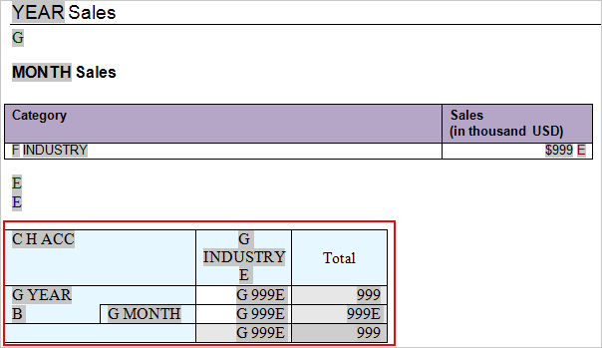Click **OK**. The pivot table appears in the template.

**Note:** You can change the formatting of the pivot table by using MS Word. However, if you need to change the structure, delete the existing pivot table, and build a new one, the creation and editing of pivot tables is better handled in the Layout Editor than in MS Word. MS Word templates are better suited to “document style” templates.

1. 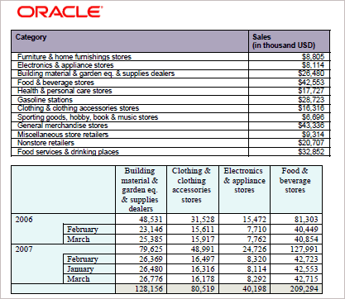Save the template and then click **PDF** in the Preview grouping to view your pivot table.
2. Close MS Word.

## Practice 7-3: Designing an RTF Template for a BI Publisher Report in Connected Mode

### Overview

Previously, you created an RTF template for a report that uses sample XML data. In this practice, you design an RTF template for a report created in BI Publisher. You log in to BI Publisher through Template Builder, define an RTF template, add a table with a running total, add grouping and sorting, add a page break, add a chart, preview data in the report by using the template, upload the RTF template to BI Publisher Enterprise Server, and view the report on BI Publisher Enterprise Server.

### Tasks

1. Open MS Word.
2. 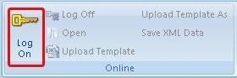In the Online grouping, click **Log On**.
3. The BI Publisher Login window appears. The first time you connect to BI Publisher from MS Word, you may be asked for the report server URL. Subsequently, this text box will be populated for you. Enter the following information:

|  |  |  |
| --- | --- | --- |
| **Step** | **Attribute** | **Values** |
| a. | **Username** | Ask the instructor for your username. (Example: weblogic1) |
| b. | **Password** | Ask the instructor for your password. (Example: weblogic1) |
| c. | **Report Server** | http://localhost:9502/xmlpserver |

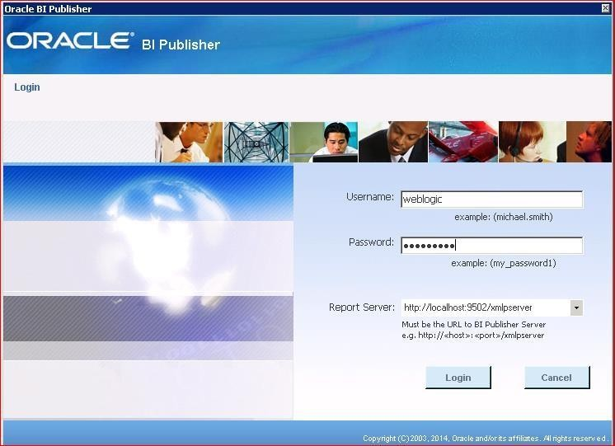

1. Click **Login**. The **Open Template** dialog box appears.

You can select a report from either Shared Folders or My Folders. After the folder is selected in the Catalog pane on the left, the reports associated with that Catalog folder appear in the Reports pane. To edit an existing template that is stored in the Catalog, select the template from the Layout Templates pane.

1. 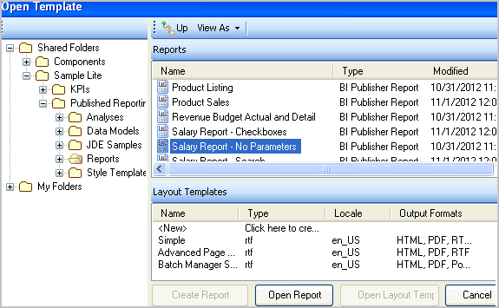Select \Shared Folders\Sample Lite\Published Reporting\Reports\ and then double-click **Salary Reports – No Parameters** from the Reports pane.

When the report opens, you will not see any data in the blank MS Word document; however, XML data definitions are loaded from the report to facilitate the definition of a template. Notice that the report name appears in the title bar of MS Word beside the document name.

1. Begin to build the template. Click **Table Wizard** in the Insert grouping. (This was practiced earlier in disconnected mode.) The “Please select your report format” page appears.
2. Accept **Table** as the default and click **Next**.
3. Accept the default data set on the “Which grouping field do you want to report on?” page and click **Next**.
4. Select **Manager**, **Department Name**, **Name**, **Annual Salary**, and **Fed Withheld** (in the specified sequence). Your selections should be listed in the right pane of the wizard page.

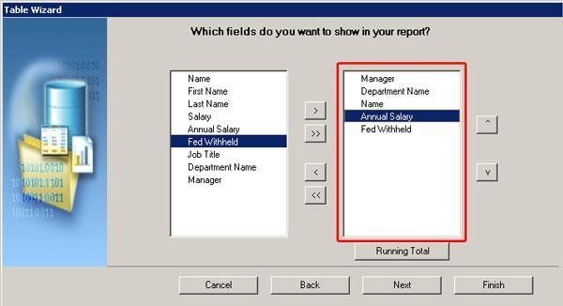Note that you can use the resequencing arrows ( ) to rearrange the fields.

1. Select **Annual Salary** and then click **Running Total**. The Running Total dialog box appears.

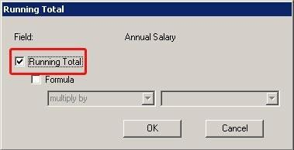Select the **Running Total** check box and click **OK**.

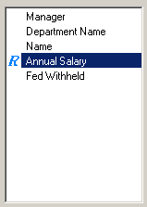Annual Salary is annotated with the running total icon ( ).

1. Click **Next**. Perform the following tasks on the “How would you like to group your report?” page:

|  |  |  |
| --- | --- | --- |
| **Step** | **Task** | **Selection** |
| a. | **Group By** | **Department Name** and **Group above** |
| b. | **Break** | **Section**  A section break starts the next group on a new page, resets page numbering, headers and footers, and any running calculations for each occurrence of the group. |

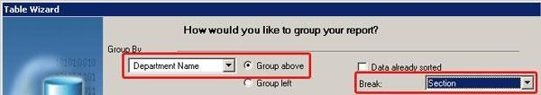

Click **Next**.

1. Sort by **Manager** on the “Which fields would you like to use to sort the data?” page. Click

#### Finish.

1. 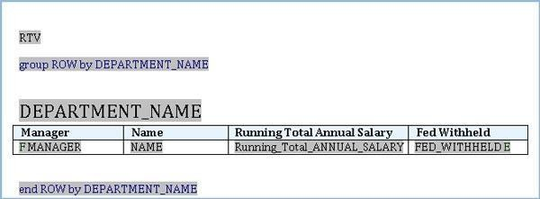The table appears in the document.
2. Add a chart. Position your cursor after the “end ROW by DEPARTMENT_NAME” form field and press **Enter** twice.
3. In the Insert grouping, click **Chart**.
4. Select **Row** in the Data pane.
5. Drag **Annual Salary** to Values in the Layout pane.
6. Drag **Manager** to the Labels text box.
7. In the Layout pane, select the following:

|  |  |  |
| --- | --- | --- |
| **Step** | **Attribute** | **Choices or Values** |
| a. | **Type** | Bar Graph - Vertical |
| b. | **Style** | Earth |
| c. | **Aggregation** | Average |
| d. | **Properties: Misc - 3D** | True |
| e. | **Properties: Misc - Gradient** | True |
| f. | **Title: Title** | Avg. Annual Salary by Manager |
| g. | **Title: Title Color** | Navy |
| h. | **Title: Title Font Bold** | True |
| i. | **Title: Title Size** | 12 |
| j. | **X–Axis Label: X–Axis Label Color** | Black |
| k. | **X–Axis Title: X–Axis Title** | Manager |
| l. | **X–Axis Title: X–Axis Title Color** | Navy |
| m. | **Y1–Axis Label: Y-Axis Label Color** | Black |
| n. | **Y1–Axis Title: Y1-Axis Title** | Avg. Annual Salary |
| o. | **Y1–Axis Title: Y-Axis Title Color** | Navy |

|  |  |  |
| --- | --- | --- |
| **Step** | **Attribute** | **Choices or Values** |
| p. | **Chart is inside group** | Select the check box. |

1. 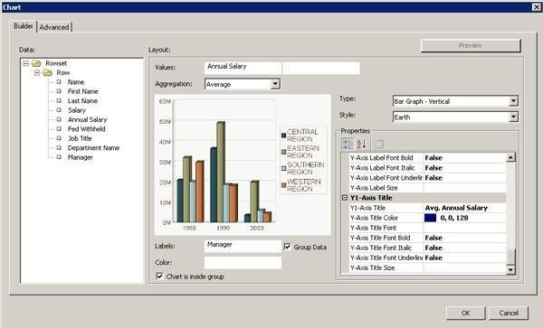The Chart Wizard should look like this:
2. Click **OK**. The chart appears in the template.

**Hint:** To edit the chart, select it and then click Chart on the toolbar again.

1. In the Preview grouping, click **PDF**. You are prompted to save the file as an RTF file before previewing. Save the file as **Manager Financials Report.rtf** in your **Learn** folder.

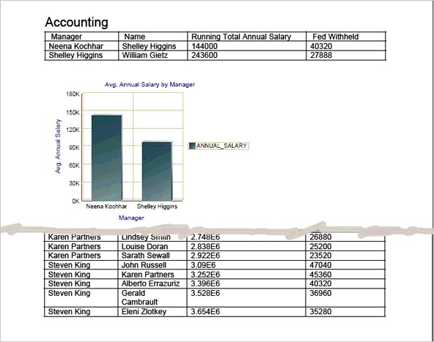The PDF appears. Notice that you used the “Group above” option; therefore, the department name appears above the table. Also note that a chart appears for each department name.

1. Close the PDF.
2. Close MS Word.
3. Log in to BI Publisher Enterprise Edition.
4. On the Catalog page, navigate to the “Salary Report – No Parameters” report and click

#### Edit.

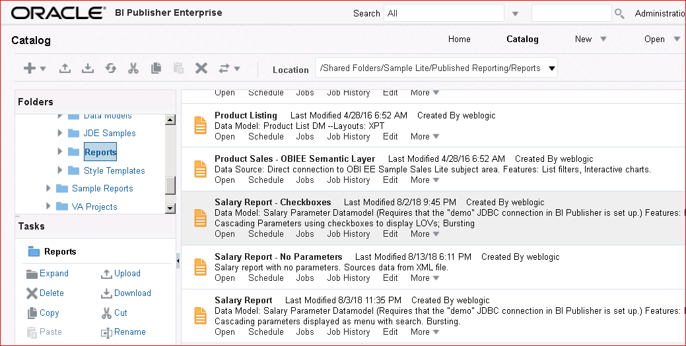

1. The Report Editor appears. Click **Add New Layout**.

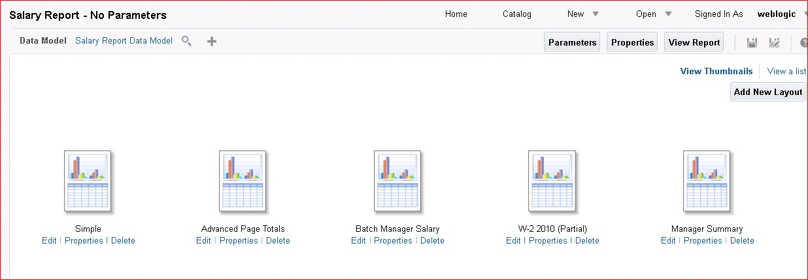

1. Report Editor displays the options for new layouts.

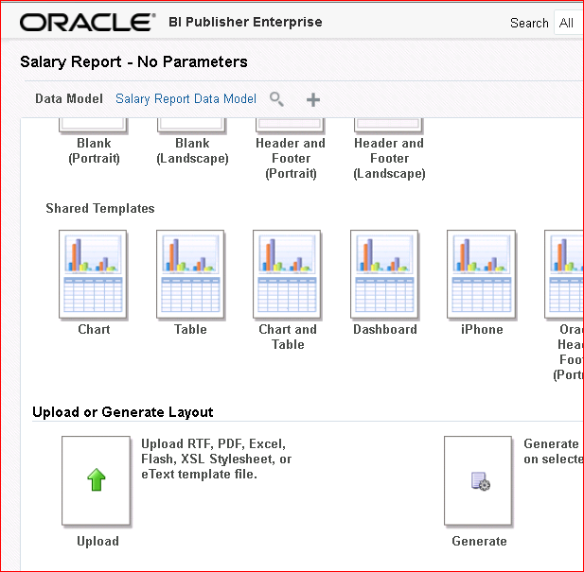

Click **Upload**.

1. In the Upload Template File dialog box, enter Dept Manager Financials as the layout name.
2. Click **Browse**.
3. Navigate to and select Manager Financials Report.rtf, and click **Open**.
4. 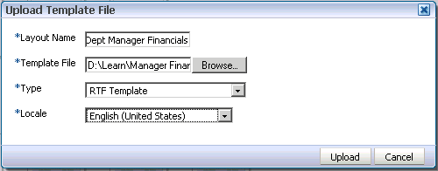Select RTF Template as Type and English (United States) as Locale.
5. Click **Upload**.
6. 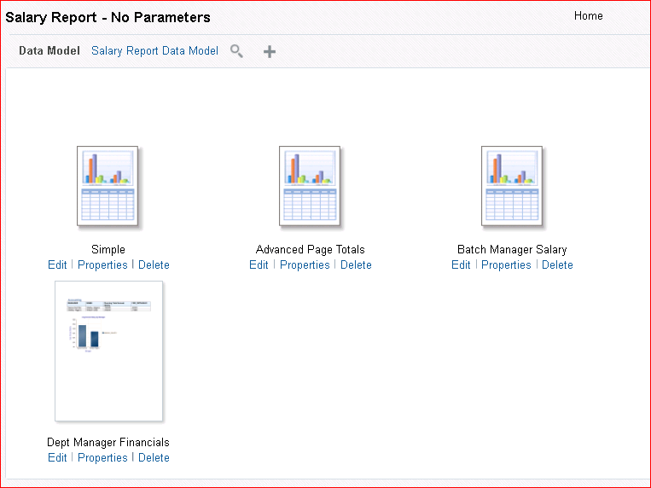Click **Save**. The uploaded template is listed in the Report Editor window.
7. 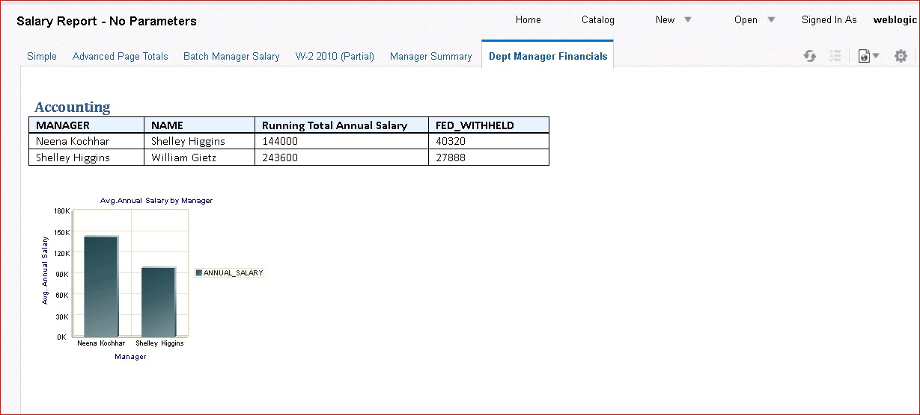Click **View Report**. In Report Viewer, click the **Dept Manager Financials** tab.

## Practice 7-4: Building an RTF Template by Using an Existing Data Model

### Overview

In this practice, you create a simple report by using an existing data model

### Assumptions

You are logged in to BI Publisher Enterprise Edition through MS Word and you have a blank document open.

### Tasks

1. Open MS Word: In the Online grouping, click **Open**.
2. In the Open Template dialog box, navigate to \Shared Folders\Sample Lite\Published Reporting\Data Models\ and select Salary Parameter Datamodel. Click Create Report

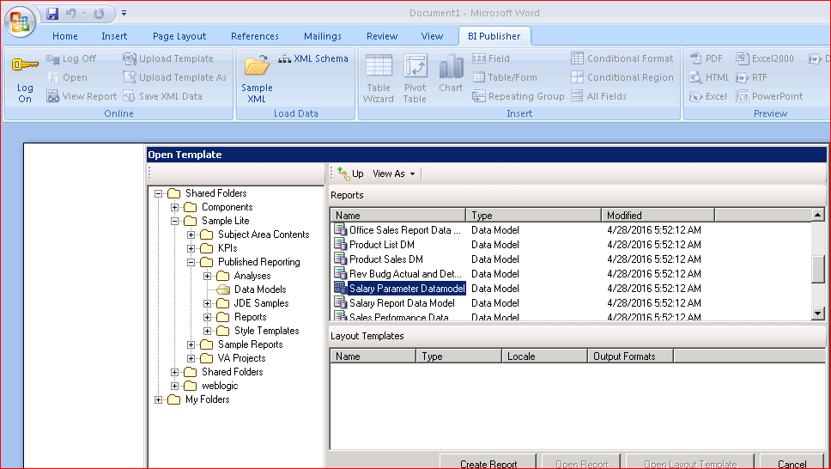

Save the New Report Definition within the BI Catalog. Name the Report **Salary Report**. Click Save

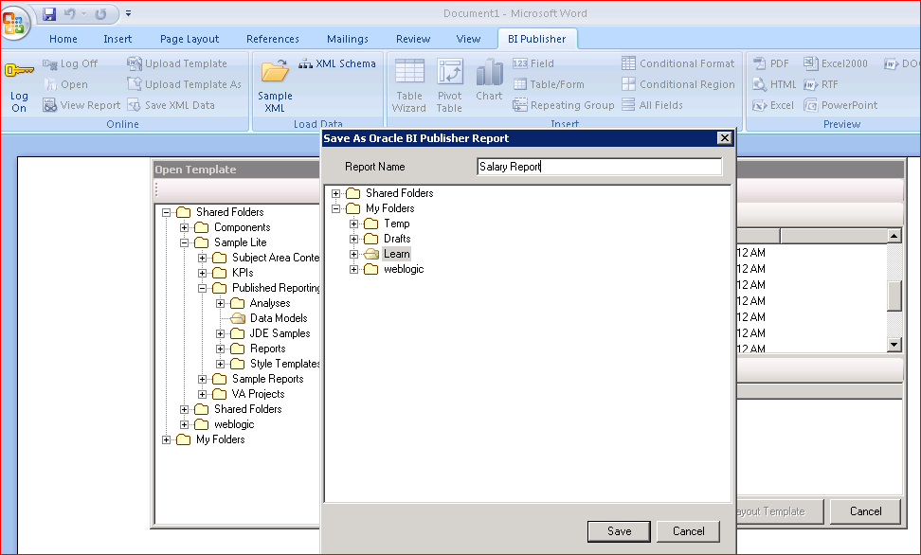

The Data Model loads into MS Word.

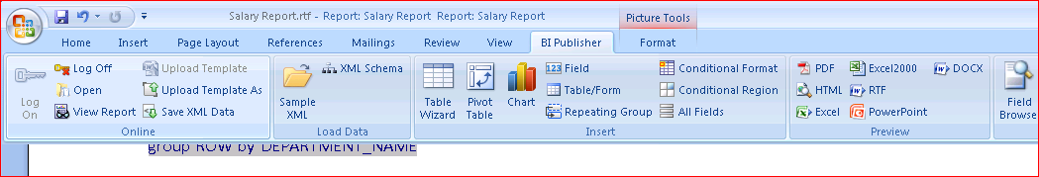

1. In the Insert grouping, click **Table Wizard**.
2. Select the **Table** option on the “Please select your report format” page and click **Next**.
3. Accept the defaults and click the Next button.
4. 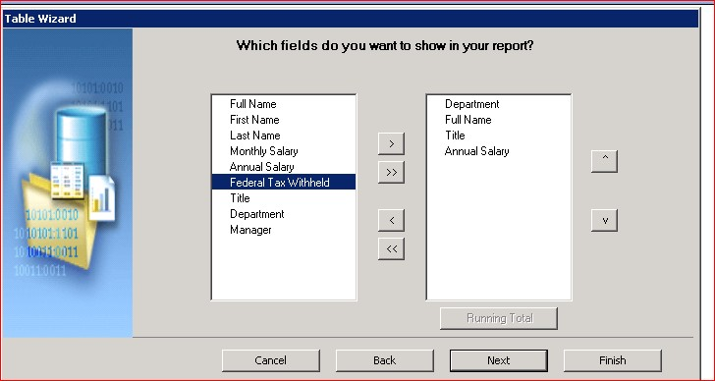Select the following fields and click **Next.**
5. Group Above by Department and Break via the Section.

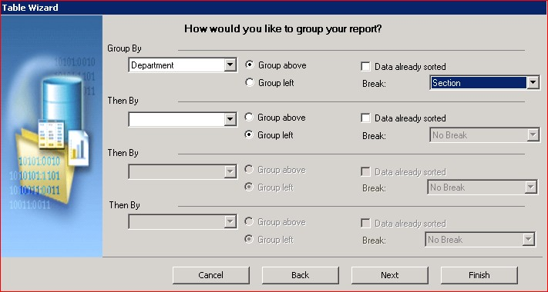

1. 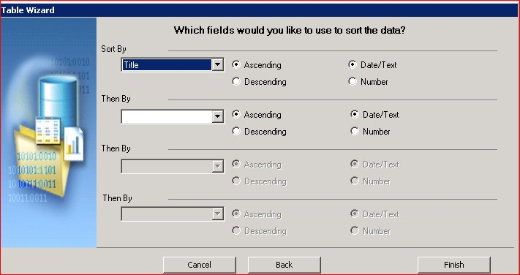Sort Title in Ascending. Click Finish.
2. Create a Chart.
3. In the Layout Pane, enter the following columns:

|  |  |
| --- | --- |
| Values | Annual Salary |
| Labels | Departments |
| Chart is Inside Group | Checked |
| Style | Autumn |

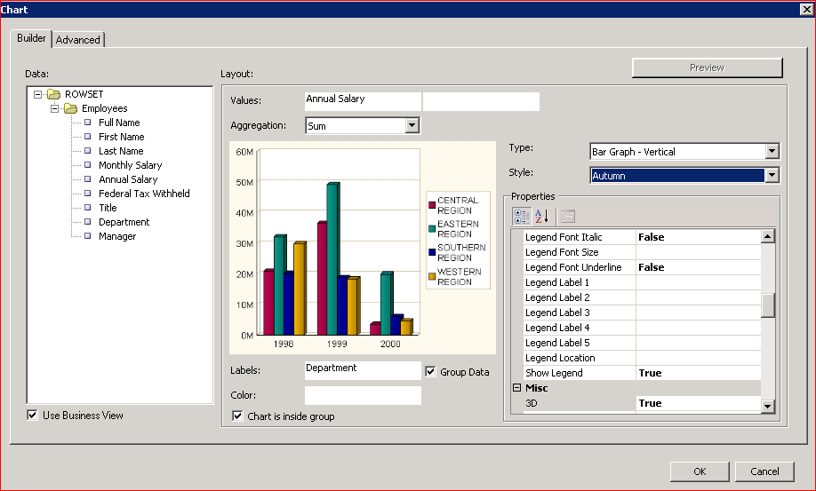

1. Click **OK**.
2. 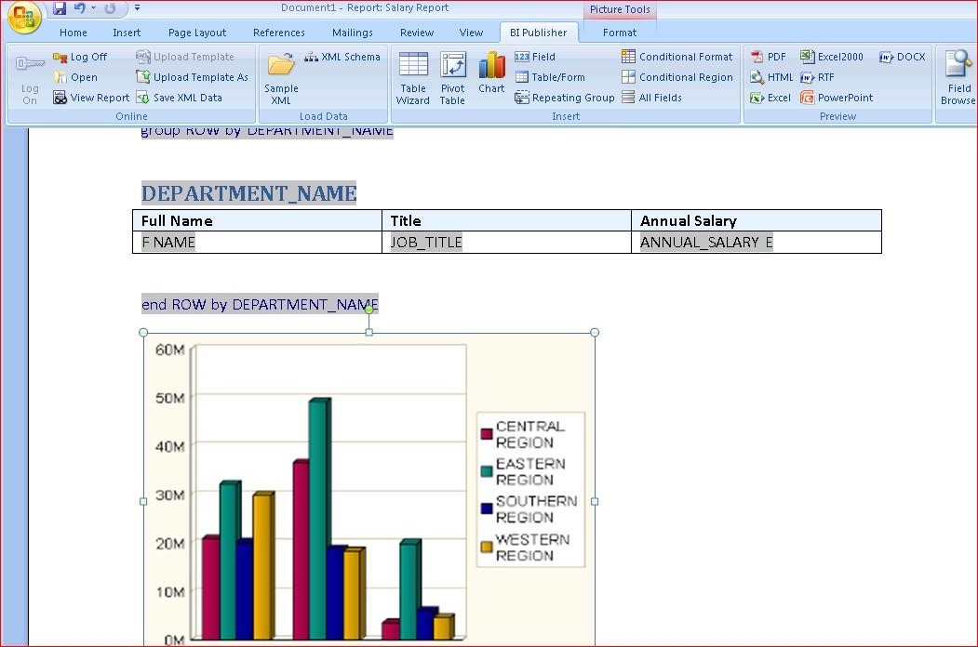The report will look like this.
3. Click Upload Template As in the Online section. Because the RTF has not been saved, the following message will appear.

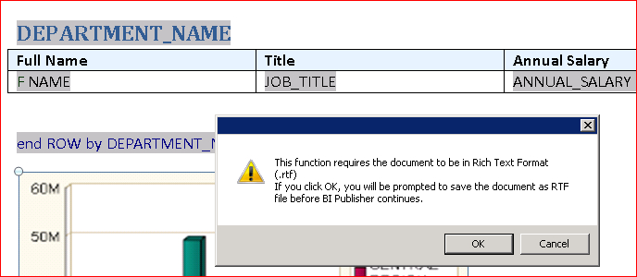

1. Click the **OK** button.
2. Save the RTF in **D:\Learn** with the file name of **Salary Report.rtf**. Click the **Save** button.

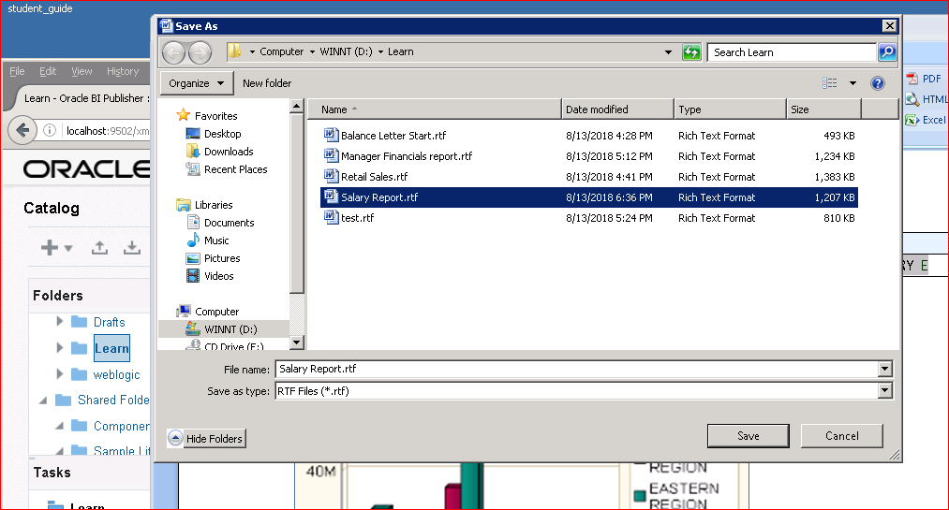

1. A screen will display asking for the name of the Report Layout Template within BI Publisher.

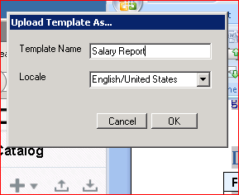

Name the Template **Salary Report** and click the **OK** button.

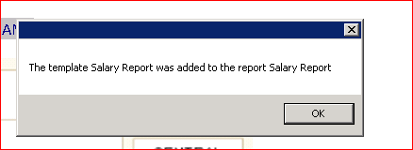

1. View the Report Template within BI Publisher. Navigate to BI Publisher > Catalog > My

Folders > Learn. Click the **Open** option for **Salary Report**.

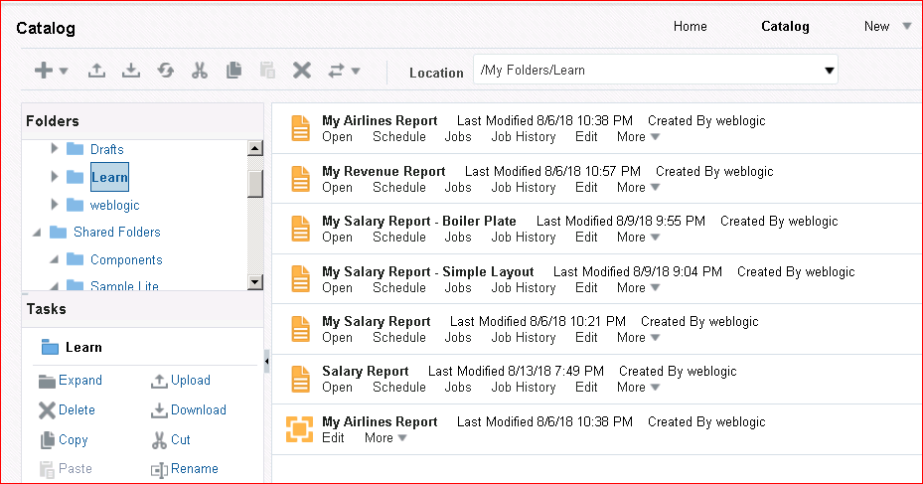

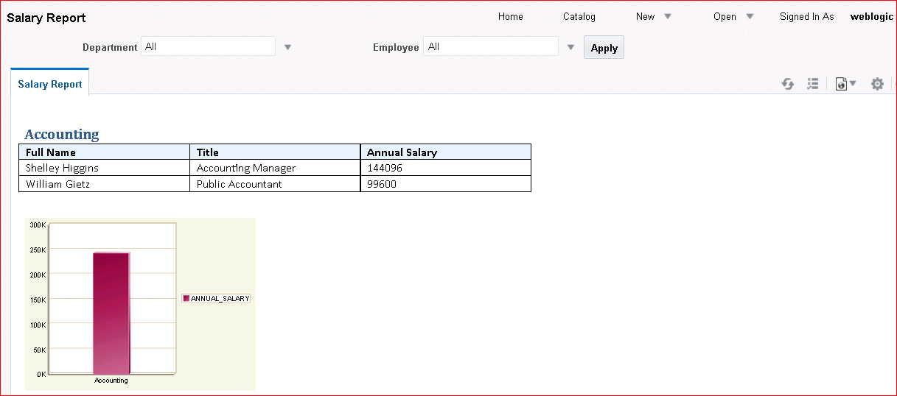The report template will be displayed.

## Practice 7-5: Reviewing a Report with Page-Level Calculations

### Overview

In this practice, you open a report locally that contains page totals and brought- and carry- forward totals, load the XML data, and preview the report.

### Tasks

1. Navigate to MyFiles folder and open Advanced Page Totals.rtf.
2. 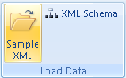In the Load Data grouping, click **Sample XML**.
3. The sample XML data is located in the same folder (“MyFiles”) as the RTF file. Select

#### Advanced Page Totals.xml.

1. Click **Open** and then click **OK** when the message dialog box appears.
2. 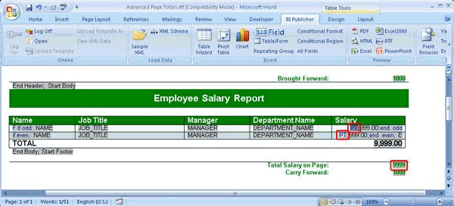The RTF template contains a page total indicated by the code variable **PT;** (highlighted in the following screenshot).

The template also contains Carry Forward and Brought Forward totals.

1. 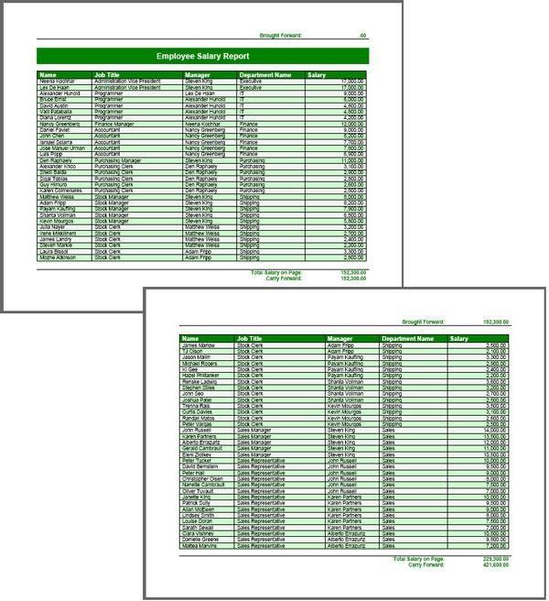In the Preview grouping, click **PDF** to view the report. Scroll down to view the Brought Forward and Carry Forward totals.
2. Close the PDF.

204 Practices for Lesson 7: Using Template Builder to Create RTF Templates

# Practices for Lesson 8: BI Publisher Server: Administration and Security

## Practices for Lesson 8: Overview

### Goal

To explore Administration within BI Publisher and perform administrative tasks, such as reviewing roles and permissions and configuring the email server

### Practices Overview

You will perform administrative tasks that include:

* Configuring data sources
* Reviewing user roles and permissions
* Configuring the email server (the Oracle classroom environment uses hMailServer)
* Configuring delivery options

### Time

15 minutes

## Practice 8-1: Defining a File Data Source

### Overview

In this practice, you define a file as the data source for BI Publisher. You may define an existing XML or MS Excel file that is stored in a directory to which BI Publisher can connect. Other data sources accessible to BI Publisher include JDBC, JNDI, OLAP, and LDAP. Note that you have already defined one data source (JDBC) in the “Using Data Model Editor” practice.

### Assumptions

You have defined the JDBC connection.

### Tasks

1. Log in to BI Publisher. Click **Administration**.
2. 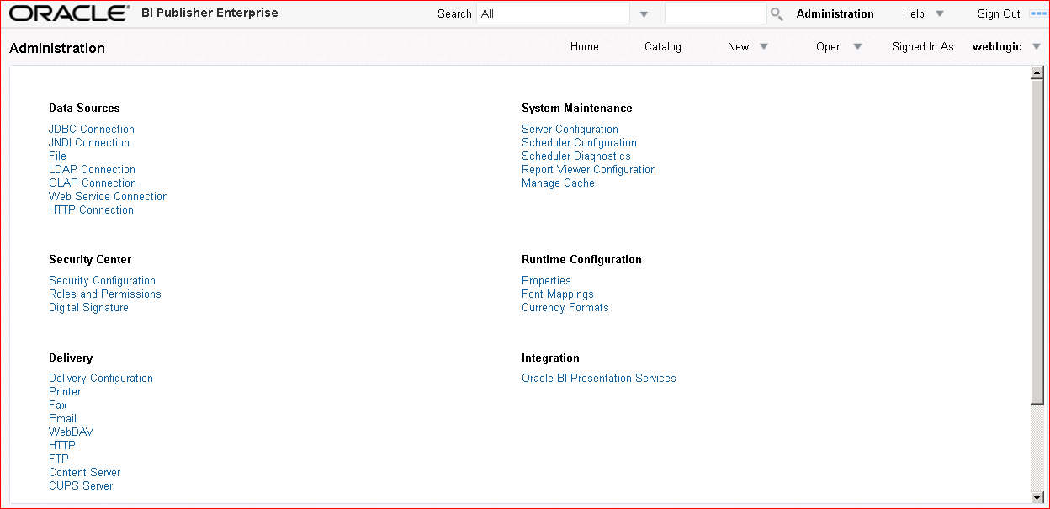Click **File** in the Data Sources section.

The Data Sources page appears. The File tab lists the existing file sources, if any.

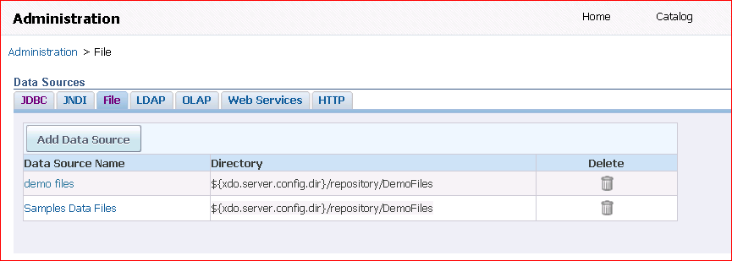

1. 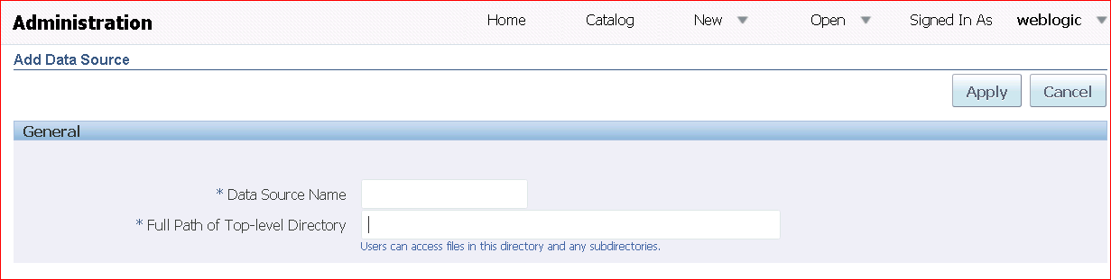Click **Add Data Source**. The Add Data Source page appears.
2. Provide the display name and path for the data source file. The display name appears in the Data Source selection list within the Data Model Editor. The path is generally the full path to the top-level directory on your server. This enables users to access files in this directory and any subdirectories.

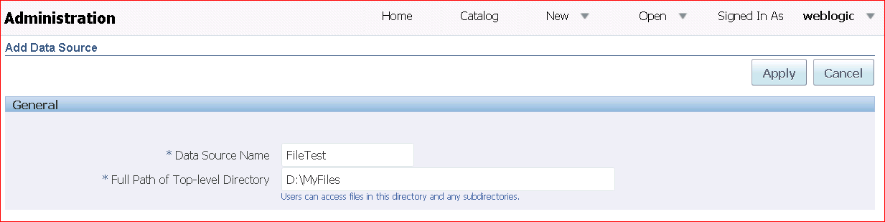Enter the following:

In general, you can also define the file data source to any directory on your system that has your XML and other template files.

1. 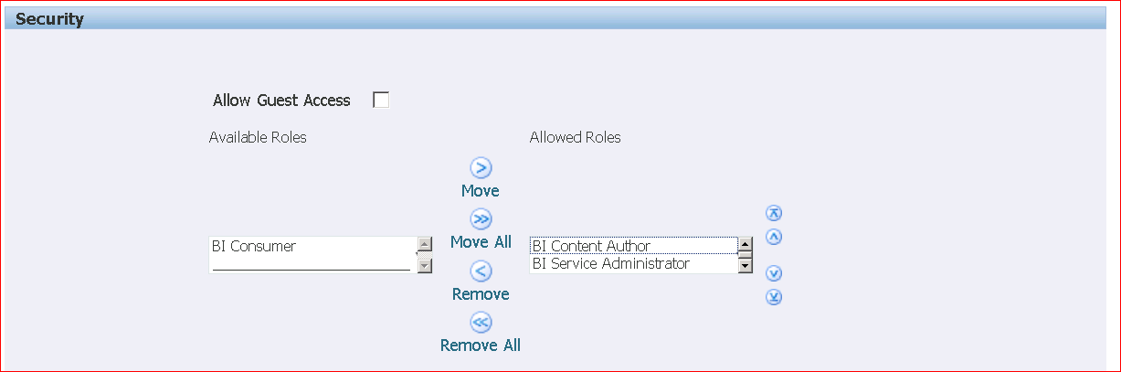You can define security for this data source. You use the shuttle buttons (  ) to move roles from the Available Roles pane to the Allowed Roles pane. Only users assigned to the roles on the Allowed Roles pane are able to create or view reports from this data source. Select **BI Service Administrator Role** and **BI Content Author Role** and click the shuttle button to move them to the Allowed Roles pane.
2. 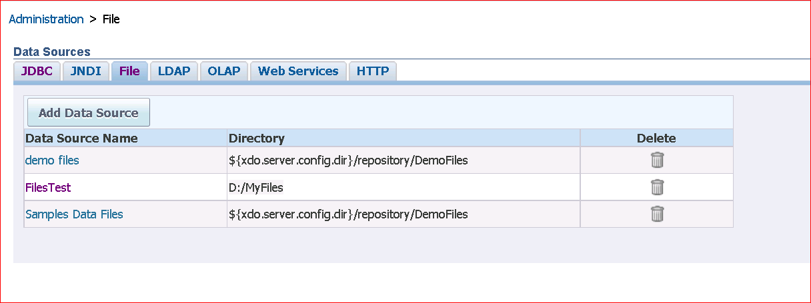Click **Apply** to save your changes. The data source appears in the list of available data sources.

## Practice 8-2: Reviewing Permissions Assigned to Default BI Publisher Users

### Overview

In this practice, you review the permissions allocated to BI Publisher users. BI Publisher users are created in WebLogic; therefore, you can only review the assigned permissions. This practice is designed to emphasize the differences between earlier version of BI Publisher and the current version, BI Publisher 12c.

### Assumptions

The default users were created during installation.

### Tasks

1. Log in to http://localhost:9500/em as an administrative user. In this case, log in as User: weblogic Password: weblogic1. Click Target Navigator and expand Business Intelligence, and click biinstance.

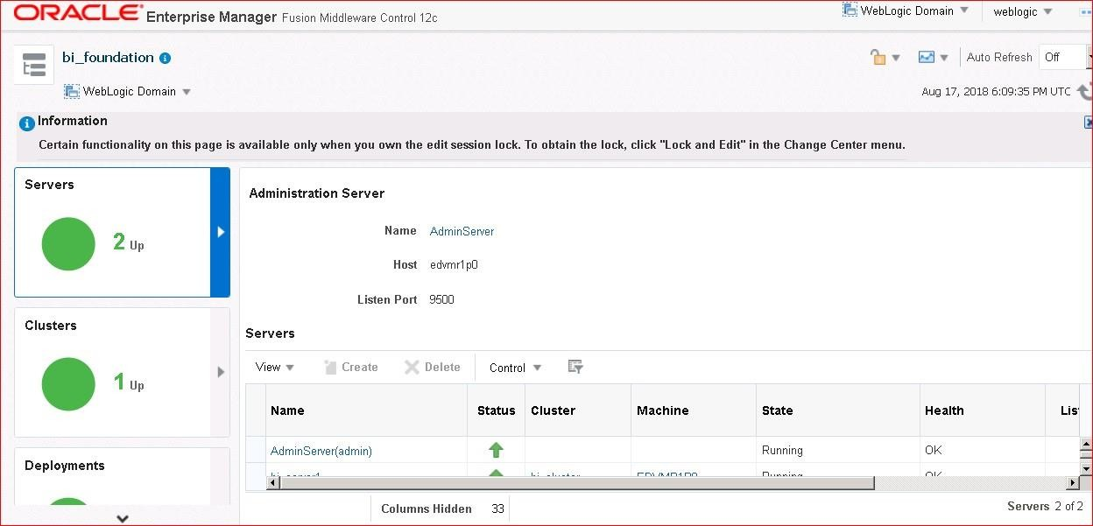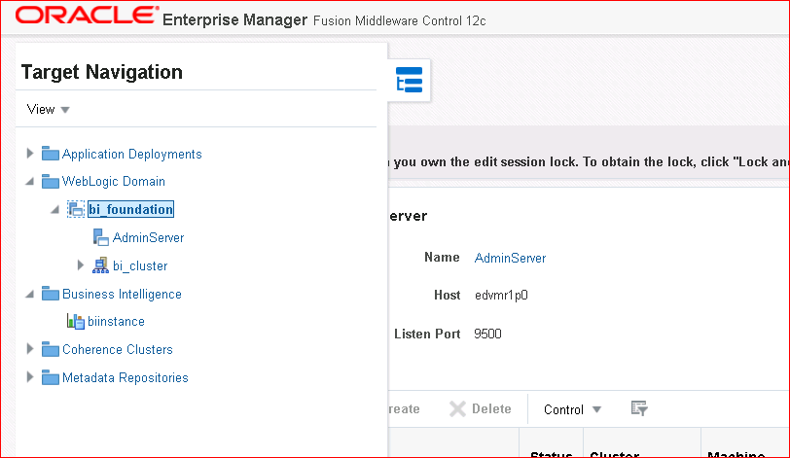

1. 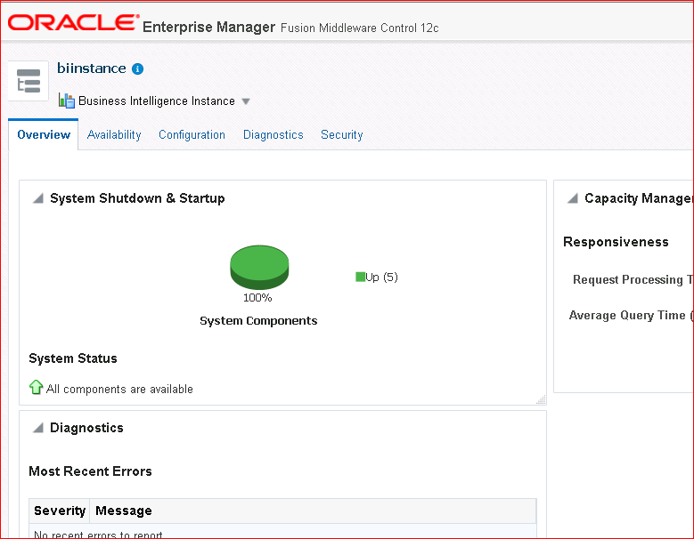You screen will look like the following:
2. Expand Business Intelligence Instance and select Security > Application Roles.

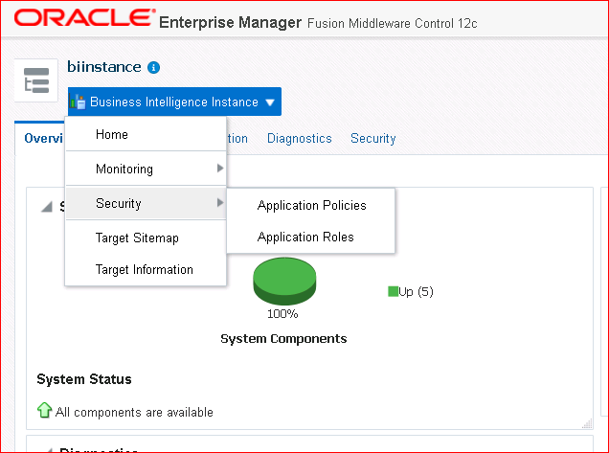

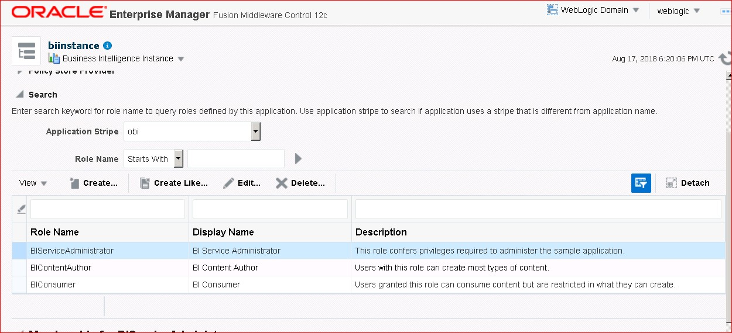Notice the Default BI Application Roles.

You can also select Application Policies to view the Default BI Policies.

1. On the BI Publisher Administration page, click **Roles and Permissions** in the Security Center section.

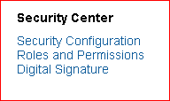

1. The preconfigured roles and permissions for the authenticated user weblogic appear. Observe that the roles for BI Service Administrator, BI Content Author, and BI Consumer are preconfigured. These are called “seeded” application roles in Oracle Fusion Middleware.

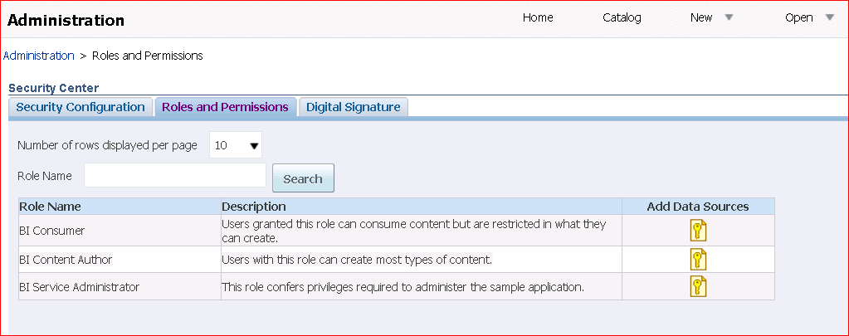

1. You can also check the account privileges for your user ID. Click the **Signed in as *<user>***

link, and select **My Account**.

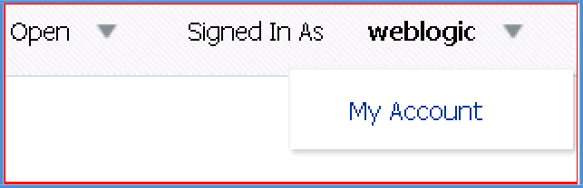

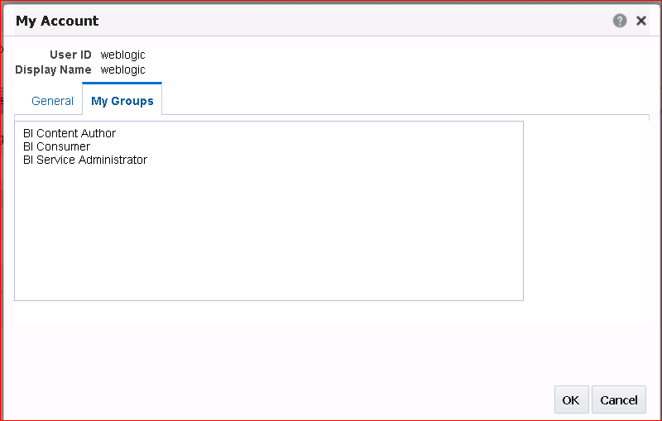The My Account dialog box appears. Click the My Groups tab. Note that the weblogic user is assigned to three roles: BI Service Administrator, BI Content Author, and BI Consumer.

1. Click **Cancel**.

## Practice 8-3: Configuring the Email Server as a Delivery Option

### Overview

In this practice, you set up hMailServer as a delivery option for BI Publisher, so that you can send reports as email attachments.

### Assumptions

You are still logged in to BI Publisher.

### Tasks

1. To begin this practice, the services for hMailServer must be running. Start hMailServer.

Click Start > Programs > hMailServer > Service > Start Service.

1. Click the Administration link.
2. 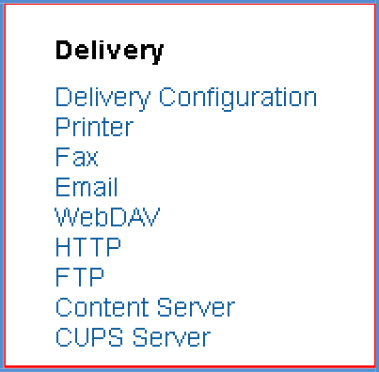Click **Email** in the Delivery section.
3. The Email tab of the Delivery page appears. Click **Add Server**.

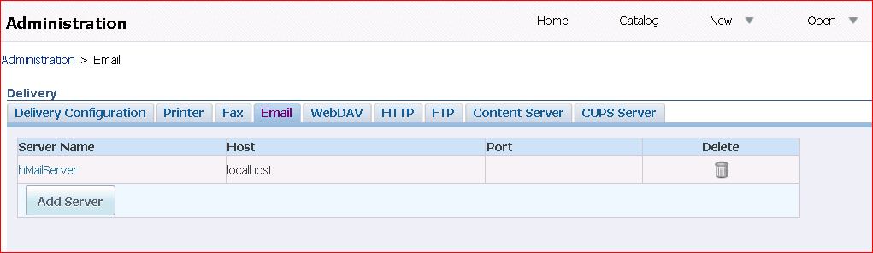

1. On the Add Server page, enter the following details:

|  |  |  |
| --- | --- | --- |
| **Step** | **Field** | **Value** |
| a. | **Name** | hMailServer |
| b. | **Host** | localhost |
| c. | **Username** | user@localhost |
| d. | **Password** | Leave this field empty. |

The Add Server page should look like this:

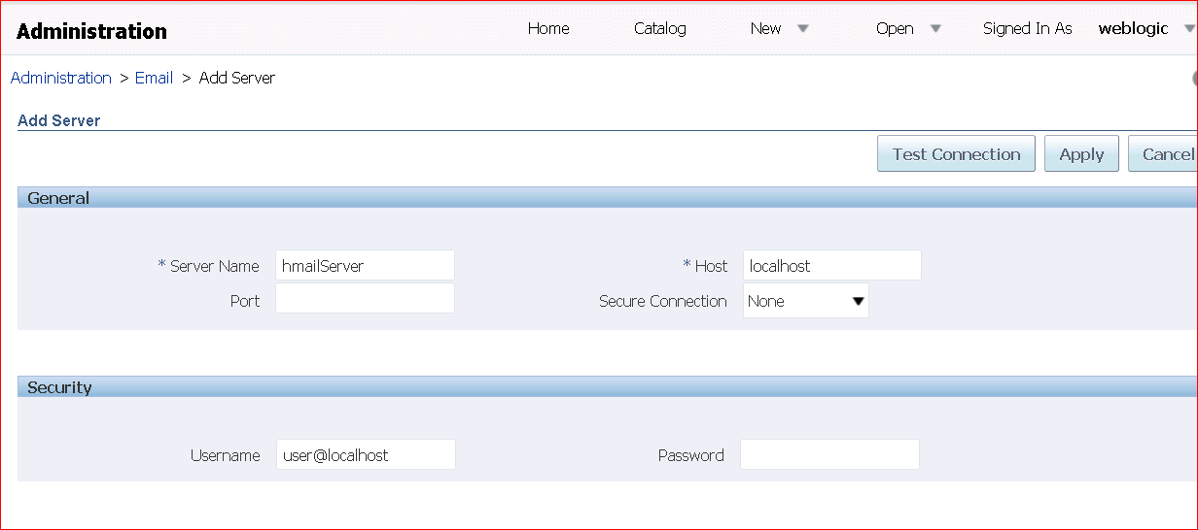

1. Click **Apply**.
2. 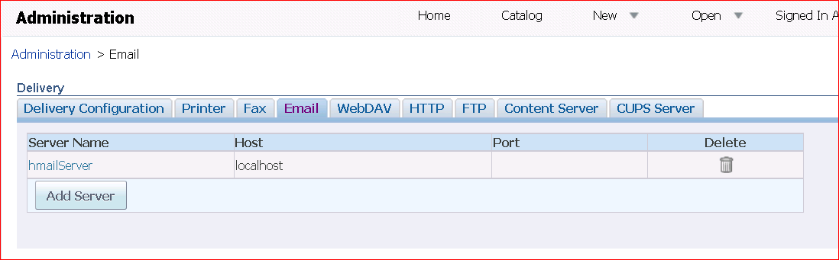Your server appears in the table. To edit the settings, click the desired server name link.

In the practices for Lesson 9, “Scheduling and Bursting Reports,” you will review the Scheduler configuration and diagnostics.

# Practices for Lesson 9: Scheduling and Bursting Reports

## Practices for Lesson 9: Overview

### Goal

To explore the scheduling and bursting capabilities of BI Publisher

### Practices Overview

You examine the BI Publisher Scheduler, schedule a report, and review the report job. You also add a scheduling trigger and review the report. You add a bursting definition for a sample report.

In this practice, you do the following:

* Review the Scheduler configuration.
* Schedule a report.
* Edit the report.
* Schedule the report with a trigger.
* Review the report job history.
* Review the data model for the report containing bursting definition.
* Add bursting definition to a sample report and review the bursting results.

### Assumptions

* Oracle BI Publisher is up and running.
* “My Files” is downloaded and unzipped.
* You are familiar with the Data model Editor and Create Report Wizard.
* You logged in with the BI Administrator role.

### Time:

35–45 minutes

## Practice 9-1: Examining BI Publisher Scheduler and Scheduling a Report

### Overview

In this practice, you explore BI Publisher Scheduler and schedule a BI Publisher report.

### Assumptions

To perform the tasks in this practice, you should have administrative privileges.

### Tasks

1. Navigate to the Administration page.
2. On the Administration page in the System Maintenance section, click **Scheduler Configuration** to examine the JNDI connection.

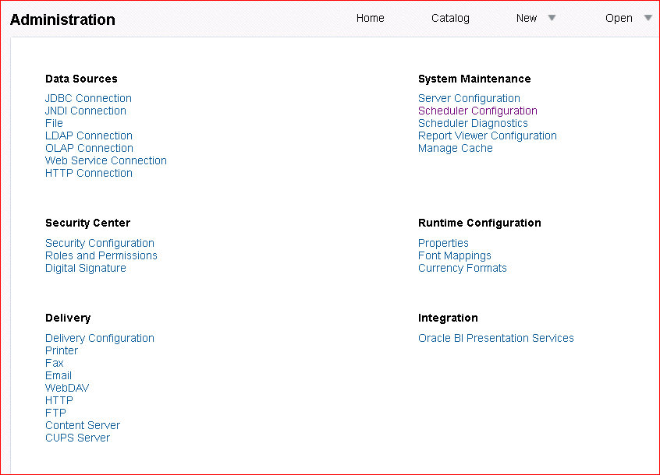

1. The Schedule Configuration page appears. Examine the Database Connection area.

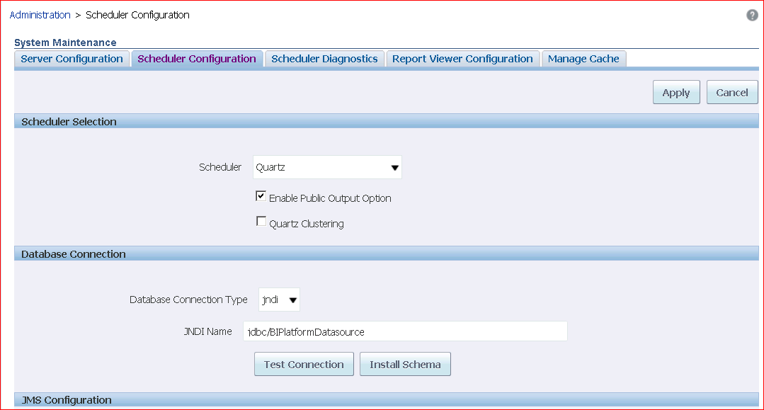

1. Click **Test Connection**. A confirmation message appears if the database connection is successfully established. Click Cancel.

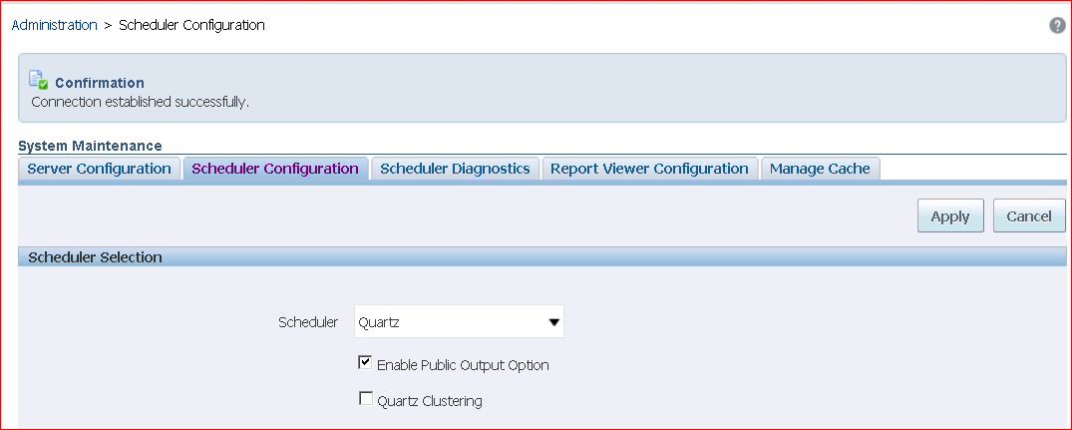

1. Click the **Scheduler Diagnostics** tab. Review the results. The **Result** area must show “passed” as indicated in the following screenshot.

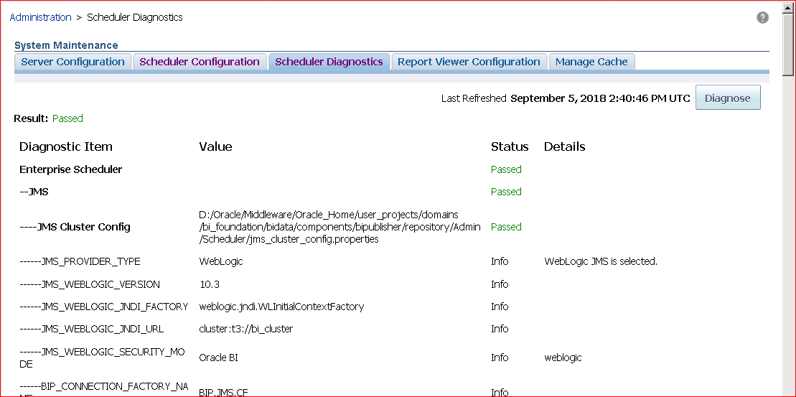

1. Select the report Salary Report from the Catalog.

(File path: Shared Folders > SampleLite > Published Reporting > Reports > Salary Report)

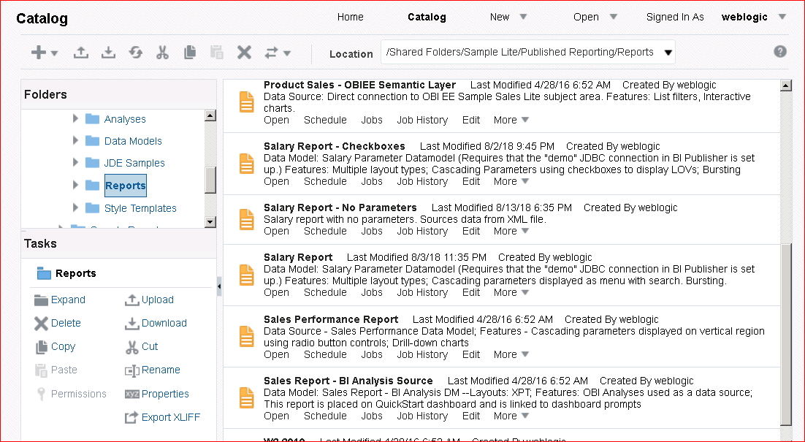

Click **Schedule.**

1. 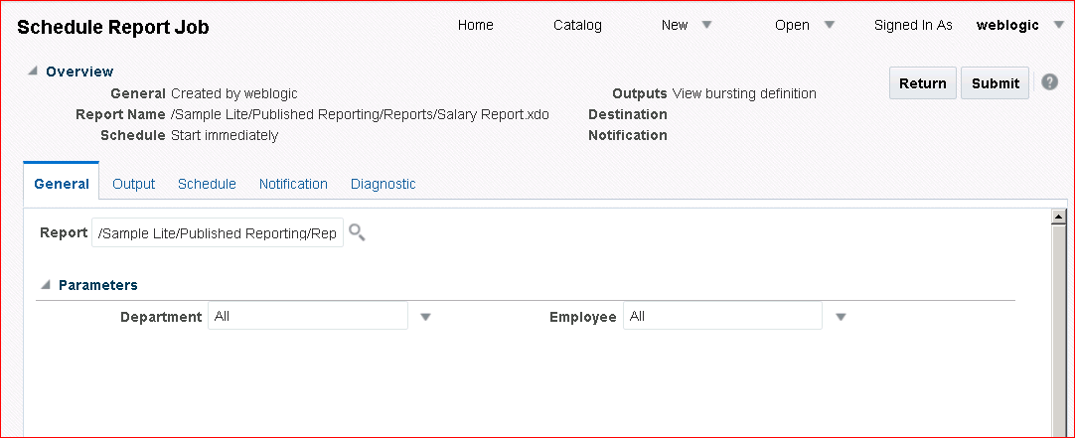The Schedule Report Job page appears with the report name displayed.

Observe that the overview displays the parameters with “All” for Department and Employee.

1. On the **Output** tab, select both the check boxes for “Make Output Public” and “Save Data for Republishing.” Make sure that the **Use Bursting Definition to Determine Output & Delivery Destination** option is deselected.

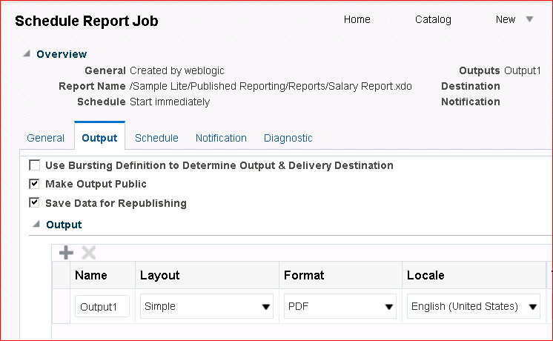

1. On the **Schedule** tab, select **Daily** from the Frequency drop-down list and then enter 1 for Every day(s). Check the Start and the End date and time. Make sure that the report does not run immediately.

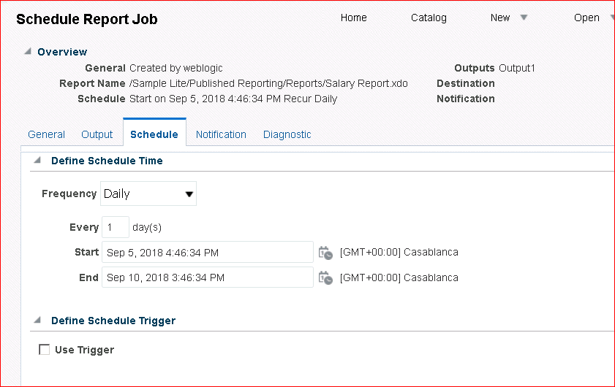

1. On the **Notification** tab, select the Notify By Email check box and enter [user@localhost.com](mailto:user@localhost.com) as the email address. This is the same email address that you created in the “Administration and Security” practice.

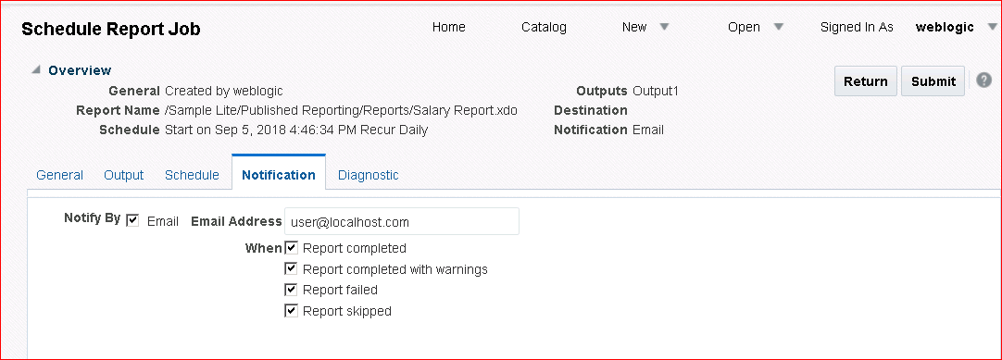

1. Click **Submit**.
2. Enter SimpleSchedule in the Report Job Name text box. Notice the schedule details in the dialog box. Click **OK.**

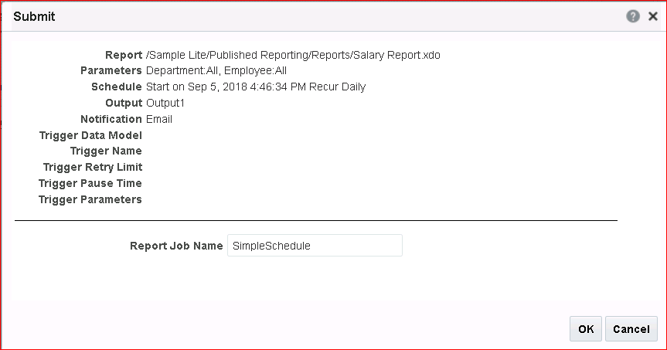

1. An alert message window appears, indicating that your job has been successfully submitted. Click **OK**.

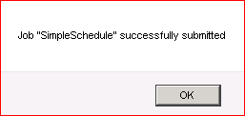

## Practice 9-2: Reviewing and Editing a Scheduled Job

### Overview

In this practice, you edit the previously scheduled report, add a schedule trigger to the report job, and view the job details.

### Assumptions

To perform the tasks in this practice, you should have scheduled the Salary Report – Search report in the previous practice.

### Tasks

1. Click Open > Report Jobs on the global header.

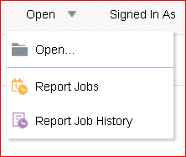

1. The Manage Report Jobs page appears. Your scheduled job, SimpleSchedule, appears in the Report Jobs table with Active status. Click **SimpleSchedule**.

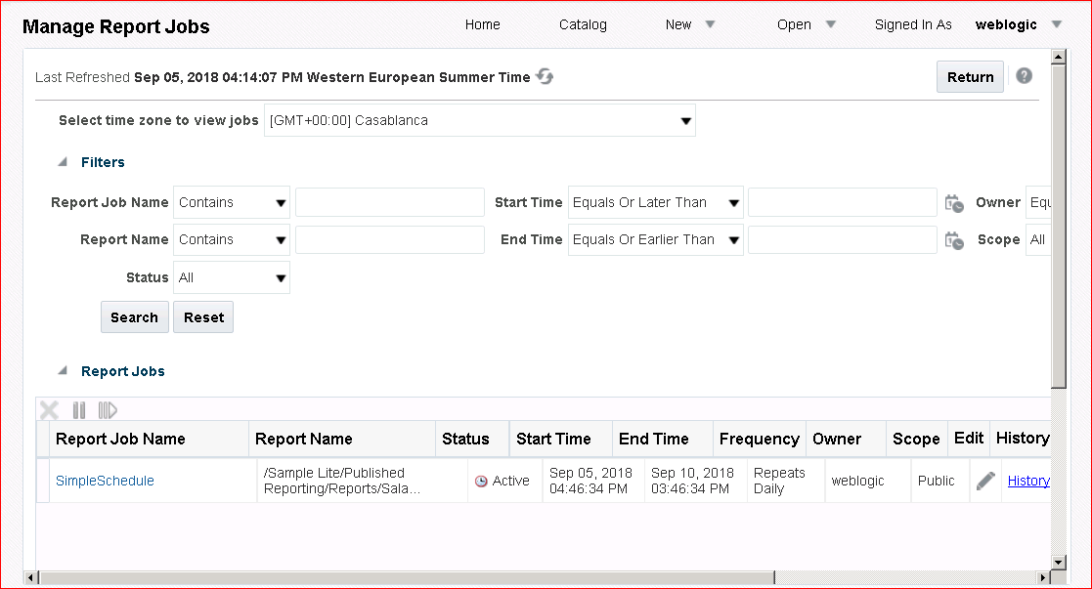

1. Note that the parameters for **department** and **employee** are set to **\*.** You can also see Active Start Date, Report Job Schedule, and so on.

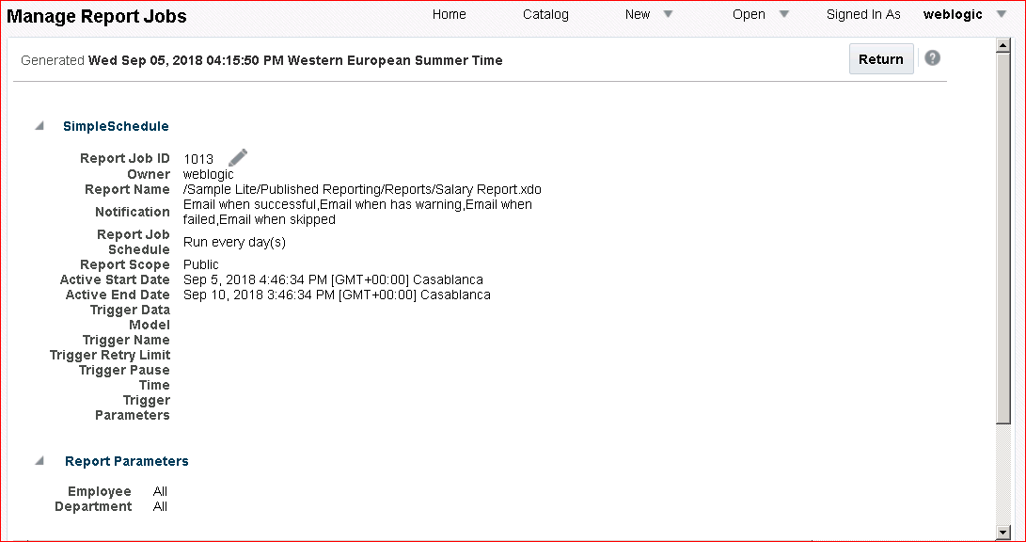

Click the **Edit** icon (  ) next to Report Job ID.

1. The Schedule Report Job page appears. On the **General** tab, change the parameters for

Department to **Marketing**, **Purchasing**, and **Shipping**.

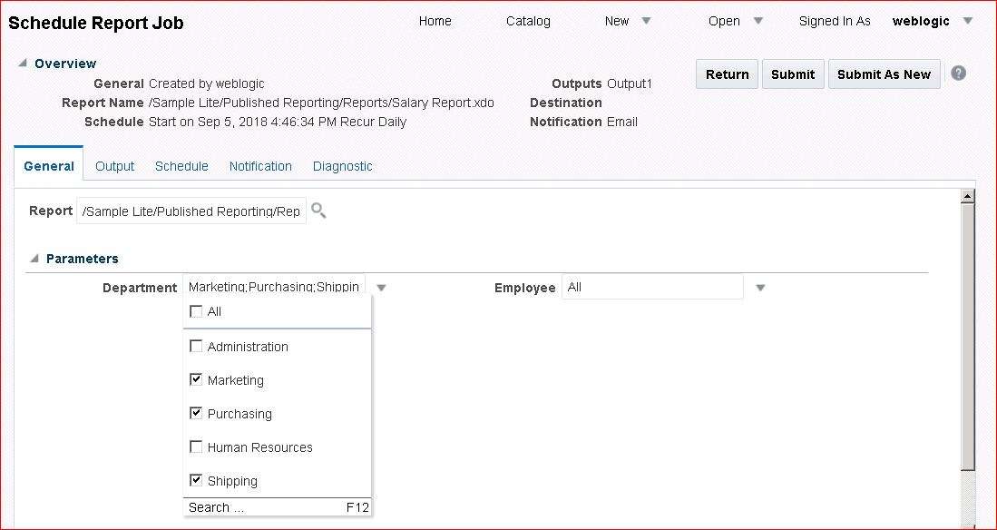

1. Click the **Schedule** tab, and change Frequency to **Once**.
2. Select the **Run Now** option.

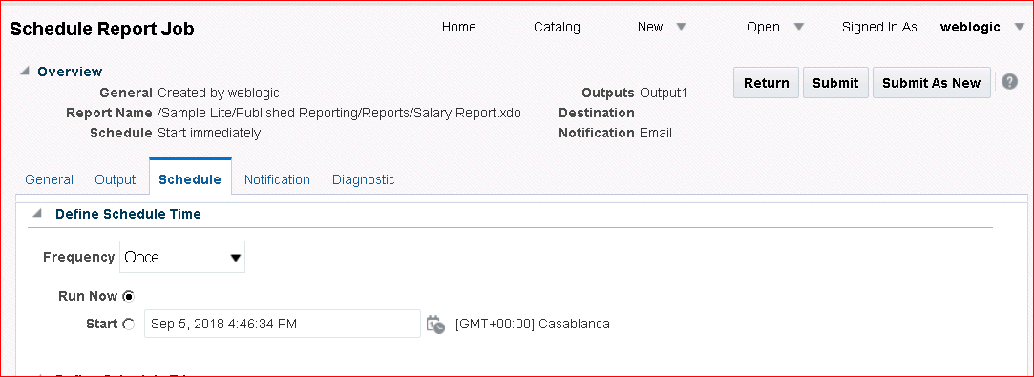

1. Click **Submit As New**. (This option submits the job with all of the current options and parameters.)
2. Name the report **ScheduleNow** and click **OK**.

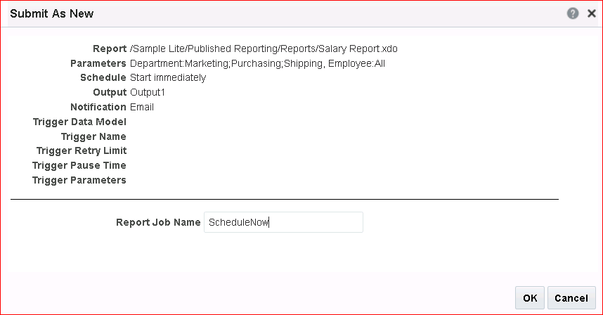

1. Click **OK** again in the confirmation window.
2. Click Open > Report Jobs. Only one iteration of the scheduled job **SimpleSchedule**

appears in the Report Jobs table.

1. Click Open > Report Job History. **ScheduleNow** is listed because it is already executed.

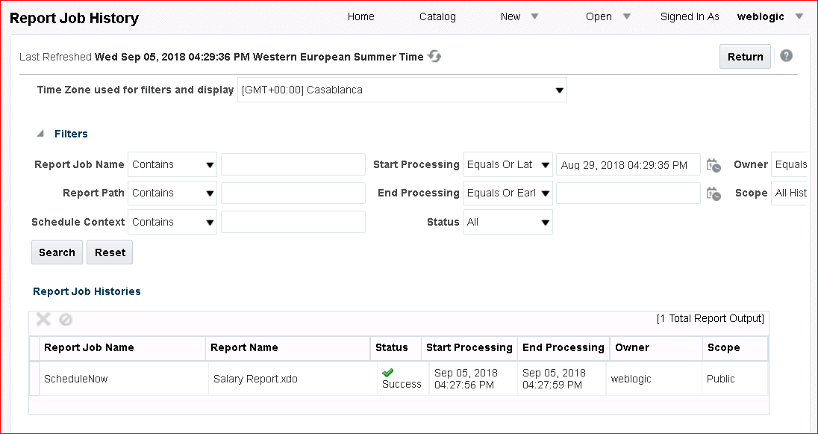

1. Click **ScheduleNow.** Notice that only three departments have been selected. Observe the schedule details as well.

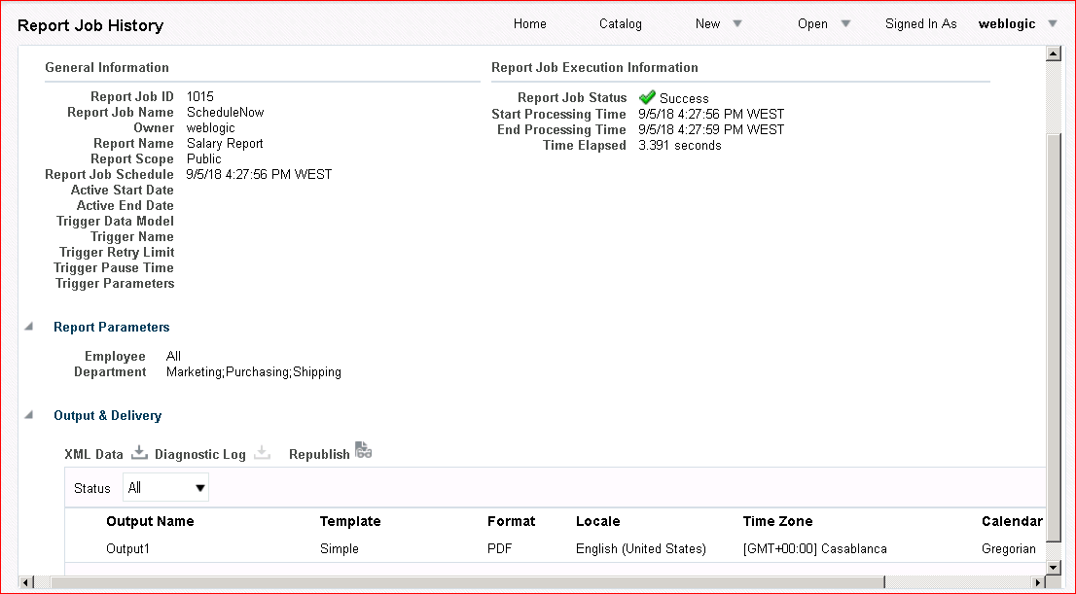

## Practice 9-3: Adding Schedule Triggers to a Report Job

### Overview

In this practice, you edit the previously scheduled report to add a schedule trigger, and view the job details.

### Assumptions

To perform the tasks in this practice, you should have scheduled the Salary Report – Search report in Practice 8-1.

### Uploading a Data Model

**Note:** The Data Model that you upload in this section includes parameters and a trigger for

scheduling.

1. Click **Catalog** on the global header.
2. Navigate to My Folders > Learn.
3. In the Tasks pane, click **Upload**.

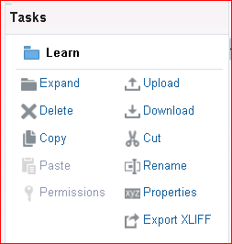

1. In the Upload dialog box, click **Browse**, navigate to the local folder D:\ **MyFiles**, and select

DMTrigger.xdmz.

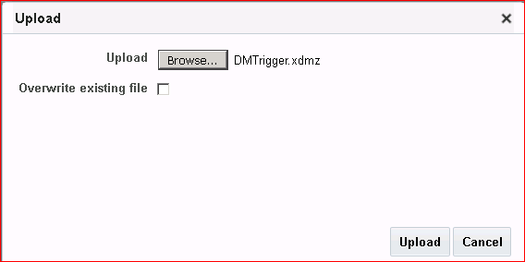

1. Click **Open** and then click **Upload**.
2. Verify that the data model file appears in the folder.

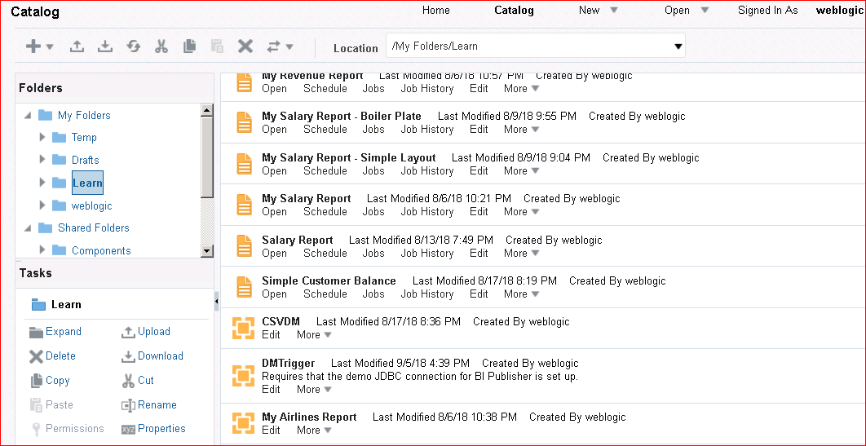

### Submitting a Job with a Trigger

1. Click **Open > Report Jobs** on the global header.
2. Click the Edit icon for the listed job from the previous practice—SimpleSchedule. (The steps are as given in the previous practice.)



1. In Schedule Report Job, on the General tab, select the parameters as given previously (Marketing, Purchasing, and Shipping).
2. Click the **Schedule** tab.
3. Keep the frequency as **Once** and select **Run Now.**

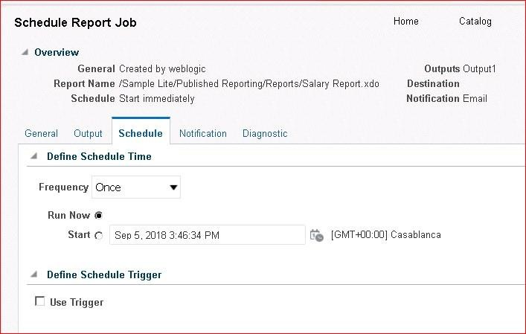

1. Select the **Use Trigger** check box. Additional options appear.

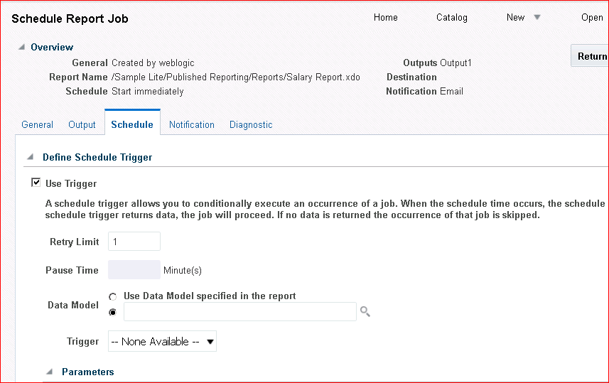

1. Select the second option for Data Model and click **Browse** ( ).

Navigate to the **My Folders > Learn** folder and select **DMTrigger**. This is the same data model you uploaded previously.

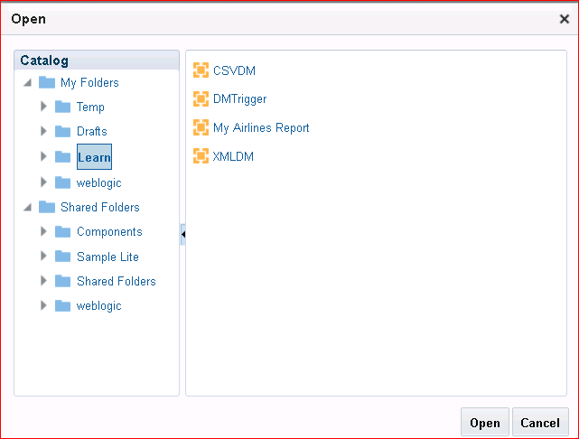

1. 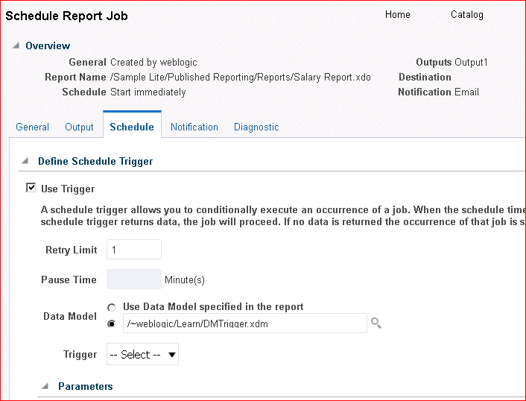Click **Open**. The data model appears in the selection field, and a trigger associated with this data model is listed in the Trigger drop-down list.
2. 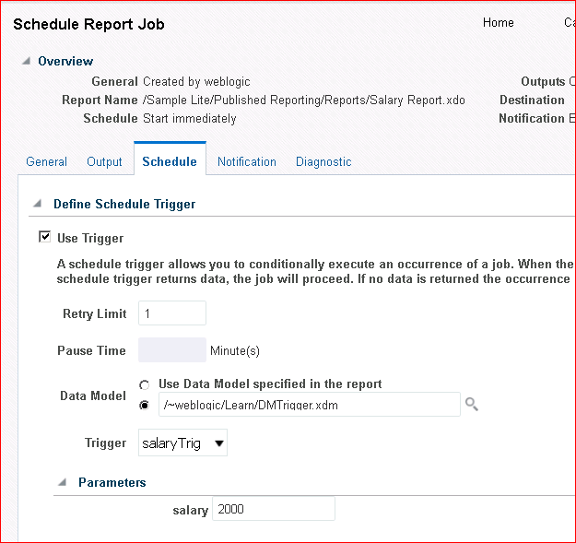Click the **Trigger** drop-down list and select **salaryTrig**. Once again, an additional option Parameter appears.

**Note:** The default SQL selection statement for SalTrig is

select 1 from dual where:sal >2000.

If the trigger parameter is equal to or less than 2000, the statement will be false and the

report will not be executed; it will have a status of Skipped.

1. Keep the default value and click **Submit As New**.
2. Name your job **TriggeredSchedule** and submit the same report job again.
3. 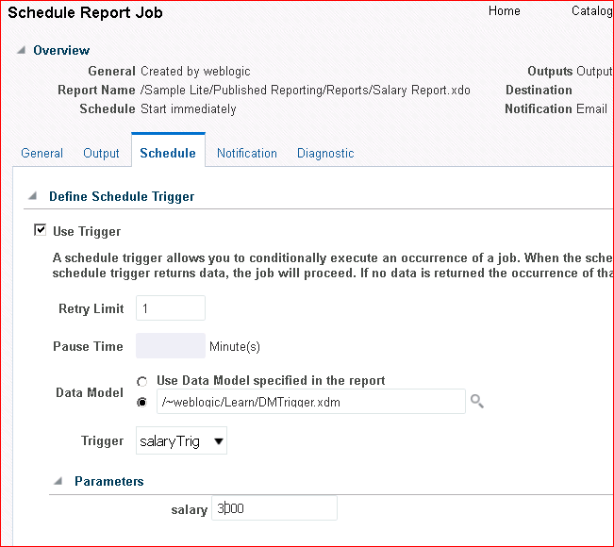Change the value for the **salary** text field to 3000.
4. Click **Submit As New** and name this job TriggeredSchedule2.
5. Click Open > Report Job History on the global header. Both the report jobs appear in the Report Job Histories table.

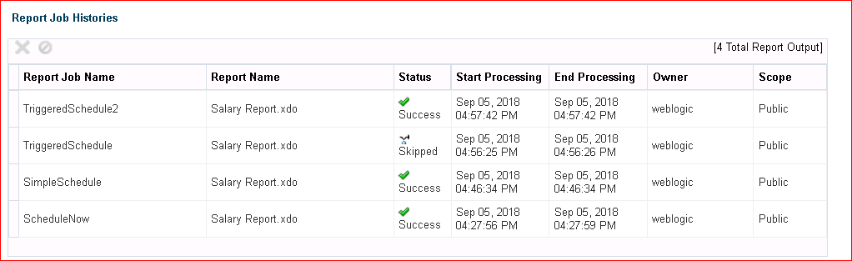

Observe the following:

* + The report job **TriggeredSchedule** has a status Skipped, and not executed, because the trigger parameter returned false.
  + The report job **TriggeredSchedule2** has a status Success, and executed, because the trigger parameter is greater than 2000, and returned true.

## Practice 9-4: Creating a Report for Bursting and Scheduling the Report to Burst to File Location

### Overview

In this practice, you upload a data model, modify the data model to add bursting, create a new report, and then schedule the report to burst to a file location. You also define the bursting properties for a report.

### Tasks

1. From the Catalog, navigate to My Folders > Learn.
2. In the Tasks pane, click **Upload** ( ).



1. In the Upload dialog box, click **Browse**.

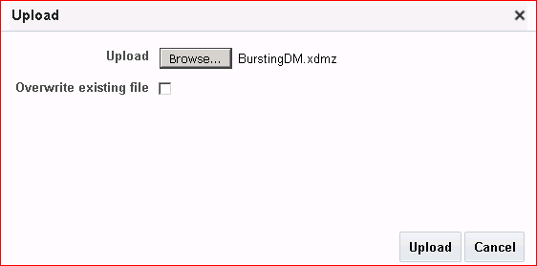

1. Navigate to the MyFiles local folder, and open **BurstingDM.xdmz**. This is a prebuilt data model. Click **Open**.
2. Click **Upload**.
3. The data model appears in the Learn folder. Click **Edit** to edit the data model.

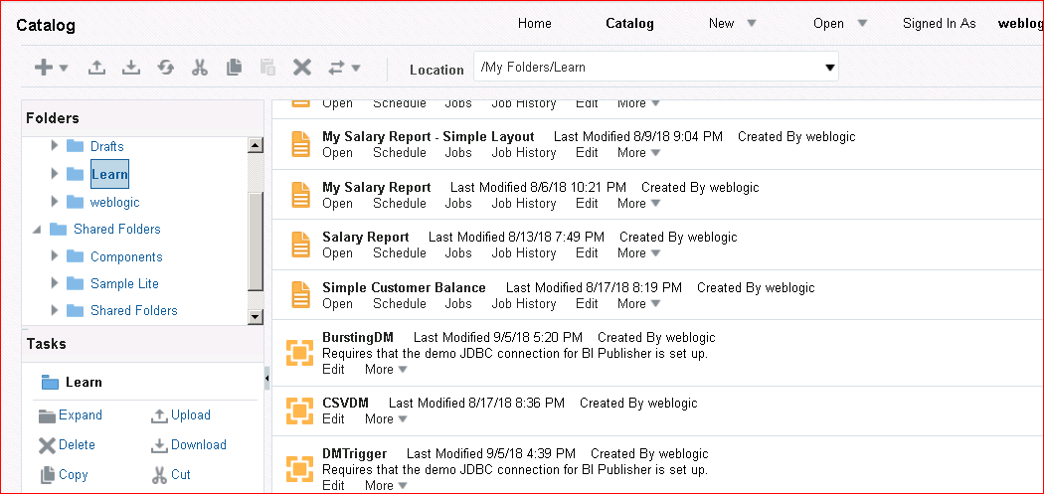

1. The data model is opened in the data model editor. Observe the data source settings and the predefined parameters.

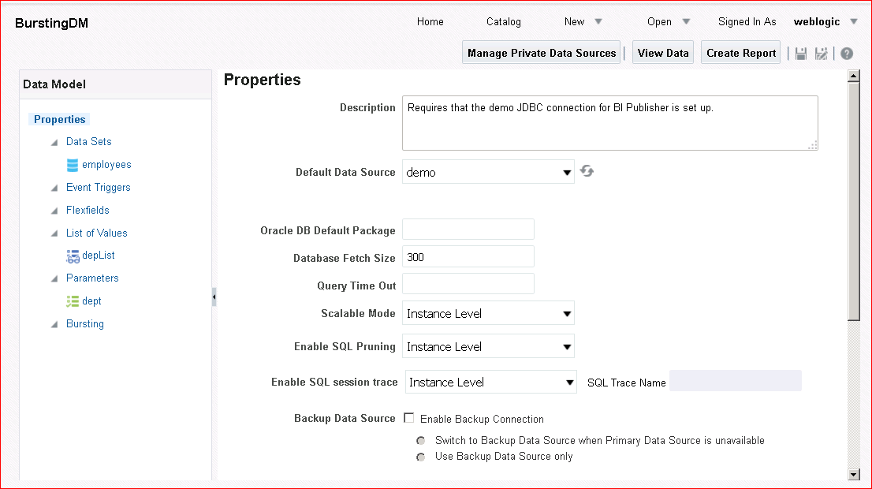

1. Click the **Bursting** node in the Data Model pane. Click the Add icon () in the Bursting pane.

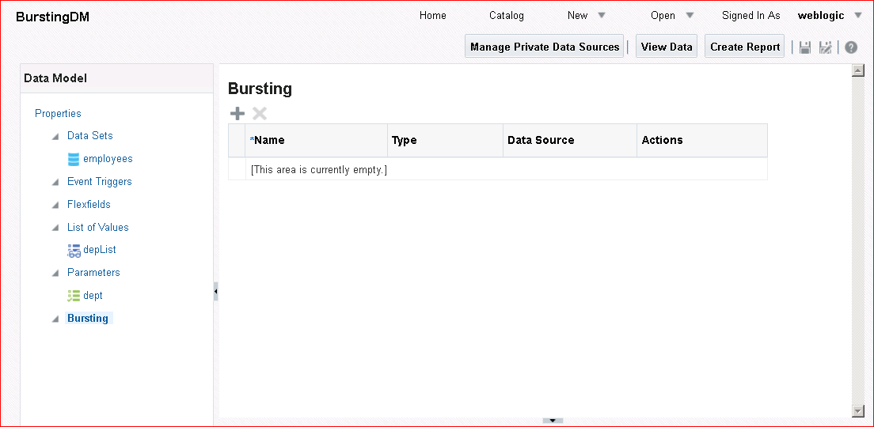

1. The Bursting pane expands and provides an additional definition area.
2. Enter the following information in the two Bursting panes:

|  |  |  |
| --- | --- | --- |
| **Step** | **Attribute or Field** | **Choices or Values** |
| a. | Name | BurstToFile |
| b. | Type | SQL Query |
| c. | Data Source | demo |
| d. | Split By | /ROWSET/ROW/DEPARTMENT_NAME |
| e. | Deliver By | /ROWSET/ROW/DEPARTMENT_NAME |

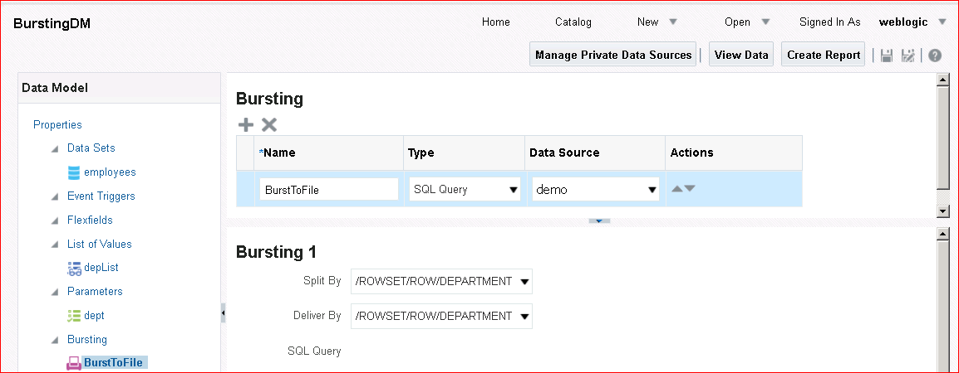

1. In the SQL Query pane below the Query Builder button, copy and paste the following code:

select d.department_name KEY, 'SimpleRTF' TEMPLATE, 'RTF' TEMPLATE_FORMAT, 'en-US' LOCALE,

'PDF' OUTPUT_FORMAT, 'FILE' DEL_CHANNEL, 'D:\Learn' PARAMETER1,

d.department_name || '.pdf' PARAMETER2 from departments d

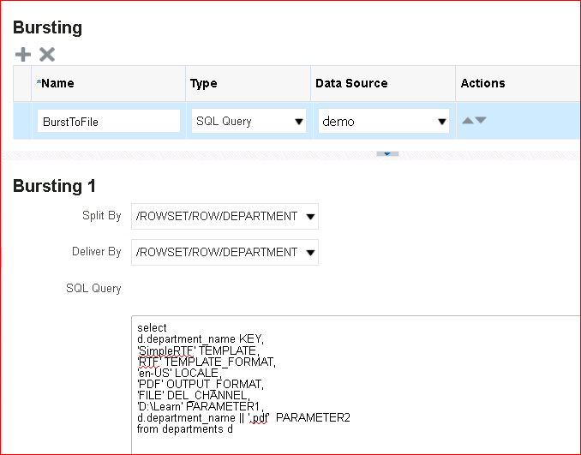

Your output will be delivered to a local directory D:\Learn. Notice that the code shows PDF as the selected output format.

1. View the data output and save the sample data. Save the data model.

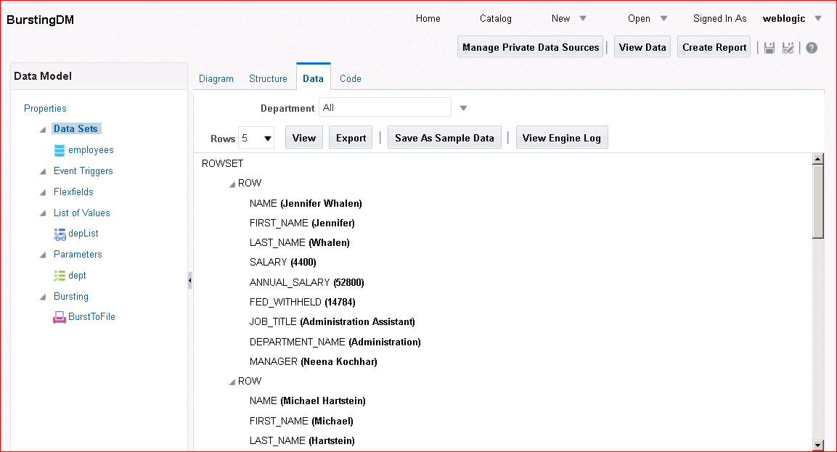

1. Click **Create Report** to create a new report based on this data model.
2. 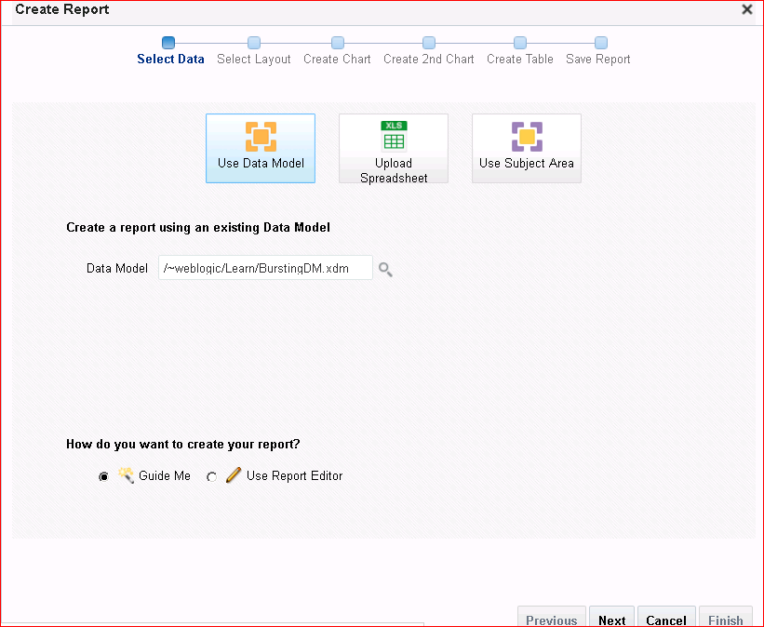The Create Report Wizard is opened with the current data model for bursting. Create the report with the help of the wizard.
3. Save it as “Salary Report for Bursting.”
4. The report is displayed in Report Viewer. Use the Actions menu to edit the report. Click

#### Edit Report.

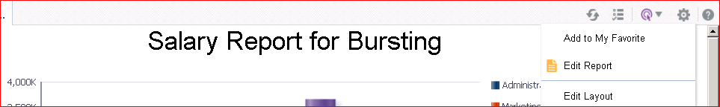

1. The report is displayed in Report Editor.

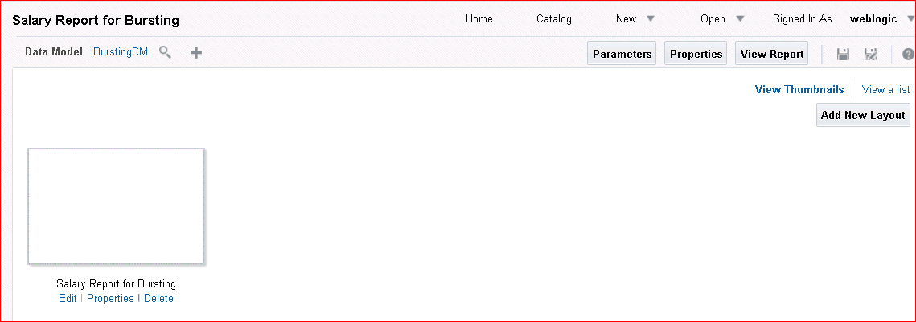

Click the **Properties** link (). The Report Properties dialog box appears.

1. On the **General** tab in the Advanced area, select the **Enable Bursting** check box and ensure that “BurstToFile” is selected from the drop-down list.

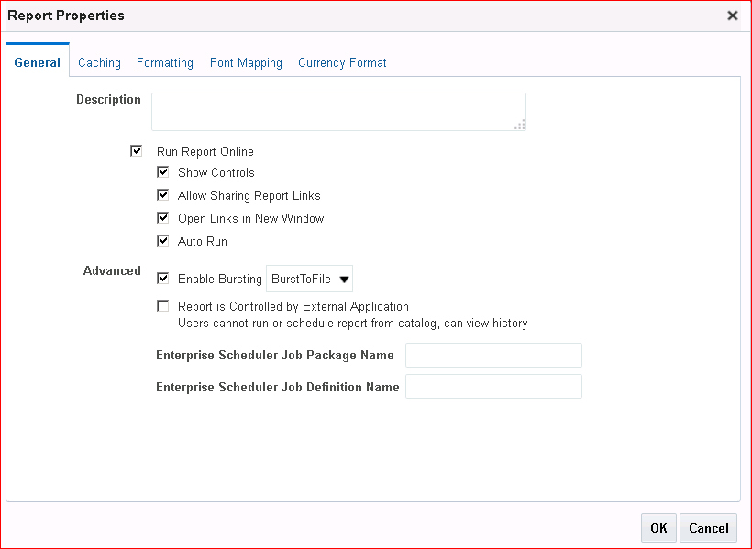

1. Click **OK**.
2. Save and view the report.
3. In the Report Viewer window, click **Schedule** from the actions menu.
4. 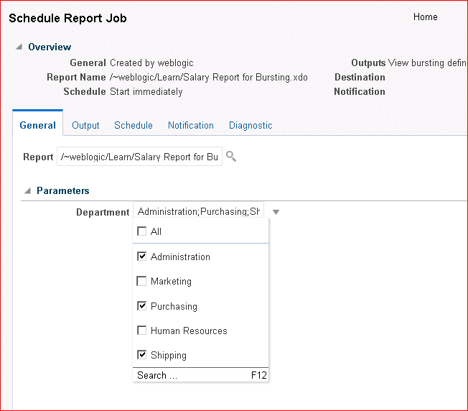The Schedule Report Job window is opened with the report selected. On the General tab, specify the Department parameters for display as Administration, Purchasing, and Shipping.
5. 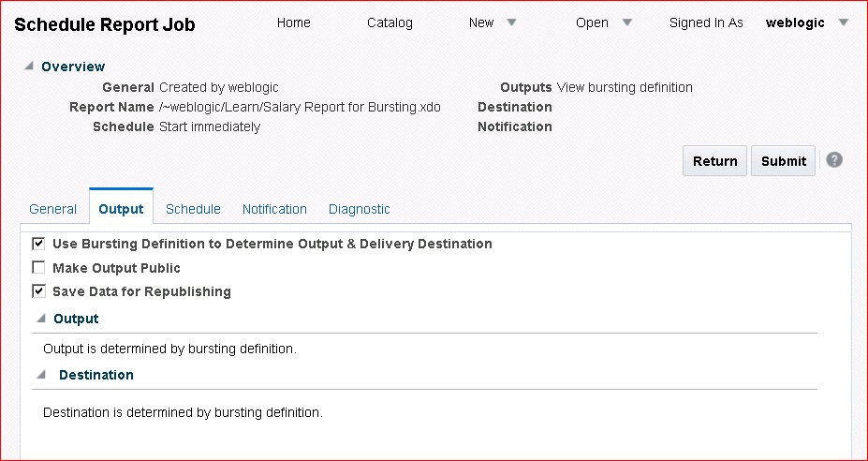On the **Output** tab, select the “Use Bursting Definition to Determine Output & Delivery Destination” check box to enable bursting. Other options for output will be hidden when this check box is selected.
6. On the **Schedule** tab, select the options **Once** and **Run now**.
7. Submit the report.
8. Name the job **BurstingtoFile**. Click **OK.**

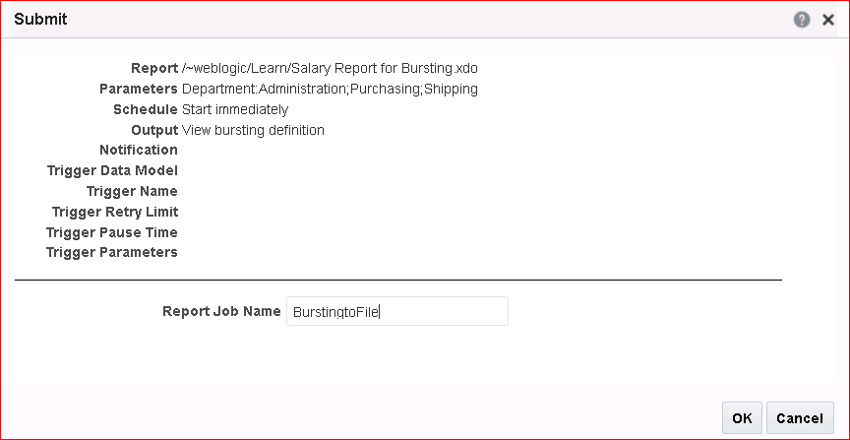

1. After you receive confirmation, open Report Job History from the global header.
2. The Report Job Histories table displays the bursting job submitted.

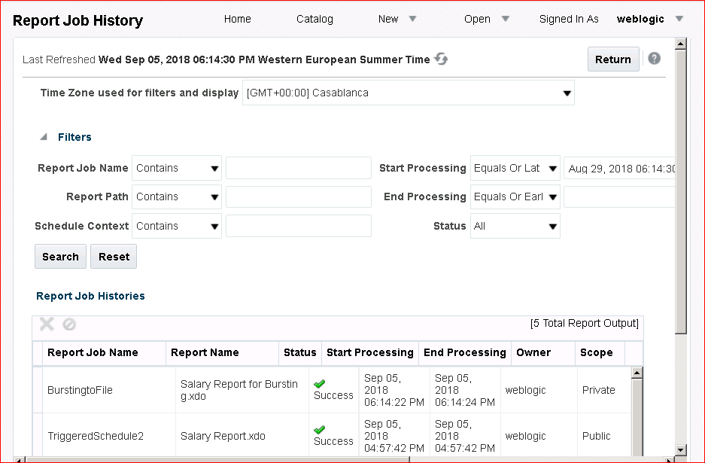

Click the job name **BurstingtoFile** to view the details.

1. The Report Job History details are displayed. Observe that the output has been split by the parameters selected while scheduling the report.

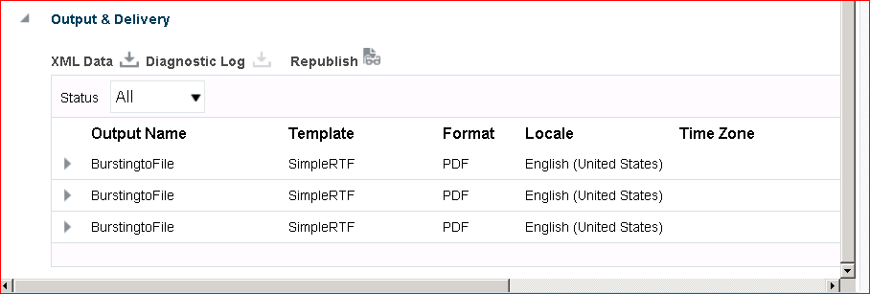

1. 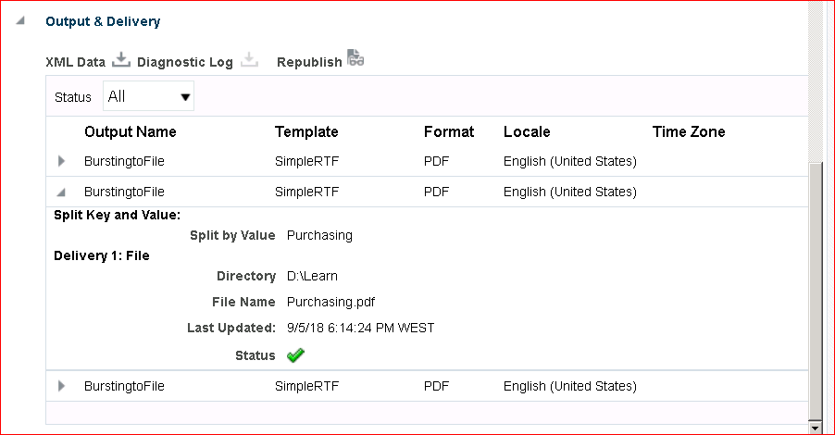Expand any of the BurstingtoFile output names and you will see the PDF file name and location.
2. Navigate to the D:/Temp folder and review the contents.

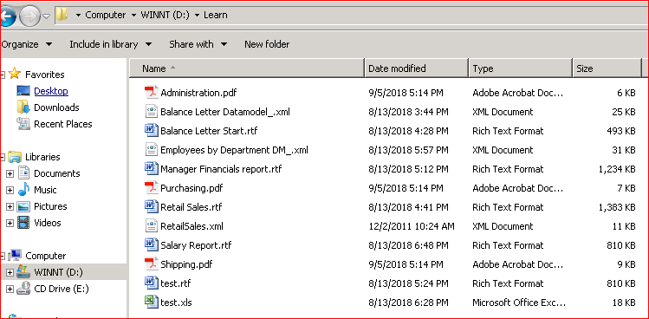

1. 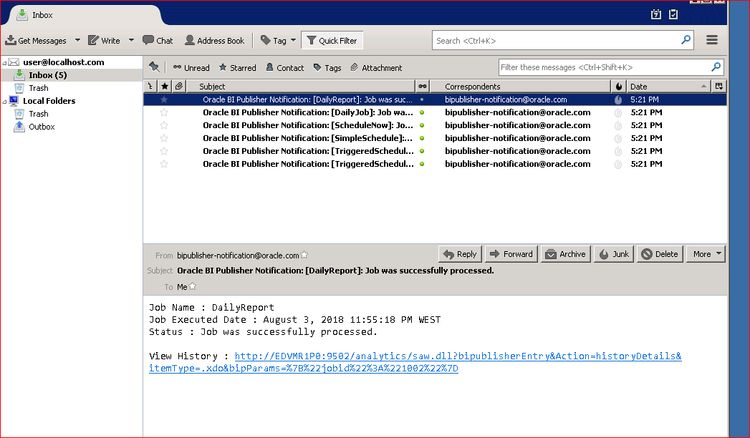If you have time, open Mozilla Thunderbird and check whether you have received the notifications.
2. Click the URL provided in the notification. If necessary, modify the URL by changing the machine name to **localhost**. You will be on the Report Job History page.

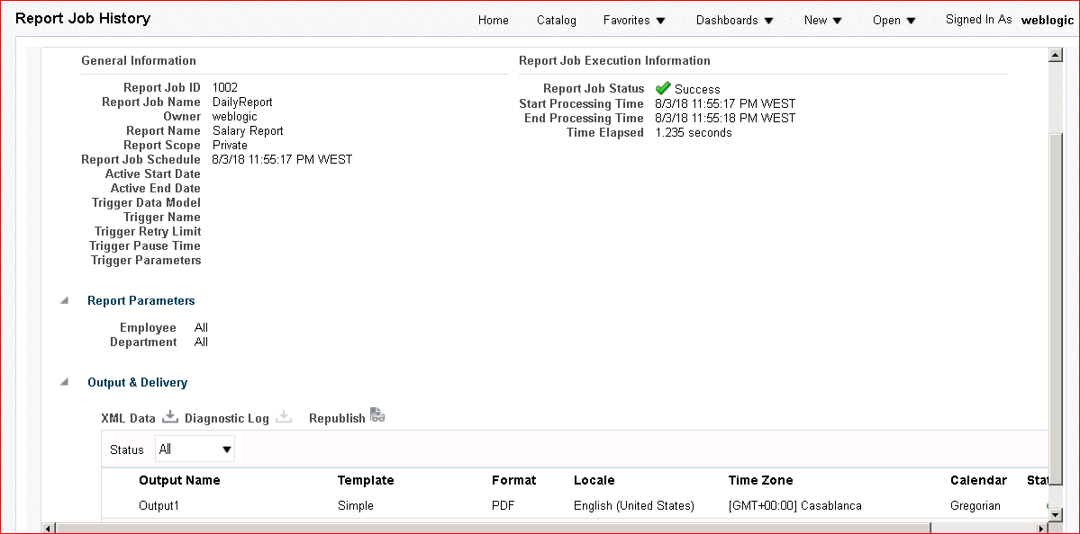

# Practices for Lesson 10: Integrating BI Publisher with Oracle BI Enterprise Edition

## Practices for Lesson 10: Overview

### Goal

To create BI Publisher reports based on BI Server and BI Analysis as data sources, and add the reports to the Oracle BI EE dashboard. You will also export these reports in MS Excel from the dashboard.

### Practices Overview

You begin by reviewing the System Maintenance – Sever Configuration page. You create a report based on a BI Server SQL query. You create an Oracle BI analysis and then create a data model and a BI Publisher report based on the BI analysis. You then add these reports to an Oracle BI EE dashboard and download the data to MS Excel.

### Time

35–45 minutes

## Practice 10-1: Viewing Presentation Catalog Integration Details

### Overview

In this practice, you open the Administration page and view server configuration details.

### Assumptions

You have enabled integration with Oracle BI EE.

### Tasks

1. Log in to BI Publisher.
2. Click Administration > Server Configuration, located in the System Maintenance grouping.

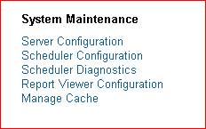

1. The System Maintenance > Server Configuration page appears. As mentioned in the lesson, this page allows you to configure BI Publisher to use the Presentation Catalog. Review the details, but **do not** make any changes.

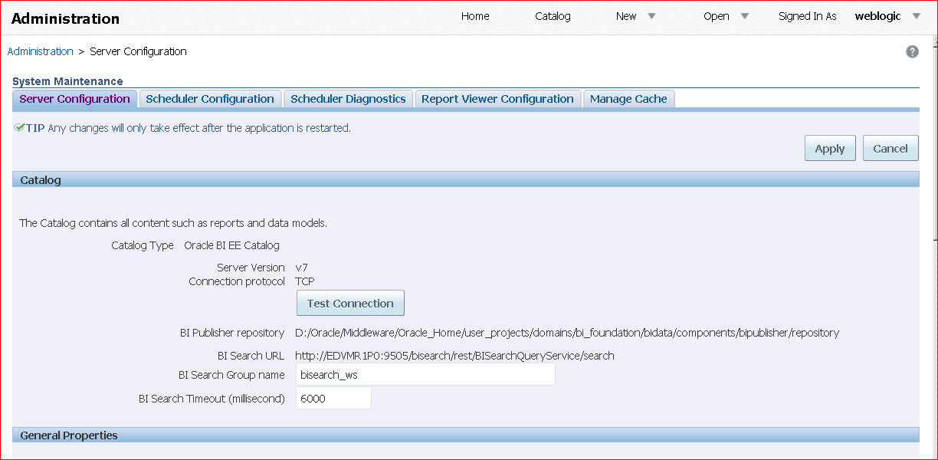

1. Click **Cancel**.

## Practice 10-2: Creating a Data Model and Report Based on an Oracle BI Server SQL Data Set

### Overview

In this practice, you create a data model and report from an Oracle BI Server SQL data set.

### Tasks

1. Log back in to BI Publisher and then click New > Data Model.
2. In the Data Model pane, select **Data Sets**, and then click **Data Sets > SQL Query**.

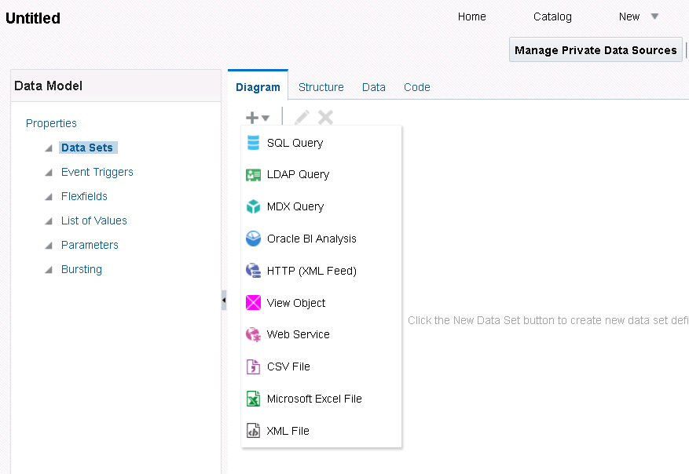

1. In the New Data Set – SQL Query dialog box, enter **NewSet** in the Name text box.

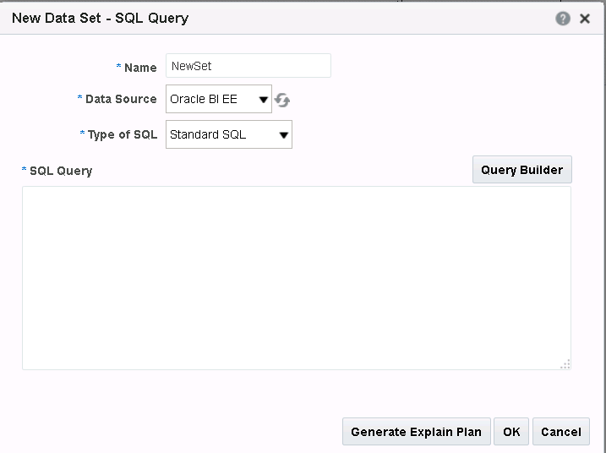

1. Select **Oracle BI EE** as the Data Source. Observe that you have selected Oracle BI EE as the data source unlike the usual **demo** or the private JDBC connections that you have used earlier.
2. 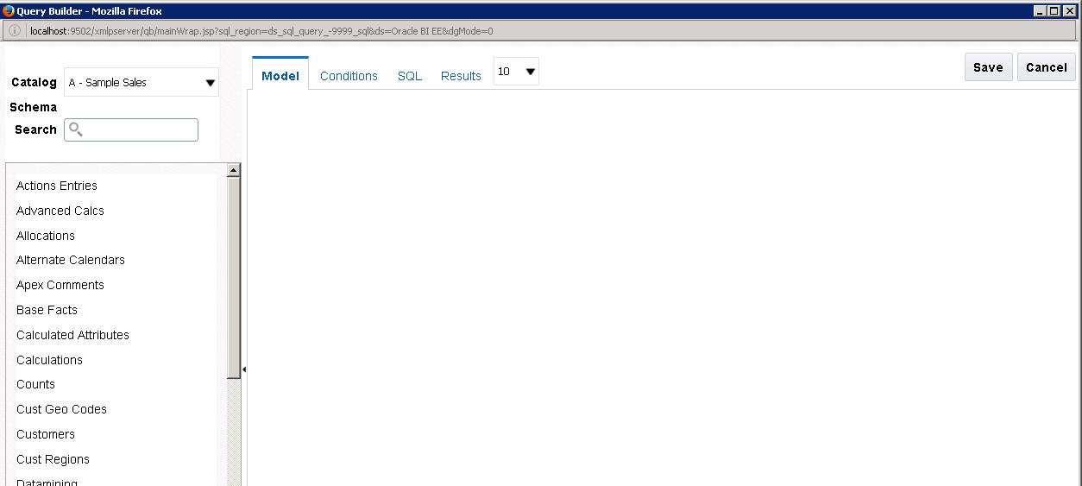Click **Query Builder**. The Query Builder window opens with the schema available for the selected data source.
3. In Query Builder, select the following tables: **Time**, **Orders**, **Products**, **Orders Dates**, and

#### Base Facts.

1. Select the following columns from each table:

|  |  |  |
| --- | --- | --- |
| **St ep** | **Table Name** | **Column** |
| a. | **Time** | Per Name Qtr |
| b. | **Orders** | Order Status |
| c. | **Products** | Product |
| d. | **Orders Dates** | Order Date |
| e. | **Base Facts** | Billed Quantity |
| f. | **Base Facts** | Discount Amount |

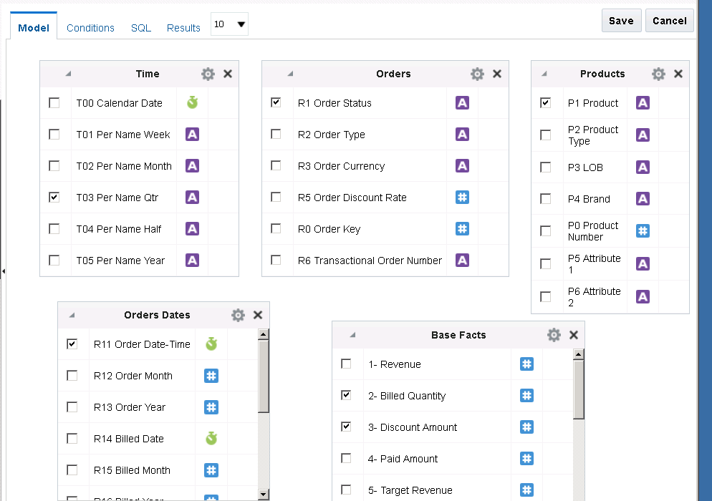The Model pane should look like this:

Note that you do not have to create any joins, because they are created in OBI EE.

1. 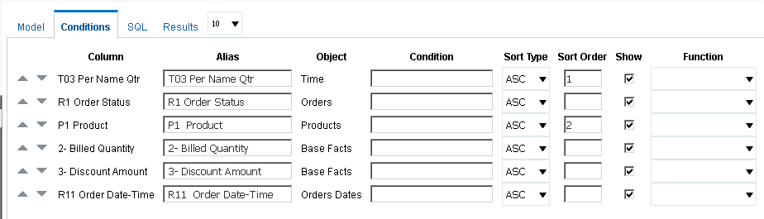Click **Conditions**. Sort first on **Per Name Qtr** and then on **Product**.
2. 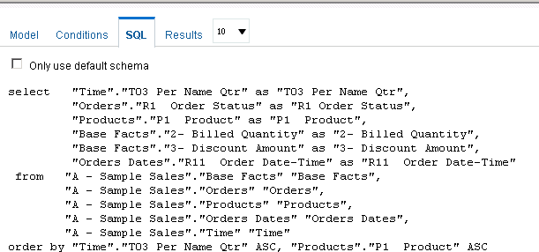Click **SQL** to view the code.
3. 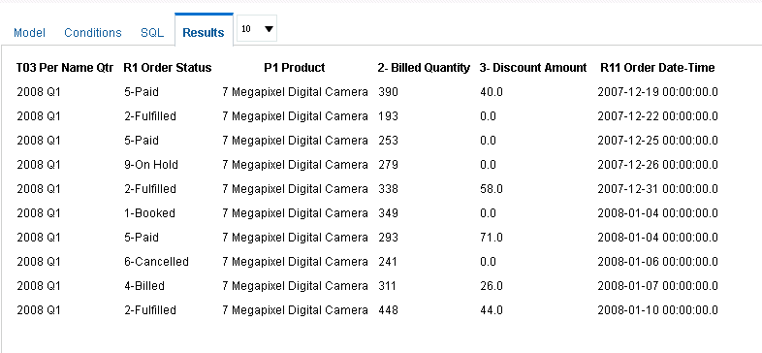Click **Results**. The results appear.
4. Click **Save**.
5. Click **OK** in the New Data Set – SQL Query dialog box. The new data set appears in the data model pane.

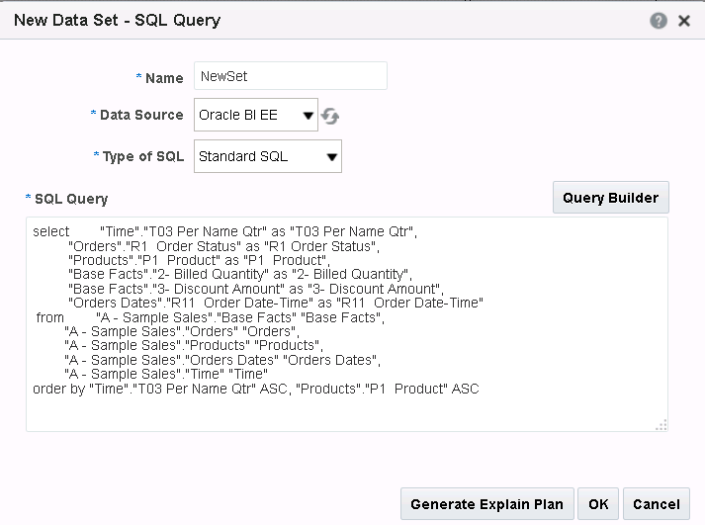

1. Click the Structure tab to change the display names for the data elements. Change the display names as given below:

|  |  |  |
| --- | --- | --- |
| **St ep** | **Data Source Column Name** | **Display Name** |
| a. | **PER NAME QTR** | Qtr |
| b. | **ORDER STATUS** | Order Status |
| c. | **PRODUCT** | Product |
| d. | **BILLED QUANTITY** | Billed Qty |
| e. | **DISCOUNT AMOUNT** | Disc Amt |
| f. | **ORDER DATE** | Order Date |

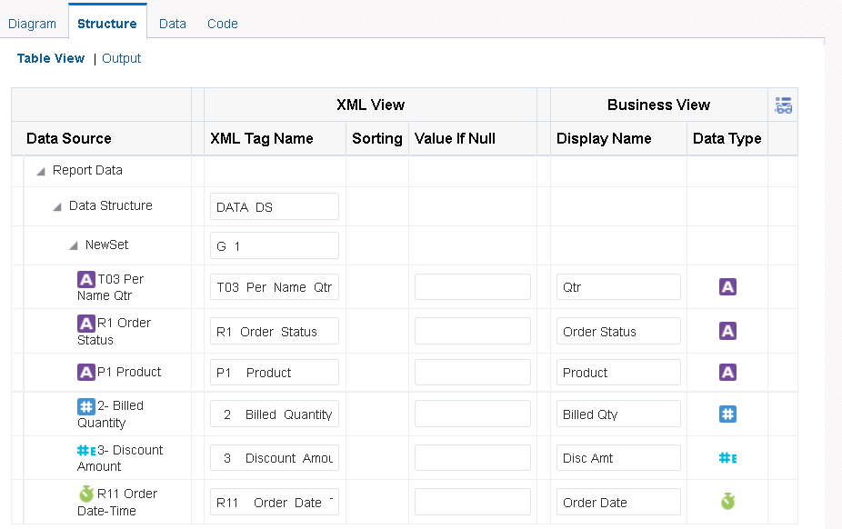The Structure tab should look like this:

1. Click the Data tab to view the data and select 5 Rows, and click View.

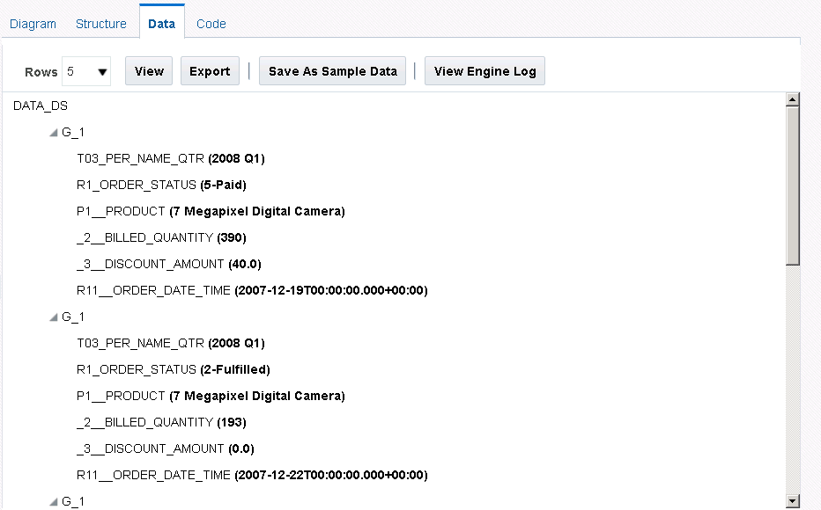

The data is displayed in a tree format. Click the Save As sample data. Save the data model

as **Fulfillment** in the folder My Folders/Learn.

1. Click **Create Report** to create a new report from this data model.
2. 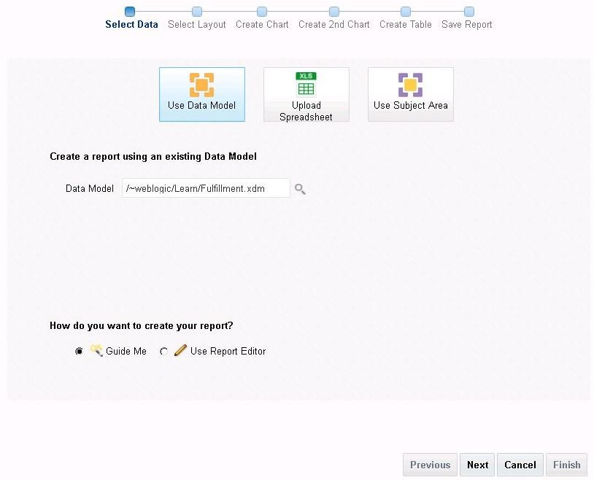The Create Report Wizard is opened.
3. 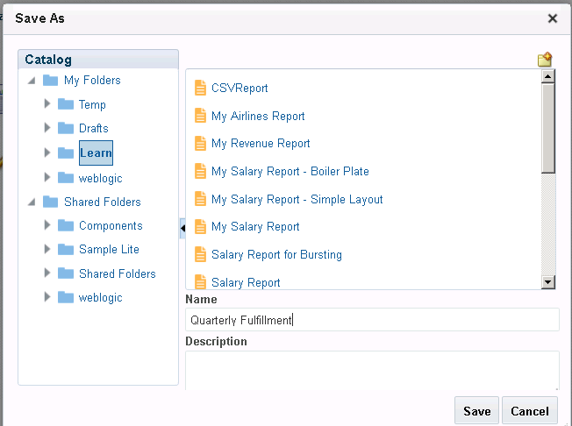Follow the steps in the wizard to create the report and save the report as Quarterly Fulfillment in My Folders/Learn.
4. 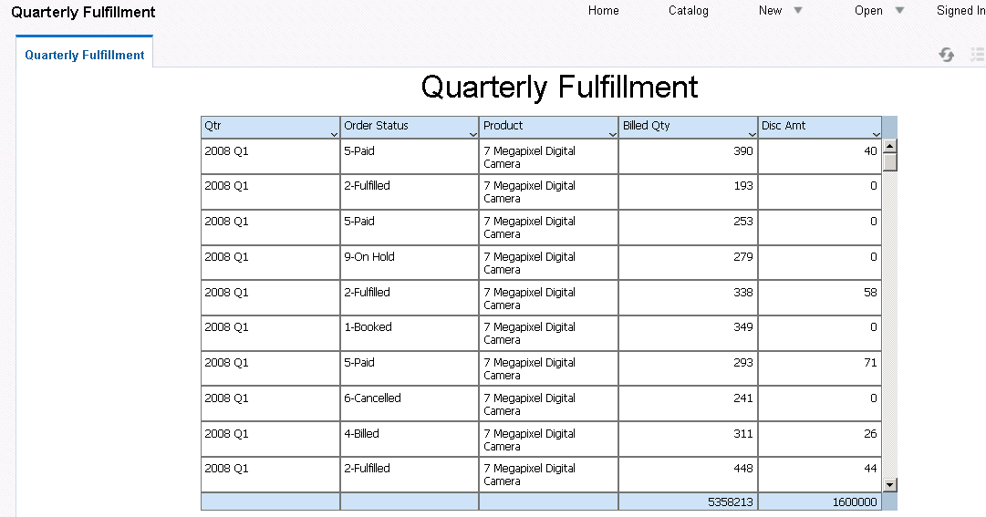After saving, the report is displayed in the Report Viewer.

## Practice 10-3: Creating an Oracle BI Analysis

### Overview

In this practice, you create a simple sales analysis by using Oracle BI Analytics, the analysis component of Oracle BI EE.

### Assumptions

You have enabled integration with Oracle BI, allowing you to access the Presentation Catalog. This allows you to create an Oracle BI analysis as a data source.

### Tasks

1. Open Oracle BI EE. Enter the URL for Oracle BI EE in a browser window by using the following format:

http://<hostname>:<port>/xmlpserver/. Example: http://localhost:9502/analytics/. Your instructor can provide you with the correct URL.

1. Sign in. On the sign-in screen for Oracle BI EE, enter the username and password for a user with BI Administrator privileges, as given by your instructor.

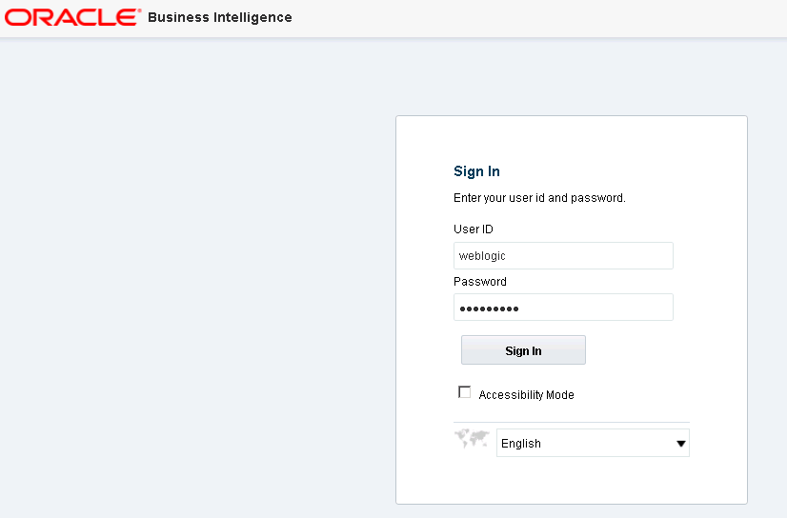

1. 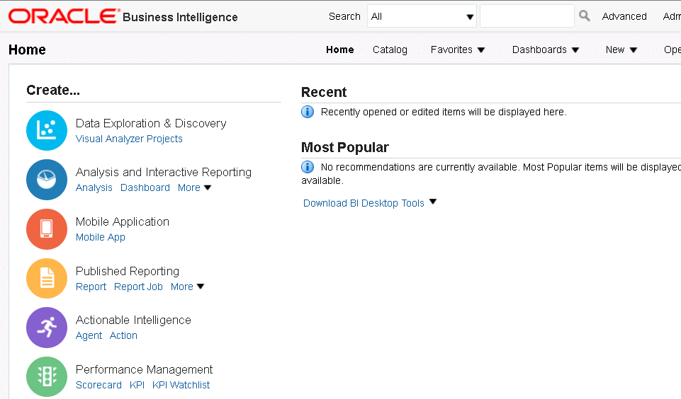Click **Sign In**. When you sign in, the Home page or your personal dashboard page, My Dashboard, appears. Oracle BI EE has many of the same features that you use in BI Publisher, such as the global header or the Create section.
2. Click the **Home** link on the global header and then click **New > Analysis**.

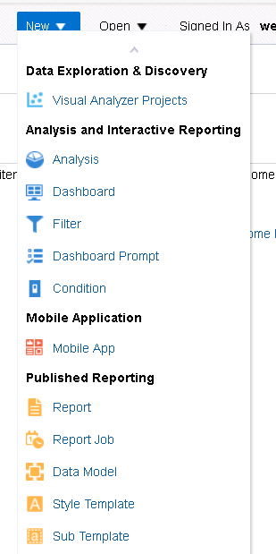

1. From the Select Subject Area dialog box, click **Sample Sales Lite**. A subject area contains folders, measure columns, attribute columns, hierarchical columns, and hierarchy levels that represent information about your organization’s business.

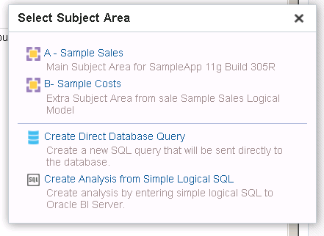

1. The Analysis Editor appears. You build your analysis by using the Criteria tab, and you review your analysis on the Results tab.

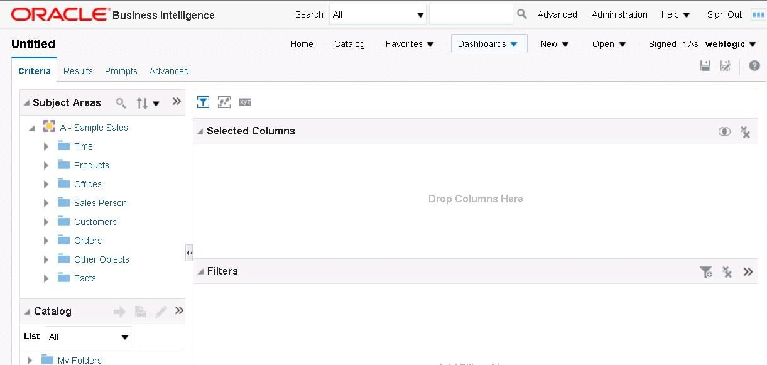

1. To build your query, you select columns from the Subject Area pane. Expand the **Offices**

table.

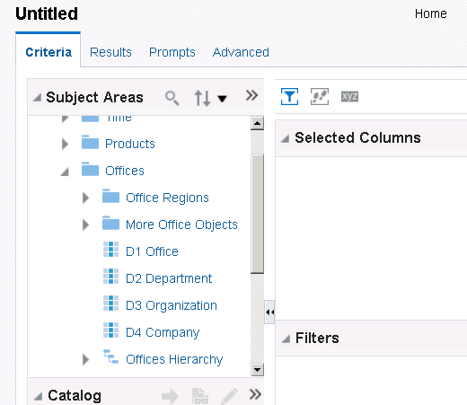

1. Double-click the **Company** column to add the column to the Selected Columns pane. Company appears in the Selected Columns pane.

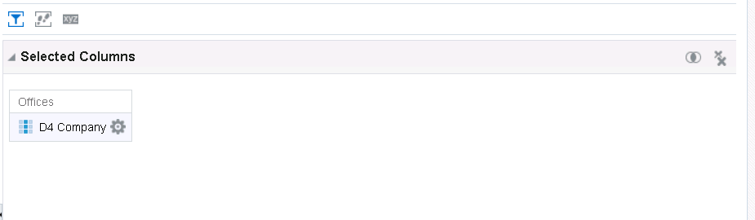

1. Expand the **Time** table.
2. Double-click the **Per Name Year** column. Per Name Year appears in the Selected Columns pane.

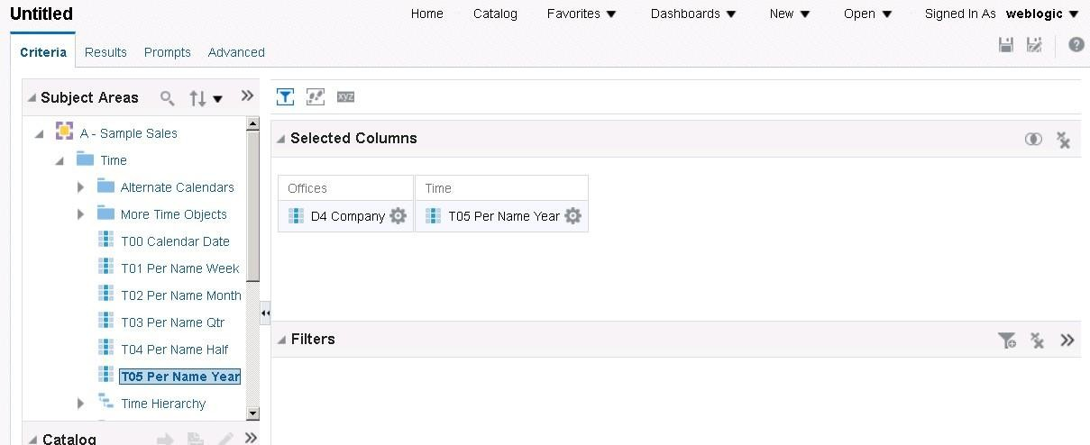

1. Similarly, expand the **Products** table and add **Product** and **Product Type**.
2. 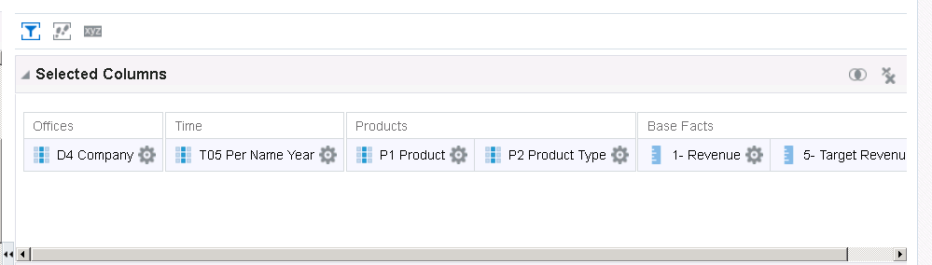Expand the **Facts -> Base-Facts** table and add **Revenue** and **Target Revenue**. The Selected Columns pane should look like this:
3. 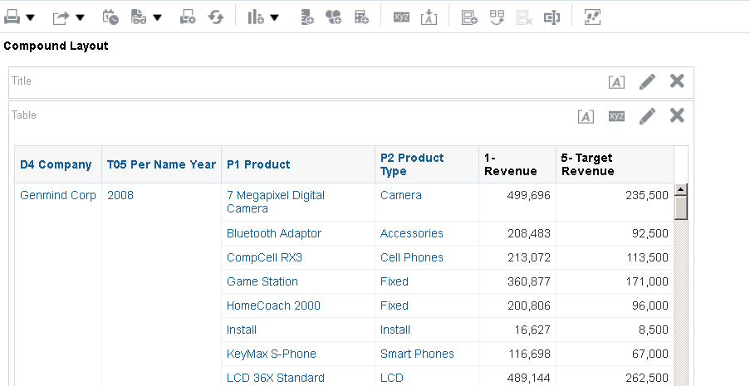Click the **Results** tab. By default, a compound layout, containing a Title view and a Table view, is created for your analysis.

**Note:** If you add a hierarchy level or hierarchical column when building the analysis, the default compound layout will contain a Pivot Table view. Pivot tables are beyond the scope of this practice.

1. Click **Delete** () to remove the Title view.



Observe that although you have removed the Title view from the Compound Layout, it is still available in the Views pane.

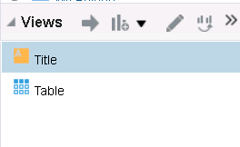

1. Save the analysis. Click **Save** (). Save the analysis as Company Product Revenue by Year in the Learn folder. Click **OK.**

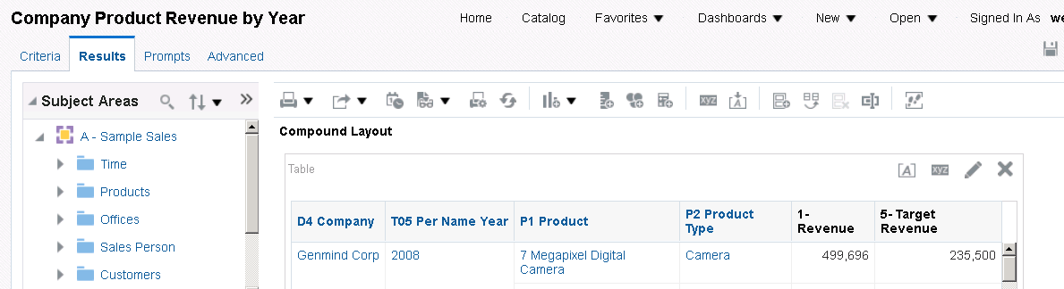The name of your analysis appears on the tab.

1. Click **Sign Out.**

## Practice 10-4: Creating a Data Model and Report Based on an Oracle BI Analysis

### Overview

In this practice, you create a data model and report from an Oracle BI analysis data set.

### Assumptions

You have successfully created the Oracle BI analysis. You will use this analysis to create a data set for this practice.

### Tasks

1. Log back in to BI Publisher
2. Click **New > Data Model**.
3. In the Data Model pane, select **Data Sets** and then click Data Sets > Oracle BI Analysis.



1. In the New Data Set – Oracle BI Analysis dialog box, enter Brand in the Name text box.
2. Click the **Search** icon (  ). Navigate to the \My Folders\Learn and select **Company**

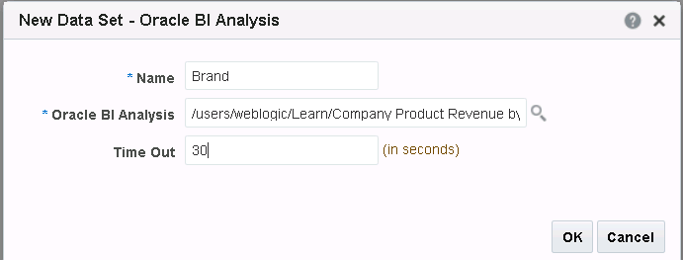**Product Revenue by Year** from the Oracle BI Catalog dialog box.

1. Enter **30** in the Time Out text box.
2. 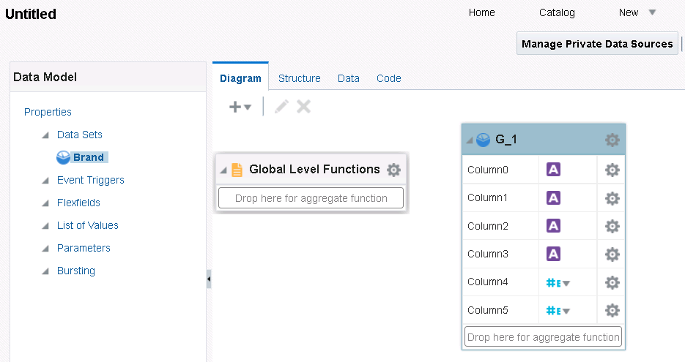Click **OK** in the New Data Set – Oracle BI Analysis dialog box to return to Data Model Editor.
3. 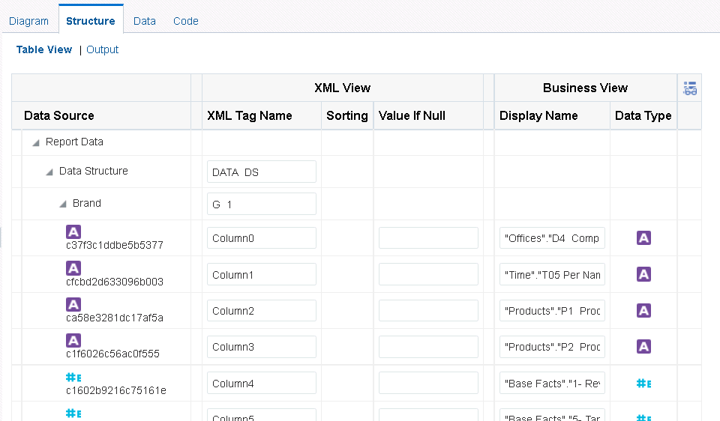After you have added the Oracle BI analysis as your data set, the data set name appears in the Data Model pane. Column names for the data set are inherited from Presentation Services and are not meaningful to the end user because they appear as a combination of column type and column name (for example, Column0). Edit the columns to display names that are more meaningful. You can use the Structure view to edit the XML tags and display names. The Structure view has two modes: Table View and Output. Table View displays element properties in a table and enables you to update XML element alias names, presentation names of the elements, sorting, null values, and reset options.

The Output view provides a clear view of the XML structure that will be generated. The Output view is not updatable.

1. Click the **Data** tab. This opens the Data view for the data set. Select the required number of rows for display and click View to see the data associated with this analysis.

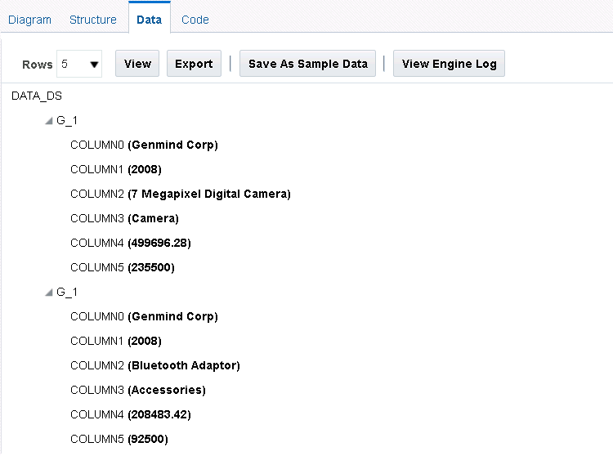

1. After the data is displayed, click Save As Sample Data. You will receive a confirmation. Close the confirmation message.
2. 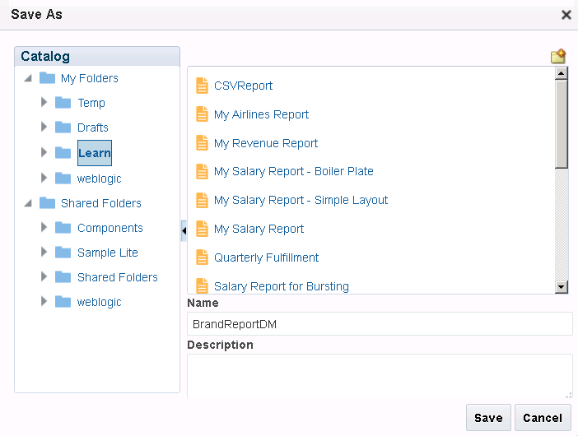Save the data model as **BrandReportDM** in the **Learn** folder.
3. Click Create Report. This opens the Create Report Wizard.
4. 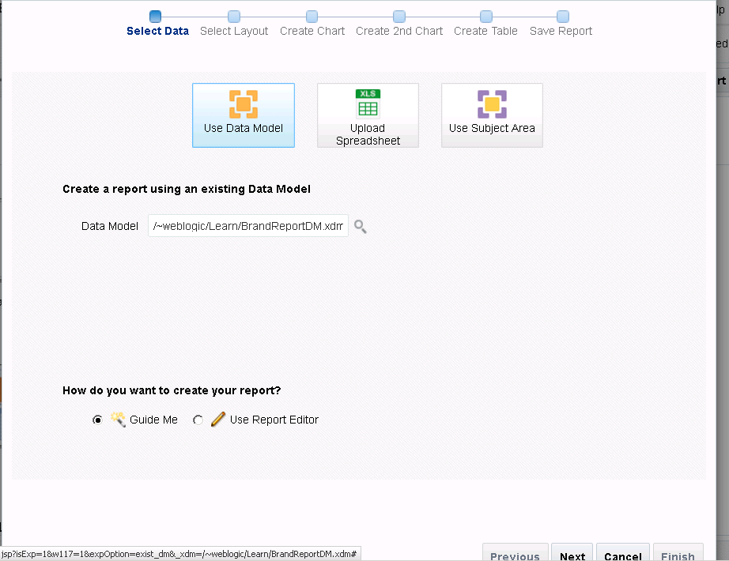Observe that the Create Report Wizard is selected with the data model that you created with the analytic data source. Select the Guide Me option to create a simple report.
5. Complete the wizard steps to create the report.
6. Save the report as **Brand Revenue** in the **Learn** folder.
7. 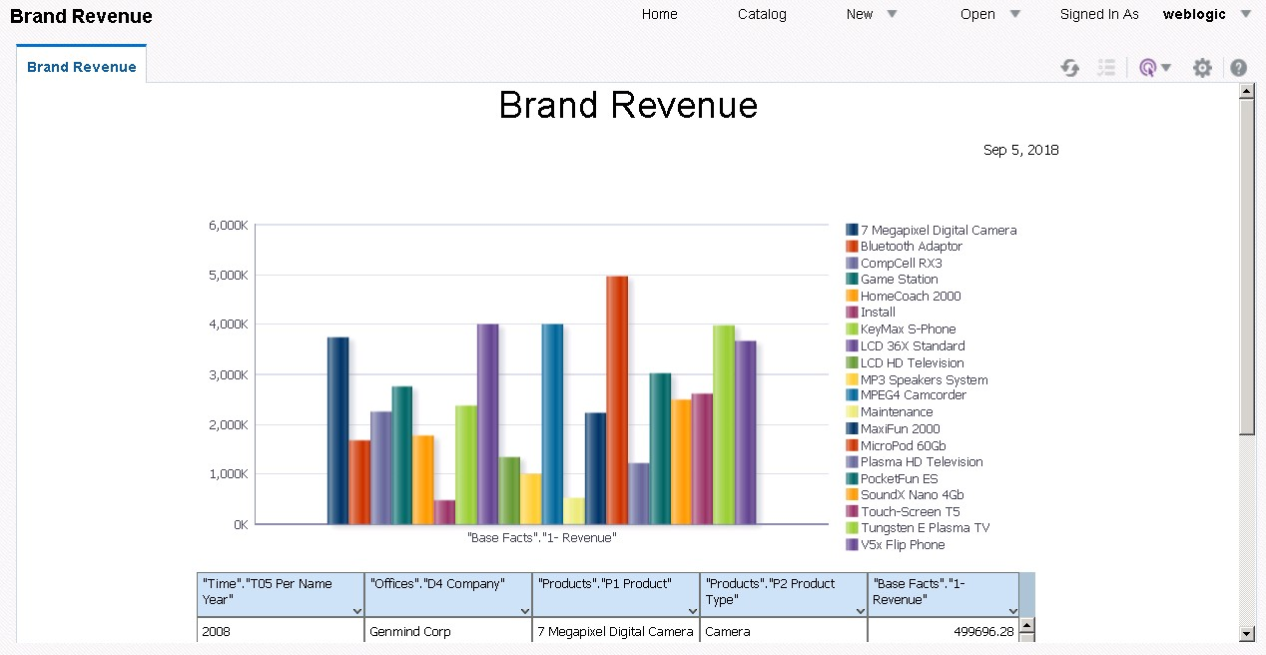Because you chose the View option while saving the report, it will be opened in Report Viewer.

## Practice 10-5: Adding a BI Publisher Report to an Oracle BI EE Dashboard

### Overview

In this practice, you add a BI Publisher report created from an Oracle BI analysis and BI Server data set to an Oracle BI EE dashboard.

### Assumptions

You have successfully created the BI Publisher report in the previous reports. You will add

these reports to the Oracle BIEE dashboard.

### Tasks

1. Open a new browser window. Log in to Oracle BI EE. (Enter http://localhost:7001/analytics in the address bar.)
2. Enter your credentials in the User ID and Password text boxes in the Oracle BI EE Sign In window and click **Sign In**.
3. Click Dashboard and select My Dashboard.

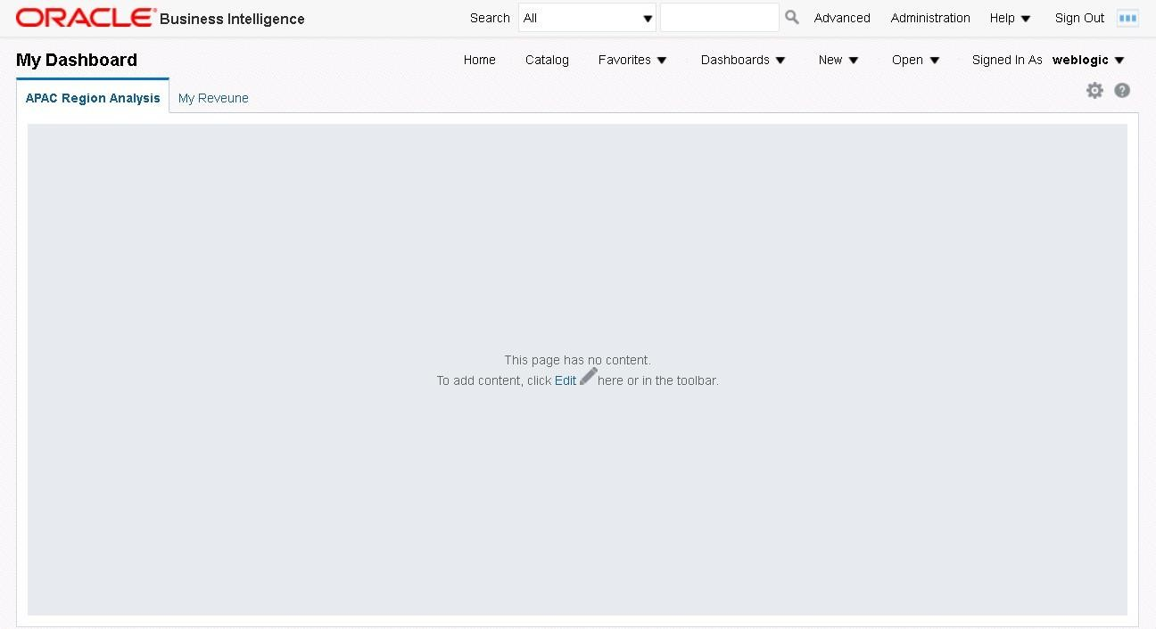

1. 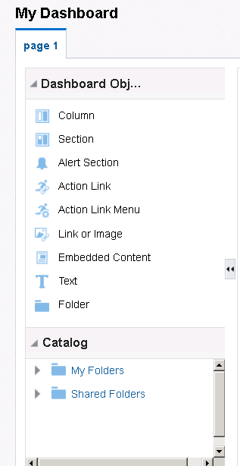Click **Page Options** ( ) **> Edit Dashboard** or click **Edit** ( ) to edit the dashboard. The Dashboard Editor appears. The Dashboard Editor is composed of three areas: the Dashboard Objects pane, Catalog pane, and the work area (Drop Content Here).
2. When you open a new dashboard, a new page, named page 1, is available by default. You can either rename this page or add a new page. In this example, you add a new page. Click the Add a New Page icon to add a new dashboard page My Revenue.

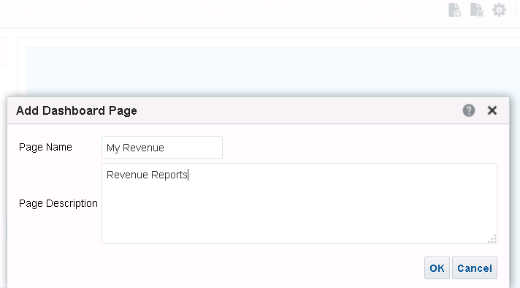

Enter the name My Revenue for the new dashboard page and click **OK.**

1. Drag and add column element and sections to the new My Revenue page.

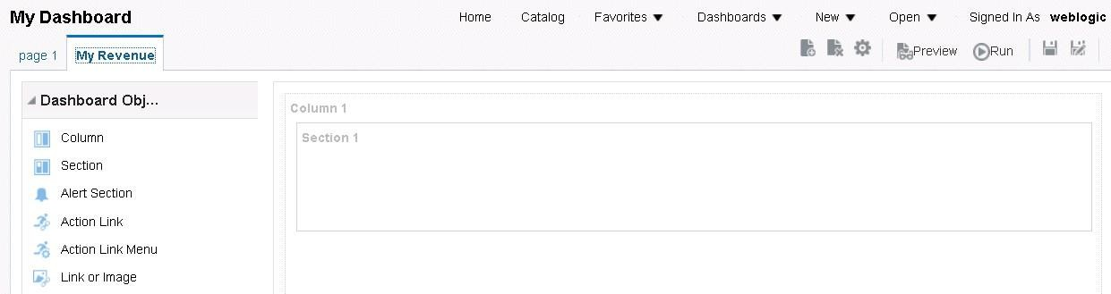

1. In the Catalog pane, navigate to My Folders > Learn and select the report Brand Revenue, which you created in the previous practice.

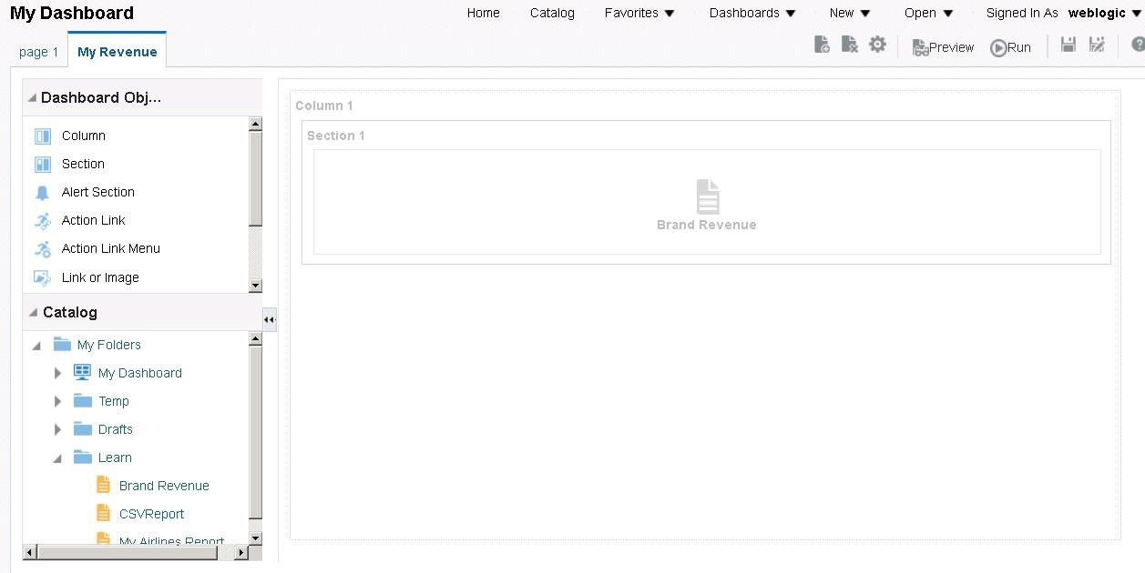

1. Drag it to the Dashboard Editor canvas on the right. You can also add any other relevant reports. The reports appear on the My Revenue page.
2. Click Save.
3. Click Run.

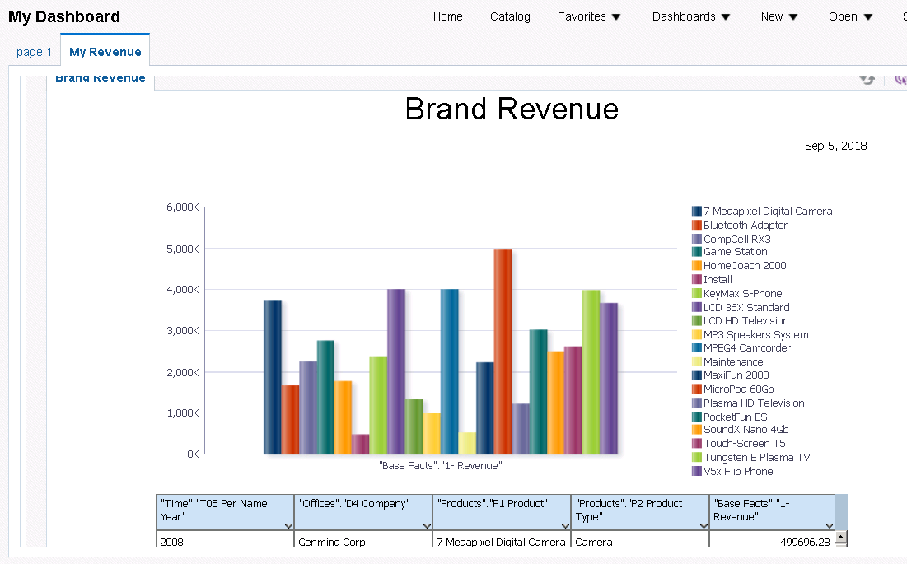The report is displayed in the dashboard.

1. Click **Page Options** ( ) **> Edit Dashboard** or click **Edit** ( ) to edit the dashboard.

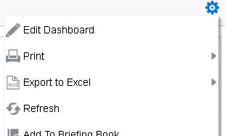

1. Select **Quarterly Fulfillment**, the report you created earlier, and drag it to the dashboard.
2. 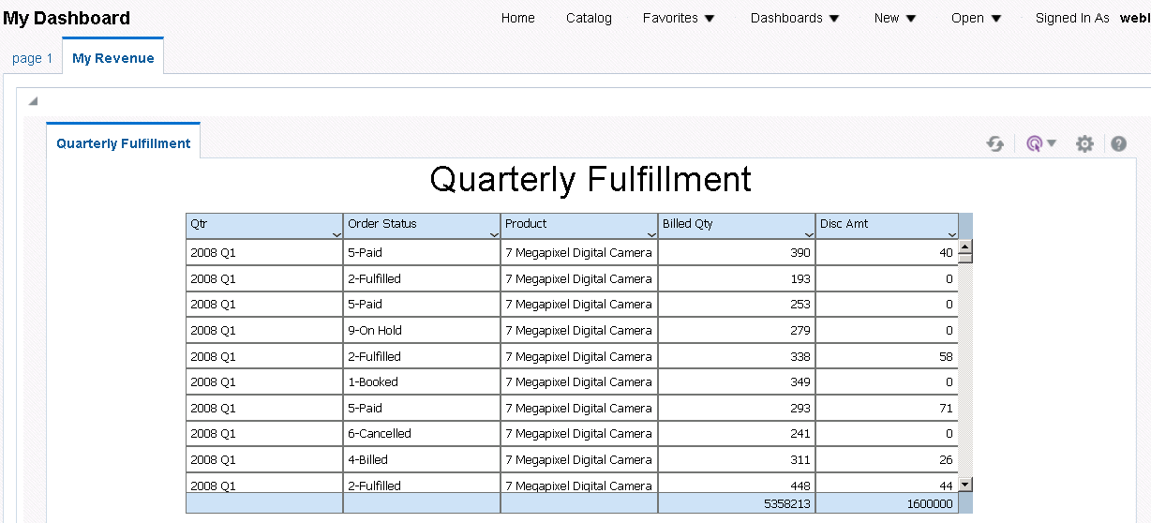Click **Save** and click **Run** to open My Dashboard to view your report. The reports are displayed in the dashboard.
3. When the report is displayed in the dashboard, use the Action menu to export the report data to an MS Excel file. Select Export>Excel (*.xlsx).

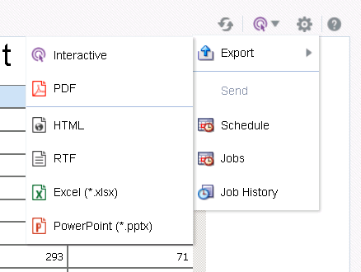

1. Open or save the file in your local folder to open it.

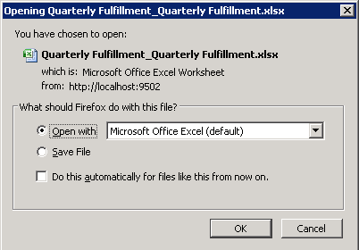

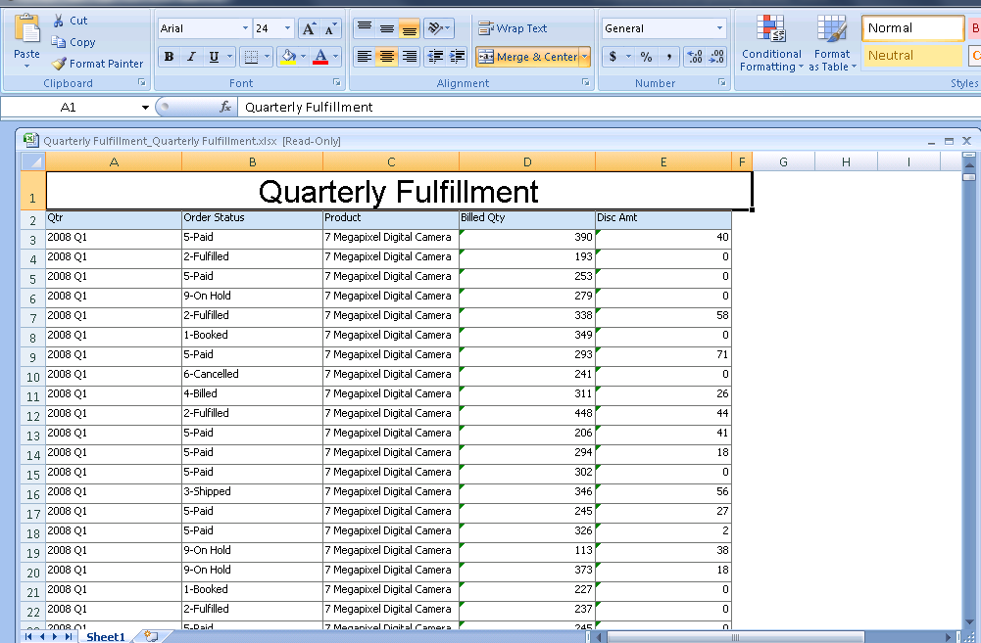The report data is exported to Excel format. Select the downloaded file to open it in MS Excel.

# Practices for Lesson 11: Creating Data Models and BI Publisher Reports Based on Other Data Sources

## Practices for Lesson 11: Overview

### Goal

To create BI Publisher reports based on an XML file and a CSV file

### Practices Overview

You create two BI Publisher reports. The first report is based on an XML file and the second is based on a CSV file.

### Time

15–25 minutes

## Practice 11-1: Creating a BI Publisher Report Based on an XML File

### Overview

You can use an XML data file stored in a directory that has been set up by your administrator as a data source; however, no metadata is available from file data sets. When you set up data sources, you define a file directory as a data set. You place XML documents in the file directory to access directly as data sources for your reports.

### Assumptions

To perform the tasks in this practice, you must have access to the demo files provided with BI Publisher. This demo file is generally found in the

*<drive>:\<FusionMdleWare_home>*user_projects\domains\bifoundation_doma in\config\bipublisher\repository\DemoFiles directory.

### Tasks

1. Log in to BI Publisher.
2. Click New > Data Model.

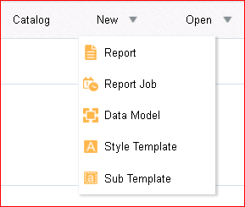

1. In the Data Model pane, select **Data Sets**, and then click Data Sets > XML File.

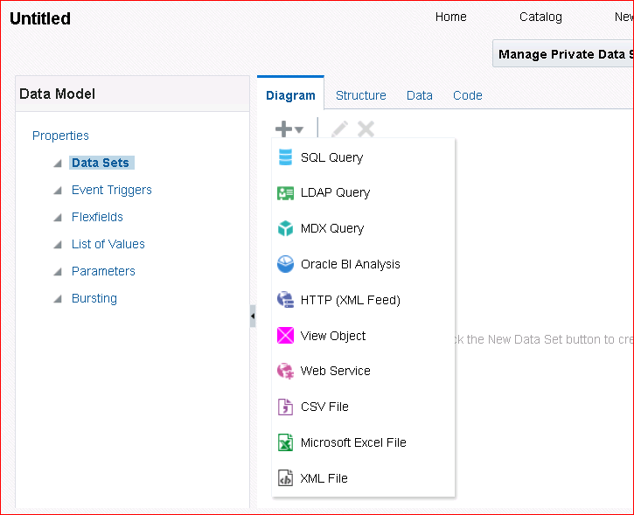

1. 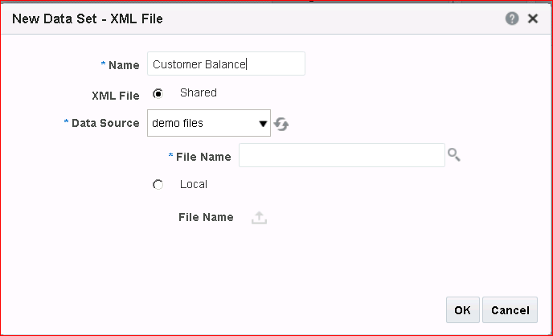In the New Data Set – File dialog box, enter **Customer Balance** in the Name text box.
2. Click the **Search** icon (  ) and select **Balance.xml** in the webpage dialog box.

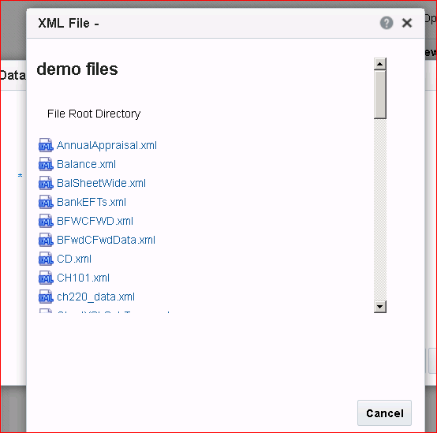

1. Click **OK**.
2. The new data set appears in the Data Model pane. Click **Data** to view the output data.

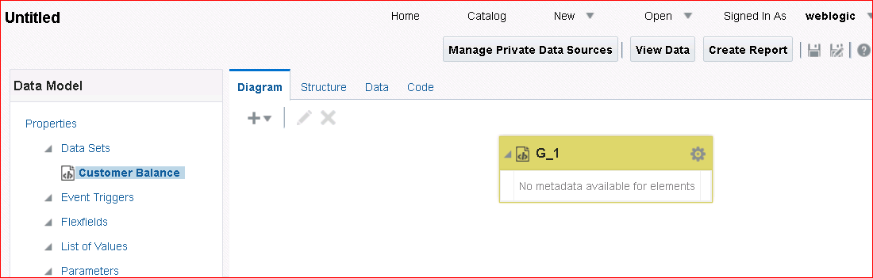

1. Click View to see the data.

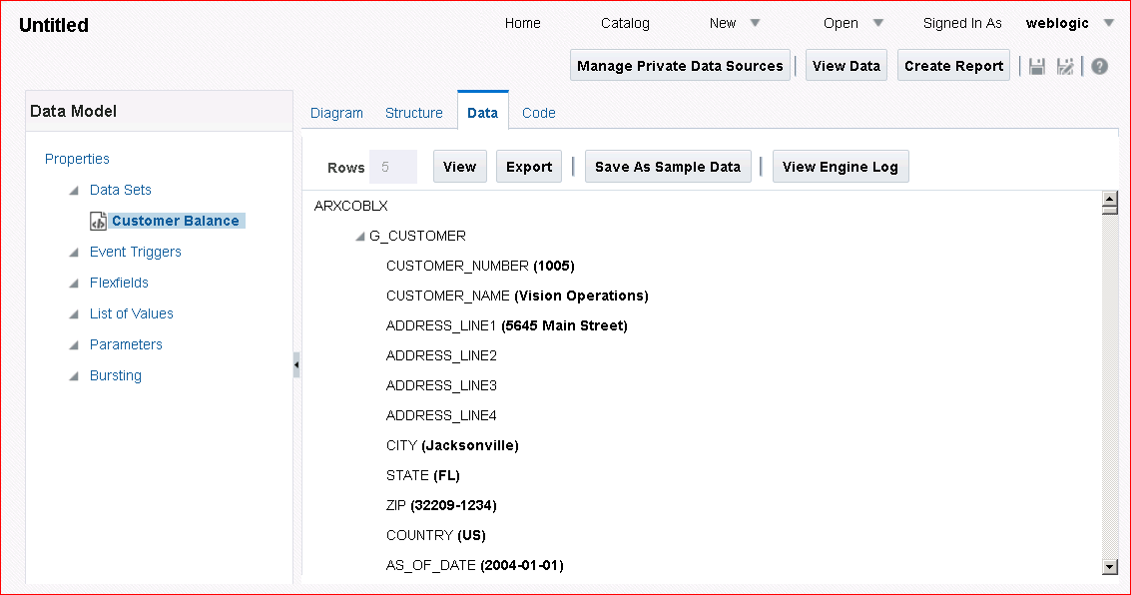

Save the sample data and then save the data model **XMLDM** in the **Learn** folder.

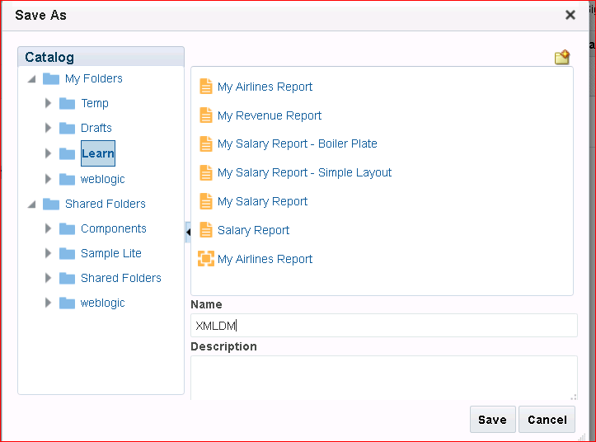

1. Click **Create Report**.

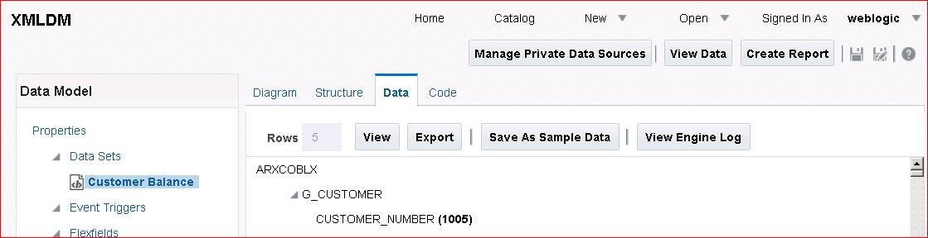

1. The Create Report Wizard is opened. Observe that the data model that you just created is selected.

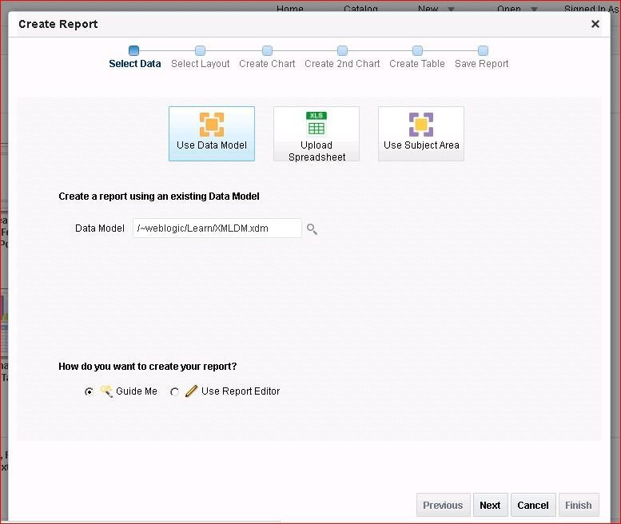

1. Click Next to select the layout as shown below. Select a simple layout with a table.

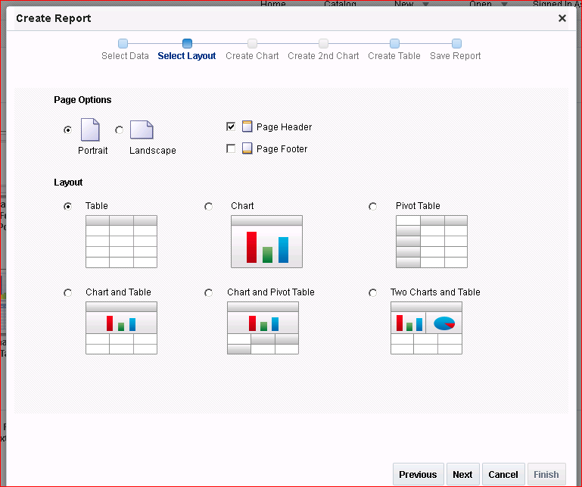

1. Click Next.
2. Drag the fields from the data source to create a table as shown below.
3. Select the fields as given below.

|  |  |
| --- | --- |
| **No** | **Fields** |
| a. | Customer Number |
| b. | Trx Number |
| c. | Transaction Date |
| d. | Trans Amount |
| e. | Trans Amount Remaining |

1. The table will look like this.

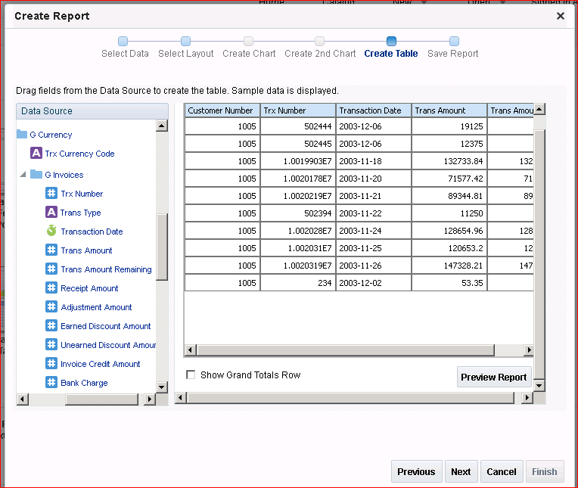

Deselect the Show Grand Totals Row check box.

1. Click **Next**. Select the **View Report** option while saving the report. Save the report as

**Simple Customer Balance** in the **Learn** folder.

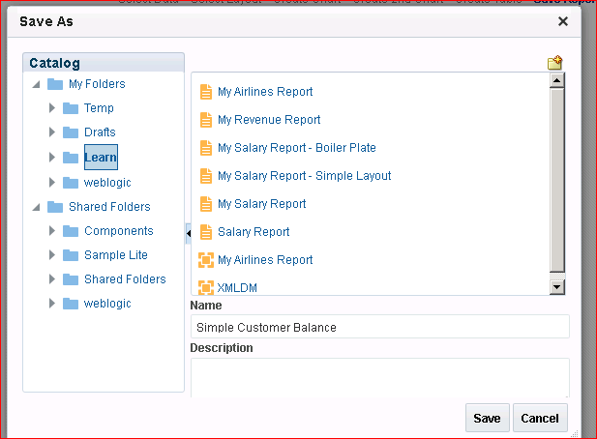

1. The report is opened in Report Viewer:

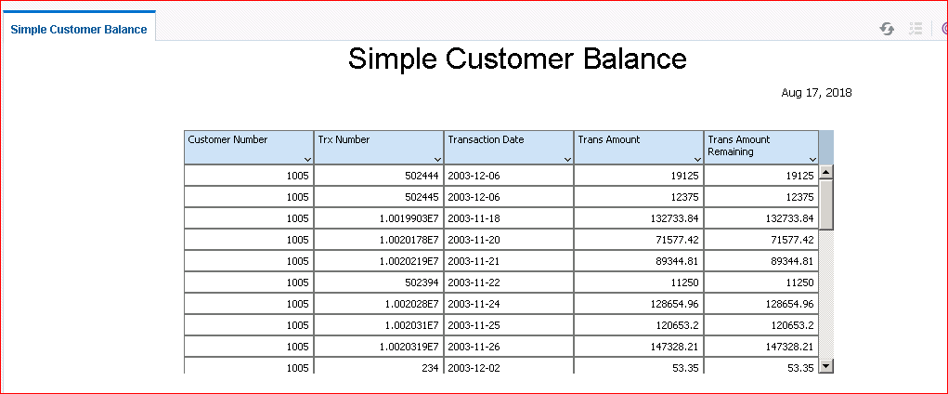

## Practice 11-2: Creating a BI Publisher Report Based on a CSV file

### Overview

You can use a flat or CSV file stored in a directory that has been set up by your administrator as a data source. (This demo directory is similar to the practice you completed previously.)

The supported CSV file delimiters are Comma, Pipe, Semicolon, and Tab.

The CSV files that you use as input to the BI Publisher data engine must be UTF-8 encoded and cannot contain empty column headers.

### Assumptions

The CSV files that you use should be either in the file location that you have defined before or uploaded to the data model from a local directory. This example uses a local file. This file is available in the MyFiles local folder.

### Tasks

1. Click New > Data Model.
2. In the Data Model pane, select **Data Sets**, and then click Data Sets > CSV File.



1. In the New Data Set – CSV File dialog box, enter **CSVData** in the Name text box.
2. Select the **Local** option and click **Upload** ( ).

**Note:** If the CSV file is shared, it must be stored in the

*<FMW_home>*user_projects\domains\bifoundation_domain\config\bipubl isher\repository\DemoFiles directory.

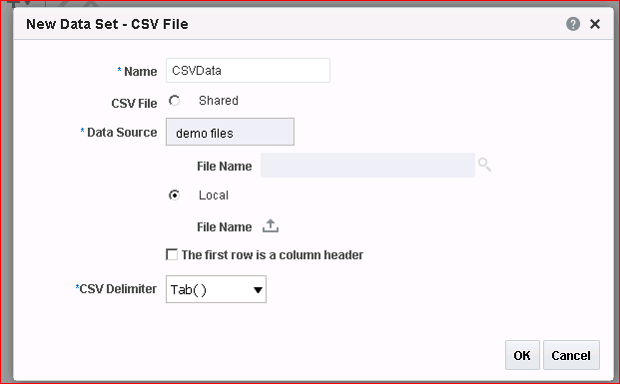

1. In the Upload dialog box, click **Browse**, navigate to the MyFiles local folder, select

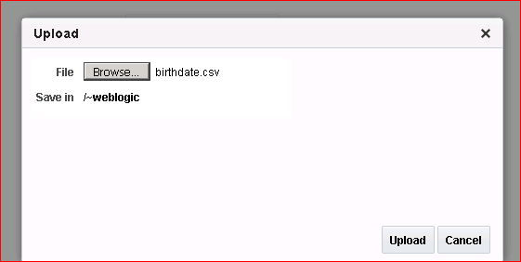**birthdate.csv,** and click **Open**.

1. Click **Upload.**
2. Select Tab () as the CSV Delimiter.
3. Click **OK**.
4. 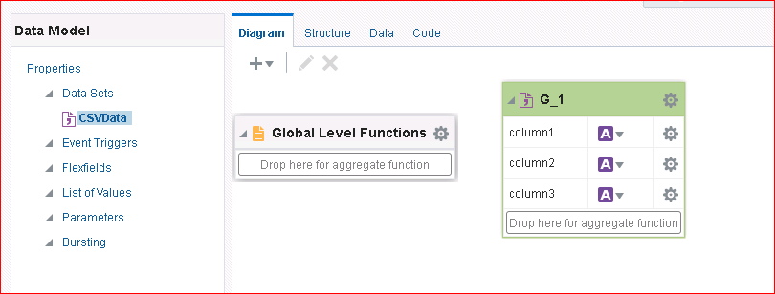The data set is listed in the Data Model pane.
5. Click **Data** and then click **View**. The data is displayed in a tree view.

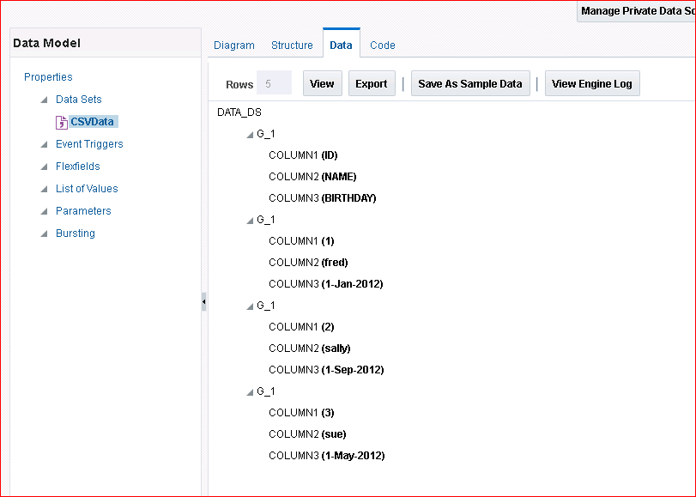

1. Save the sample data.
2. Save the data model as **CSVDM** in the **Learn** folder.
3. Click **Create Report** to create a report based on this data model.
4. 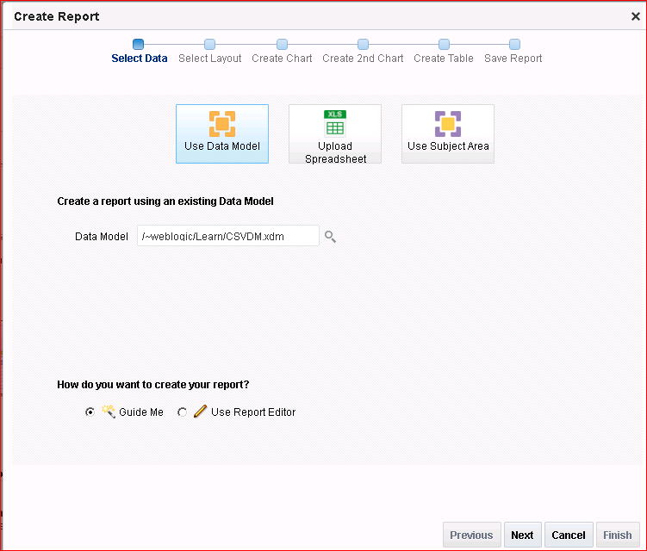In the Create Report Wizard, follow the steps to create a simple report layout.
5. Save the report as **CSVReport** in the Learn folder.
6. 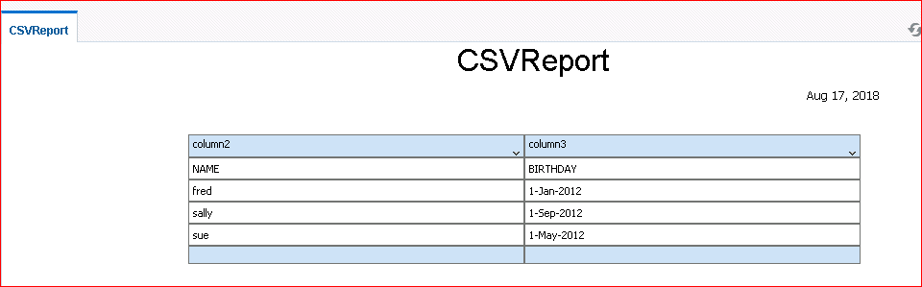Select the View Report option while saving. The report is displayed in Report Viewer.